Solicitation Addendum #1
Solicitation Number: | Doc2374792206 (16-101385-000)
Solicitation Description: | Prep, tow and sinking of the Research Vessel Cape Hatteras
Solicitation Opening Date and Time: | 10.15.2026  3:00 PM ET
Addendum Number: | 1
Addendum Date: | 9.23.2026
Procurement Specialist: | Leah Bartlett  Leah.bartlett@deq.nc.gov

- This addendum does not need to be returned.
- Following are CLARIFICATIONS received about the solicitation- Addendum #1
- Air draft 63’
- Permanently installed equipment will remain with the vessel, such as propulsion systems, generators, pumps, deck equipment (winches), and fire suppression systems.
- Removable equipment, such as lifesaving, safety, first aid kits, PPE, tools, and navigation computers, will be removed from the vessel by the RV Cape Hatteras crew after arriving at the awarded shipyard.
- The vessel will contain 8,000-12,000 gallons of diesel fuel when arriving at the awarded shipyard.
- Cape Fear Community College is organizing a legacy campaign that will include a stainless-steel plate with donor names engraved or laser-cut into it. Once completed, CFCC will transport this to the shipyard for it to be attached by the awarded vendor in a prominent location before sinking.
- Engine hours
- Port Main: 110,786
- Starboard Main: 109,817
- Forward Generator: 75,176
- Aft Generator: 76,964 (rebuilt approximately 1,500 hours ago)

- Engine(s) Details and Equipment
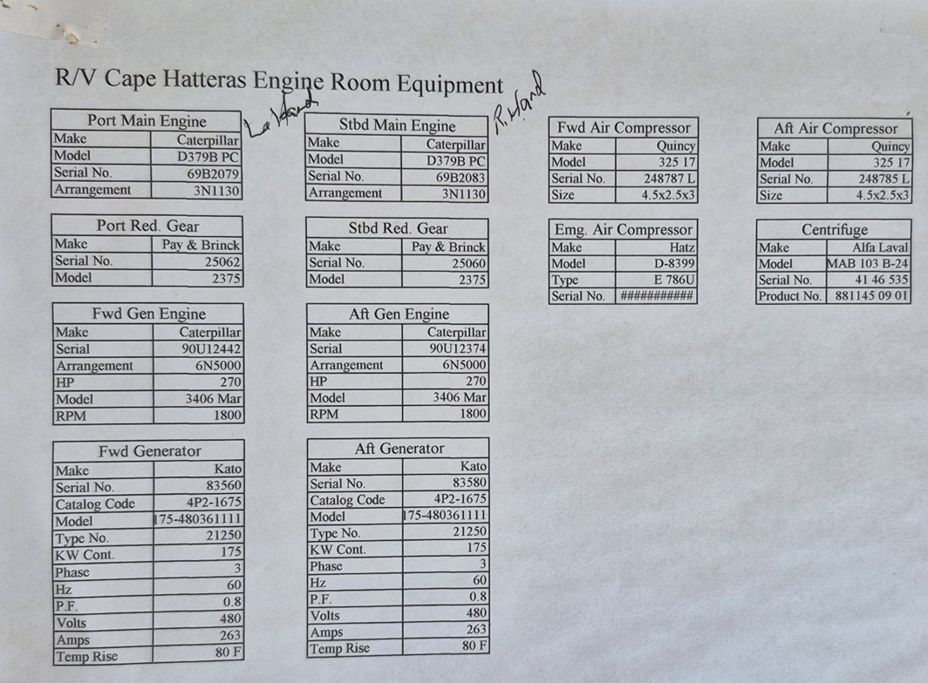

Check ONE of the following options:
☐ Bid has not been mailed. Any changes resulting from this addendum are included in our bid response.
☐ Bid has been mailed. No changes resulted from this addendum.
☐ Bid has been mailed. Changes resulting from this addendum are as follows:

Execute Addendum:
Offeror:
Authorized Signature:
Name and Titled (Typed):
Date:

