COMMONWEALTH OF PENNSYLVANIA PENNSYLVANIA GAME COMMISSION
BUREAU OF WILDLIFE HABITAT MANAGEMENT FORESTRY DIVISION
FY 2026

DEER DETERRENT FENCE INSTALLATION PROJECT

PACKAGE – STATEWIDE

CONTRACT SPECIFICATIONS

GENERAL SPECIFICATIONS

- SCOPE OF WORK:

  - The Pennsylvania Game Commission, Bureau of Wildlife Habitat Management, Forestry Division, requires woven wire deer exclosure fence installation. Services shall include, but not be limited to, the furnishing of all labor, superintendence, material, tools and equipment for the installation of woven wire deer exclosure fence as per attached Installation Specifications.

  - Any questions concerning the technical aspects of this bid, including order of fence construction should be directed to the Chief Forester or Forest Program Specialist, as identified below. Questions concerning the Request for Quote, the Purchase Order(s) or bidding procedures should be directed to the PGC Procurement Division at 717-787-6594.

Paul S. Weiss
Chief, Forestry Division
Pennsylvania Game Commission
Bureau of Wildlife Habitat Management
2001 Elmerton Avenue
Harrisburg, PA 17110-9797
717-787-2039
Aaron Tyson
Forest Program Specialist (Operations)
Pennsylvania Game Commission
Bureau of Wildlife Habitat Management
197 Nursery Road
Howard, PA 16841
570-317-6185
Fax 717-787-6957

CONTRACT TASKS:
  - Project Location(s):

    - Approximately 39,098 linear feet of perimeter on several blocks of State Game Lands as identified on the attached maps.
    - Counties Involved: Jefferson, Centre, Cumberland, Luzerne
  - Contractor shall comply with Attachment I, Fence Installation Specifications.

SITE INSPECTION AND ASSISTANCE:
An optional site inspection tour for each fence location may be conducted by contacting the Regional Forester to make an appointment:

North Central Region
Paul Lupo (Regional Forester)
1566 South Route 44 Highway
P.O. Box 5038
Jersey Shore, PA 17740
Phone: 570-398-4744

South Central Region
Roy Bucher (Regional Forester)
8627 William Penn Highway
Huntingdon, PA 16652
Phone: 814-643-1831

Northwest Region
Dave Smerkar (Regional Forester)
1509 Pittsburgh Road
Franklin, PA 16323
Phone: 814-432-3187

Northeast Region
Matt Engel (Regional Forester)
3917 Memorial Highway
Dallas, PA 18612
Phone: 570-675-1143

CONTRACT REQUIREMENTS:

The contractor agrees to comply with specifications in all attachments.

INSURANCE REQUIREMENTS:

  - The contractor will provide Workmen’s Compensation insurance sufficient to cover all the employees of contractor working to fulfill this contract.
  - Comprehensive General Liability Insurance, including bodily injury and property damage insurance, to protect the Commonwealth and the contractor from claims arising out of the performance of the contract. The amount of bodily injury insurance shall not be less than
$300,000.00 for injury to or death of persons per occurrence. The amount of Property Damage Insurance shall not be less than $300,000.00 per occurrence.
Such policies shall name the Commonwealth as an additional insured. Prior to the commencement of work under this contract, the contractor must provide the Commonwealth with current Certificates of Insurance. These Certificates shall contain a provision that coverage’s afforded under the policy shall not be canceled or changed until at least thirty (30) days prior written notice has been given to the Commonwealth.

HOLD HARMLESS:
The contractor shall be responsible for and agrees to indemnify and hold harmless the Commonwealth from and against damages to property or injuries (including death) to any persons and other losses, damages, expenses, claims, demands, suits, and actions by any party against the Commonwealth in connection with the work performed by the contractor.

BIDDING:
  - RECEIVING AND OPENING BIDS - The bid shall be awarded on a line item basis. Bids must be submitted via the PA Supplier Portal, to be found at www.pasupplierportal.state.pa.us Faxed bids and mailed bids will NOT be accepted. Bids will be publicly opened on October 22, 2026 at 2:00 PM., at the Pennsylvania Game Commission, 2001 Elmerton Ave., Harrisburg, PA 17110-9797.
The price per linear foot of fencing shall include all labor, equipment, tools, insurance, materials disposal and all items necessary for the completion of the project.
Prices bid shall be in dollar and cents only.
  - BID RESULTS - Bidders can obtain results at www.emarketplace.state.pa.us/bidtabs.aspx The posted results will contain the information of the apparent bidders, and all bids are under review until final award of the purchase order. Quantities herein are only estimates and may increase or decrease dependent upon the needs of the Commission. Operator shall be paid at the unit price bid for actual services performed. The Commission reserves the right to reject any or all bids and award contracts as it determines to be in the best interest of the Commission. Bidder may bid on all location sites; however, bid will be awarded on a line item basis as identified below.

PERFORMANCE SECURITY:

  - As further guarantee of faithful performance of the conditions set forth in this contract, the Contractor hereby agrees to furnish the Commission with Certified Check, Savings Account, Irrevocable Letter of Credit, or other security acceptable to the Pennsylvania Game Commission, in the sum of $5,000.00 per Line Item.

ANY SECURITY POSTED MUST HAVE AN EXPIRATION DATE A MINIMUM OF ONE YEAR BEYOND THE EXPIRATION DATE OF THE CONTRACT.
  - Performance Security is due no later than 30 days after written notice of the bid award. Time is of the essence with regard to the provision of Performance Security. At the option of the PGC, failure to provide an acceptable Surety within 30 days will result in cancellation of the contract and the PGC may declare the bidder ineligible on future projects.

  - Failure to comply with any of the conditions of the contract herein mentioned may result in cancellation of the agreement and claim may be made against the surety or the security for all or part of the damages sustained by such noncompliance.

OPERATOR REFERENCES:
After bid opening and prior to awarding the Purchase Order(s), the Commission has the right to request three (3) references (name, addresses and telephone numbers) of similar work performed in the previous two (2) years as proof of qualifications to perform the work involved in the project(s).

CONTRACT TERM:
  - The contract term shall begin at the issuance of PO and terminates June 30, 2027. All fences other than the Redlick Fence must be installed by June 30, 2027. The Redlick Fence, on SGL 100, must be completed by March 1, 2027.
  - The following will be “No-Work Days” during the contract period:
- All Saturdays in the months of October, November, December, and January.
- The opening day and all Saturdays during spring turkey season, including the youth spring gobbler hunt.
- From the start of the general statewide bear season to the end of the general firearms deer season.
- All days during elk season, unless approved by PGC Forestry Staff.
- The opening day of the flintlock muzzleloader season
- Any Sundays approved for hunting by the Commission

The contractor, employees, and sub-contractors may not hunt to, from, or at the job site when the work location is beyond a gated road that is closed to traffic. The contractor may travel to and from the work location on no-work days to check on the condition of equipment.

It is unlawful to be present on State Game Lands from November 15 through December 15 inclusive when not engaged in lawful hunting or trapping and fail to wear a minimum of 250 square inches of daylight fluorescent-orange material on the head, chest, and back combined, or in lieu thereof, a hat of the same colored material. The material shall be worn so it is visible in a 360-degree arc.

PAYMENT TERMS:

Payment shall be on a reimbursement basis for actual lineal feet installed as measured by a Forestry Division employee unless otherwise agreed to by the Commission.

INVOICES:

Original invoices must be sent to:

Commonwealth of PA – PO Invoices
P.O. Box 69180
Harrisburg, PA 17106 A copy must be sent to:
Paul S. Weiss
Chief, Forestry Division Pennsylvania Game Commission
Bureau of Wildlife Habitat Management 2001 Elmerton Avenue
Harrisburg, PA 17110-9797

All invoices must have the Purchase Order Number, as well as the Operator’s SAP Vendor Number on the invoice. The name and address listed on the purchase order must also be on each invoice. Failure to provide this information may result in a delay of payment.

PURCHASE ORDER(S) TERMINATION:

The Commonwealth may terminate the Purchase Order(s) for its convenience if the Commonwealth determines termination to be in its best interest. Operator shall be paid for work that is completed to the specifications in this contract.

ATTACHMENT I
FENCE INSTALLATION SPECIFICATIONS

HAZARD TREES:

  - After the location of the fence has been determined, all hazard trees, which are within tree length of the fence, must be felled. Hazard trees are dead and dying trees, split trees, heavily leaning trees, and/or root sprung trees, which are in a position to fall across the fence.

  - A Forestry Division representative will consult with the vendor to determine which trees are to be considered hazard trees. All trees determined by the Forestry Division to be merchantable will be cut in such a manner as to preserve the value of the sawlogs.

CLEARING FENCE AREA:

  - It is the responsibility of the contractor to clear and level a maintenance path at least six feet wide, but not more than eight feet wide, of all brush, stumps, rocks, or other obstructions.

  - Obstructions, which in the opinion of the Forestry Division representative will cause greater installation or maintenance problems, may be left in place.
  - The maintenance path will lie outside of the fence and will serve as the access corridor for equipment during installation and for future use as a fence maintenance corridor.

  - Disturbance of the entire perimeter may not be necessary. In those areas where the ground is naturally level, free of stumps, brush, and rocks, disturbance may not be required.

  - A bulldozer of at least the Caterpillar D4 class should be adequate in completing the required fence line clearing.

  - The contractor will be responsible for, and may be invoiced for, damage to standing trees. Tree damages will be calculated by using the Forestry Division's timber stumpage values for the Region. The stumpage value will then be doubled or tripled depending upon the severity and/or amount of contractor negligence. The severity of negligence will be determined by the Forestry Division representative. The minimum charge for any commercial, non-commercial, merchantable, or non-merchantable tree shall be twenty-five dollars ($25.00). The Forestry Division will have the final determination in all damage disputes.

EROSION AND SEDIMENTATION CONTROL:

  - Equipment will not be operated when ground conditions are such that excessive damage will result.

  - Where possible, the fence maintenance path is to be shaped to allow for sheet flow of water away from the fence to an area where it can infiltrate naturally. The cross-slope should be approximately 8%. That’s approximately one inch of fall per horizontal foot of width.

  - The contractor will be required to repair areas that become rutted due to work and install waterbars to prevent erosion. Waterbars must be installed at the spacing listed in waterbar spacing chart shown below. Additional waterbars may be required if conditions dictate.

Waterbar Spacing
Grade of Maintenance Trail (% Slope) | Recommended Spacing (ft)
0 – 5 | 250
5 – 15 | 150
15 – 30 | 100
30 & above | 50

Standard Construction Detail for Waterbars
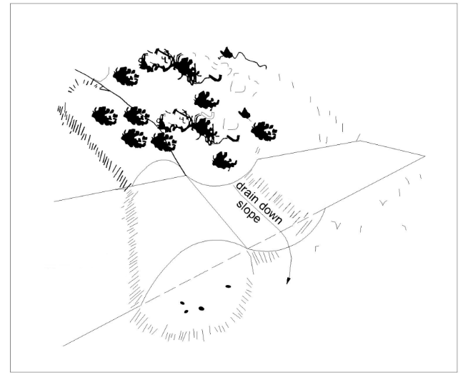

  - The contractor will be required to seed any disturbed areas around the fence path at a rate of 50 pounds/acre of wheat or oats (seasonal). All seeding must occur Aug 15 - Oct 15 or Mar 1 - Jun 15. The Forestry Division representative may decide to waive this requirement on certain sites.

  - Small intermittent or perennial streams, adjacent stream banks, or seeps, which are unavoidable, will be cleared by hand. The Forestry Division representative reserves the right to determine which areas are to be cleared by hand.

FENCE SUPPORTS:
  - The contractor will erect the fence by fastening the fence to posts or trees. All trees will be protected by having a 2" x 4" board of sufficient length placed between the fence and the tree. The board will be nailed to the tree at the top and bottom of the board and the fence will be attached to the board with staples to the same specifications as attaching to a wooden post.

  - The Forestry Division reserves the right to waive the above attachment rule in instances it determines tree damage is not a consideration.

  - Posts that are to be installed to serve as in-line posts must be a minimum of 4" x 4" treated square posts, steel posts that weigh two pounds/foot, or round treated posts that taper from 3” at the small end to 4” at the big end. Corner posts must be a minimum of 6" x 6" treated square posts or round treated posts that taper from 4” at the small end to 5” at the big end. Posts are to be ten feet long and placed in the ground at least two feet but no more than three feet. The Regional Forester may lessen the required post depth if adverse digging, drilling or driving conditions exist. Posts made of Southern yellow pine are strongly recommended.

  - Single corner posts must be braced with a second post that is attached at a diagonal on the inside of the fence. H-brace corners and H-brace posts on either side of skidder gates and truck gates must have diagonal wires or cables added to prevent the posts from leaning. Bracing must be sufficient to prevent the post from bending, leaning, breaking, or pulling free of the ground. All bracing outside the fenced area must be clearly marked to prevent a safety hazard to all persons.

FENCE MATERIALS:

The installed fence will stand approximately seven-feet high using a minimum of two-47-inch rolls or one-seven and half foot roll of fencing. The fencing material must be fixed knot or hinge joint knot woven wire design made of galvanized steel, Bezinal coated steel, or class 3 zinc coated steel. The wire fencing material will be 14-1/2 gauge wire or heavier and have no more than six inches between vertical stay wires and have a minimum of twelve horizontal line wires. Products deemed equal may be approved at the discretion of the Chief Forester.

FENCE STRETCHING:
  - The finished fence will be at least seven feet high with approximately a six-inch overlap on the ground. The fence is to be pulled to the outside of the fenced in area whenever it is not necessary for it to be on the inside of the fence for structural reasons. The fence will be stretched so that the wire is pulled against a corner or turning support. Maximum distance between fence supports will be no greater than 35 feet between posts or trees.

  - Where two rolls of fence are used to achieve a seven-foot-high fence, the second to the bottom wire of the top roll must be fastened to the top wire of the bottom roll every three feet using 14 gauge or heavier stainless steel or galvanized hog rings or 14-1/2 gauge or heavier stainless steel or galvanized wire. The fasteners that are used to connect the top and bottom of the fence together must be strong enough to withstand the weight of PGC personnel climbing over the fence. The Forestry Division may specify the point where fence stretching begins. This is to facilitate the driving of deer from the fenced area.

- FASTENERS:

  - Each 47-inch roll of fence will be fastened in three places: Top, middle, and bottom. Seven and half foot fencing must be fastened to posts at seven places, spaced evenly apart. The top wire must always be fastened to the post. Ties to secure the fence to metal poles will be 14-1/2 gauge galvanized or stainless steel wire ties or other commercially suitable ties.

  - Staples will be one and one-half inch galvanized steel. No staples will be driven into trees.

  - The nails used to fasten the 2" x 4" boards to the trees must be larger than #8 common and must hold the board securely to the tree while the fence is being stretched. The nails used should be long enough to securely hold the 2" x 4" in place and still leave approximately one inch exposed to facilitate eventual removal.

    - No aluminum may be used in the installation of the fences.

SECURING FENCE BOTTOM:

  - The fence must be installed so that deer will be unable to crawl under the fence. An approximate six-inch overlap on the ground, predominantly on the outside of the fence will be established. The fence is to be anchored to the ground by covering the bottom six inches of fence with dirt and rocks or by stapling the bottom of the fence to sound wood every ten feet.

  - Gaps between the ground and the fence of over three inches in height and six inches in length will be filled with dirt or rocks or stapled at the bottom to sound wood. Other means may be used if approved by the Forestry Division representative.

ACCESS:

  - The specific number of each type of gate required for each fence project are indicated on the attached maps and project list spreadsheet. Locations for all gates will be determined by the Forestry Division representative and will be explained to the contractor. All gate designs must be approved by the Regional Forester. See attached diagram images for gate dimensions.

  - Walk through type/man gates will normally be required on all fence projects. The gate frame material for walk-through gates must be at least one-half inch metal rod or rebar or three-quarter inch pipe that is welded together. Gate doors must swing outwards and overlap the bottom of the opening by at least two inches. All walk-through gates will be primed and painted yellow.

  - Sixteen-foot-wide truck gates may be required for each fence project. The sixteen-foot truck gates must be installed using two eight-foot gates. The two gates must be chained shut with no more than a two-inch gap between the gates. The fencing that is attached to the gates must contact the ground the entire length of the gates. Truck gates must be mounted to a five-inch diameter post or larger on either side of the gate. These posts are to each be connected to a second five-inch post using a horizontal post mounted approximately one foot from the top of the posts.

  - Forty-foot-wide skidder gates may be required for each fence project. Skidder gates are made up of a 40’ section of fencing stretched between two five-inch diameter or larger posts. These posts are to each be connected to a second five-inch post using a horizontal post mounted approximately one foot from the top of the posts. This section of fence serves as a gate. The hinging end of this gate is to be secured to one of the five-inch posts with a seven-foot pressure treated 2x4. The other end of this gate that can be opened and closed is to be sandwiched between two seven-foot-long pressure treated 2x4s that are connected together with at least nine three-inch-long exterior screws with washers. This end of the fence is to be ratcheted tight to the second five-inch post using two ratchet straps. The fence must be tight when this end of the gate is secured to the second five-inch post. Two chains with clips must also be placed on this end of the gate to keep it secured once the ratchet straps are removed. When closed, this gate is to have no more than a two-inch gap between this end of the gate and the post. An eight-foot metal t-post must be placed one foot in the ground at the midpoint of this gate. The gate is to be wired to this post for added support.

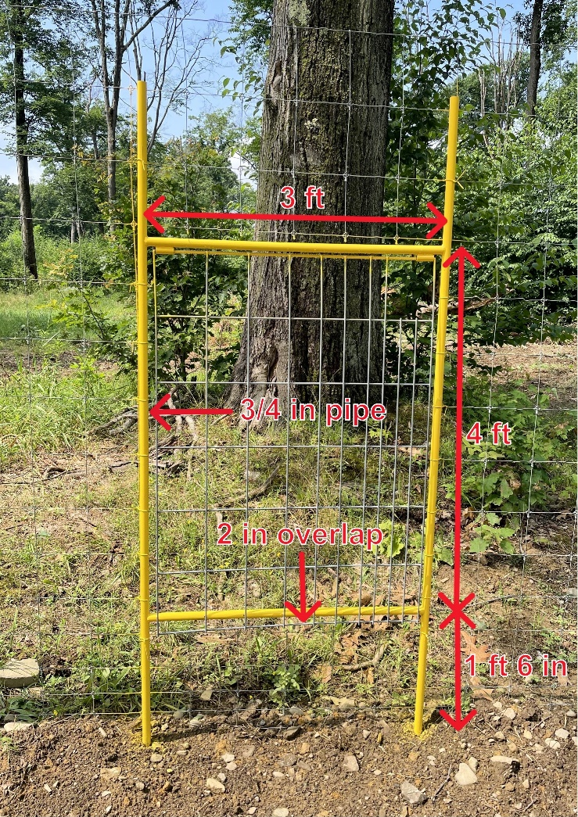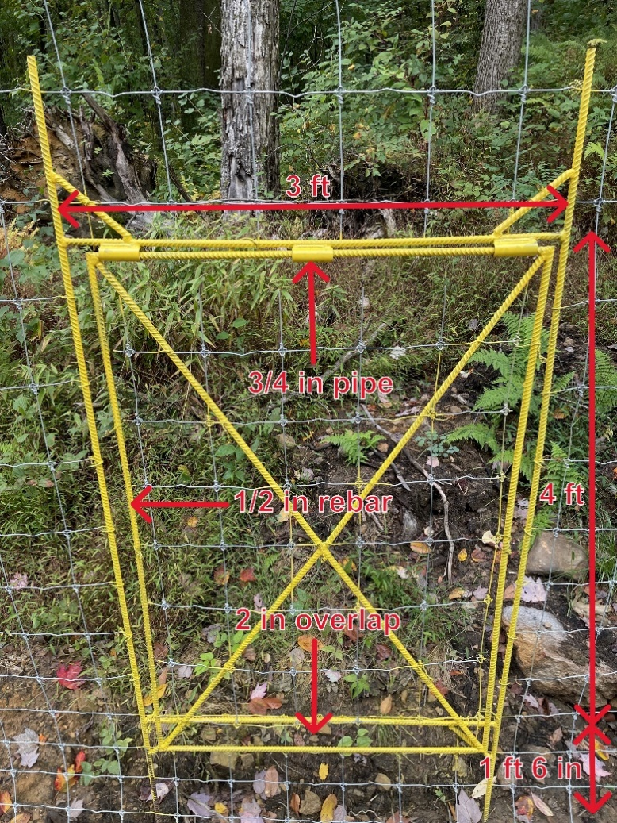
Man Gate (hog panel/pipe design) Man Gate (rebar/woven wire fence design)

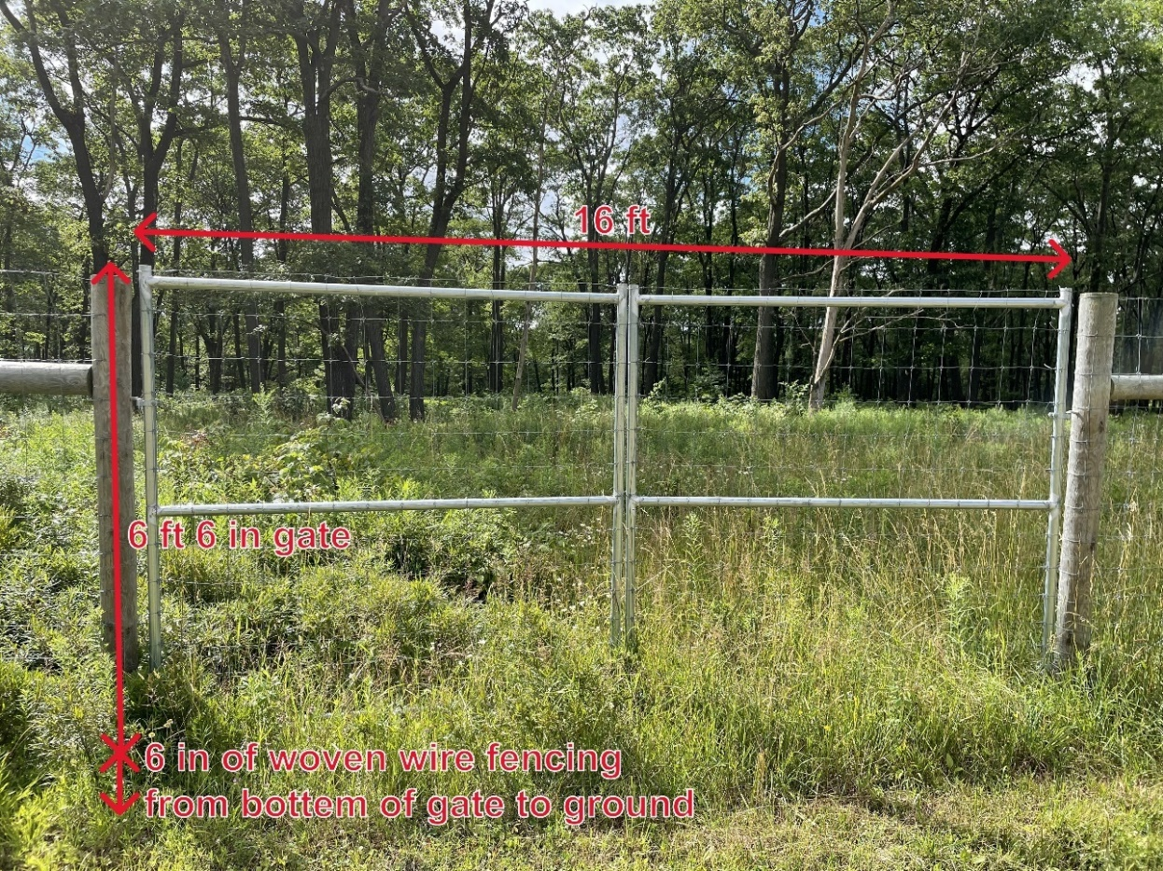
Truck Gate (dimensions)

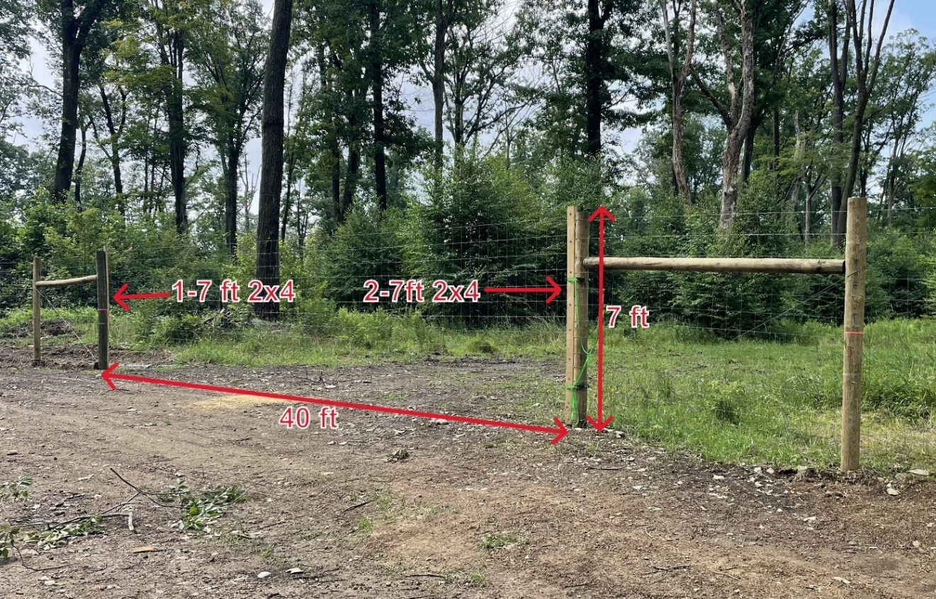
Skidder Gate (dimensions)

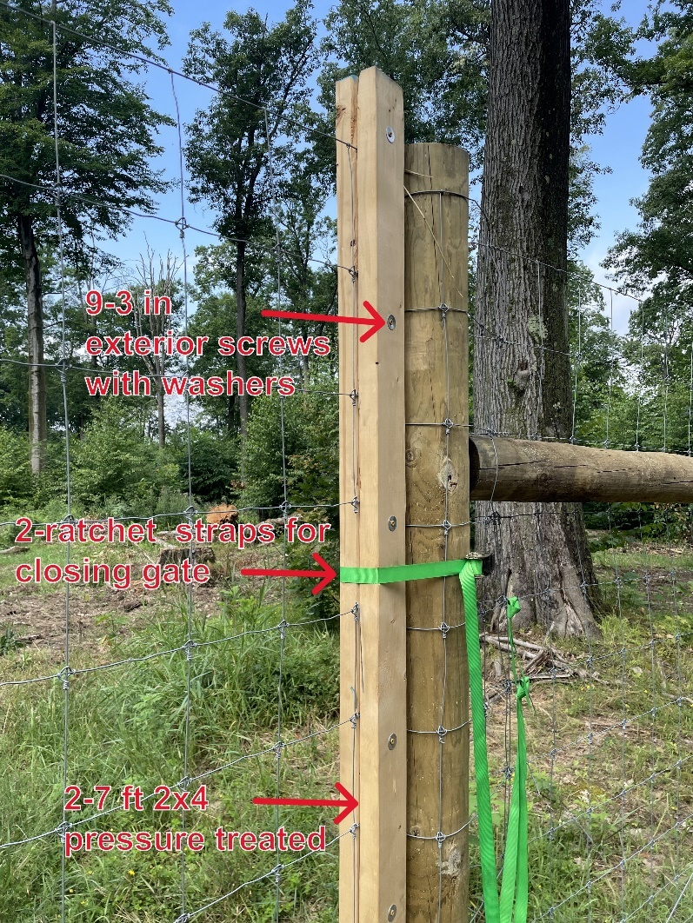
Skidder Gate (closure)

DEER RAMP:

Some fences require the installation of an experimental deer ramp structure. The contractor must construct a fence corner using four six-inch posts connected together with two four-inch horizontal posts. Two diagonal cables will be added for additional support. Ten pressure treated 2X12X12s will be attached to the inside of the six-inch posts using galvanized or other corrosion resistant nails. A support cable is to be wrapped around the corner posts three feet from the top of the fence. This cable is to be pulled tight and the other end is to be secured to a one-foot-tall wooden support post that is driven into the ground at least two feet. The support post is to be on the inside the fence at approximately seven feet from the corner posts. Once the fencing is wrapped around this corner, a mound of dirt is to be piled against the 2X12s on the inside of the fence. The dirt will be piled the highest in the corner, at which point the top of the pile is to be flattened to form a roughly 4’ X 4’ platform. This platform must be within two feet of the top of the seven-foot-tall fence at this point. From the edge of this platform, the pile is to be tapered down to the ground inside the fence at a 1:1.5 slope. The support cable and support post will be buried under this dirt mound. The location of the deer ramp and the location from where the dirt is to be excavated will be determined by Game Commission personnel. A Forestry Division representative must be notified prior to beginning construction of the deer ramp.

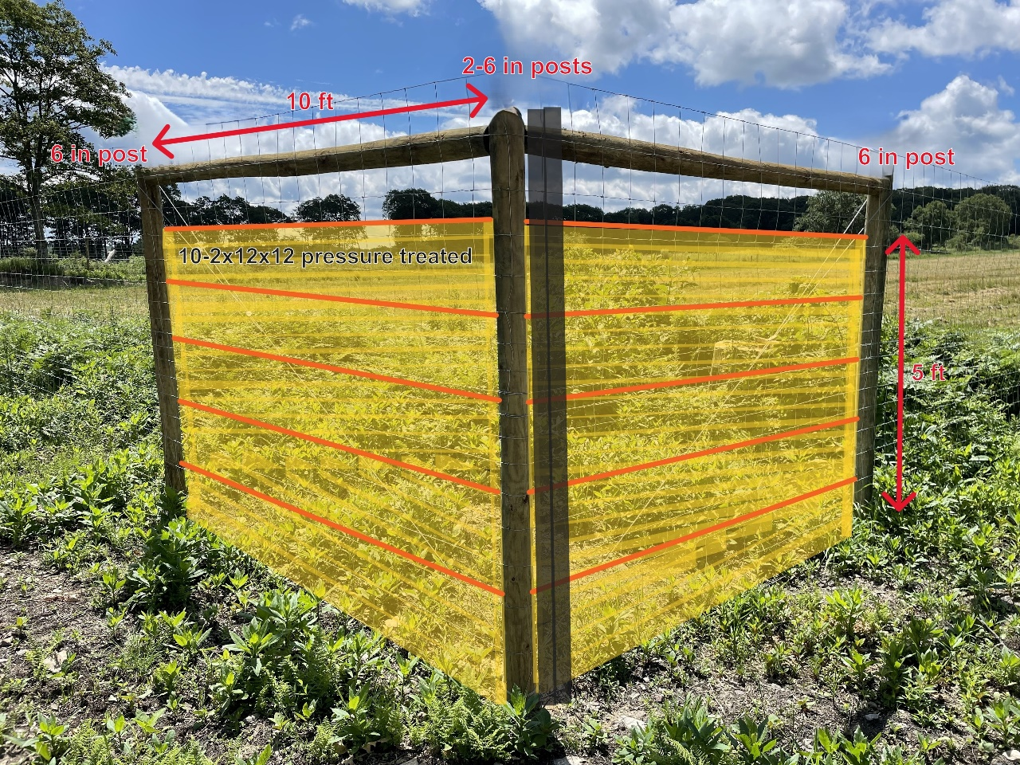
Deer Ramp Structure (dimensions)

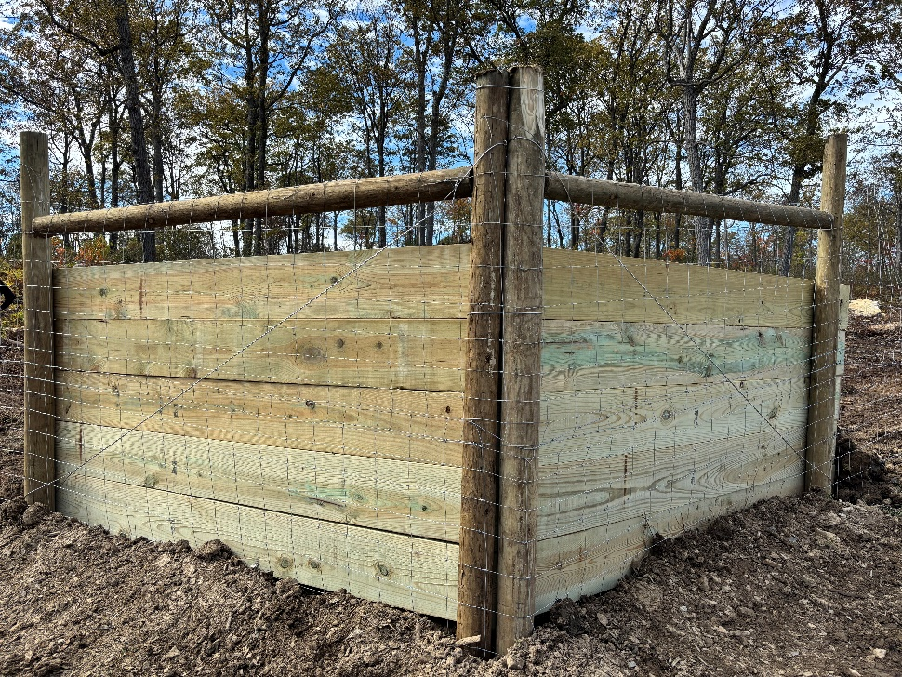
Deer Ramp Structure (outside)

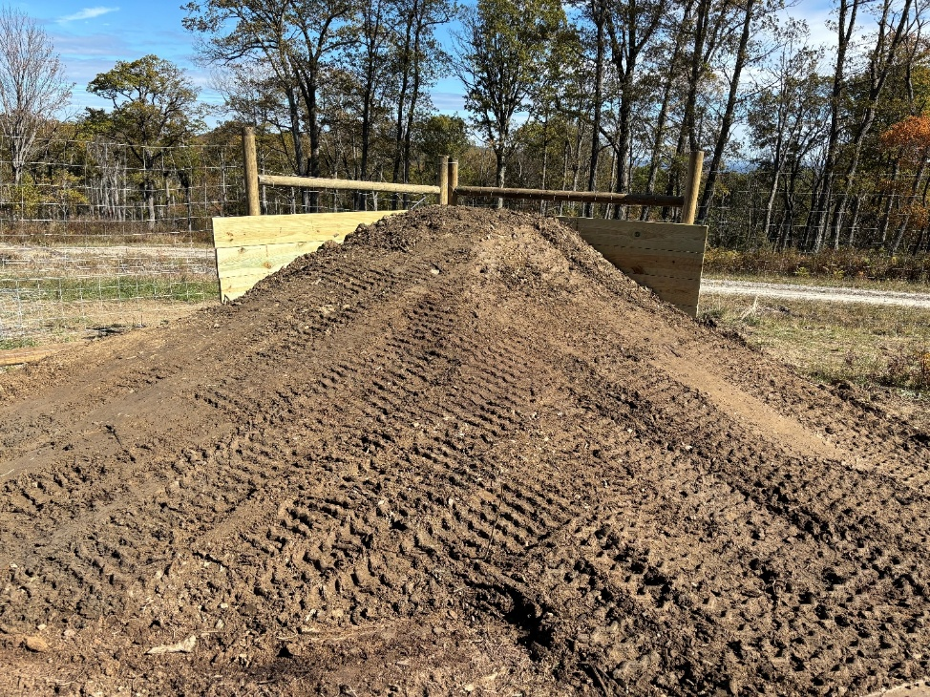
Deer Ramp Structure (inside)

DEER DRIVE
The contractor must drive all deer from the fenced area prior to the closing of the fence. The contractor will notify the Forestry Division representative 48 hours prior to conducting the deer drive. The deer drive must be conducted with a Forestry Division representative on site. The fence will be closed the same day that the deer drive takes place.

OPERATING AREA
The contractor may operate vehicles on the cleared fence path. Vehicles may not travel into the area to be fenced in without approval of the Forestry Division representative.

SECURITY

If guard service for the fencing equipment and/or supplies is required or desired, the Operator must provide the necessary personnel. For security purposes, the Operator and support staff are authorized to stay overnight with their equipment on State Game Lands upon approval from the Regional Forester for the region that the project is located. The overnight location will be determined by Game Commission personnel and no more than 6 people are authorized to stay at the overnight location at one time. A camper or tent may be used at this location upon approval. No open fires are permitted other than what is specified in Game Commission regulations.

DEBRIS AND GARBAGE

The contractor will remove all trash and garbage generated during the completing of this contract. This is to include all materials generated from the installation of the fence and items generated from the personal use by the contractor's employees.

WORK SCHEDULE

PGC Forestry Division Staff reserve the right to dictate the order that the individual fence projects are completed. The contractor will notify the Forestry Division representative three days prior to the beginning of each fence. The contractor may work at times other than the schedule of the Forestry Division representative.

FY26 Deer Fence Install Statewide Contract

Line Item 1 – 39,098 linear feet

