Atlanta; Downtown; Delineated area

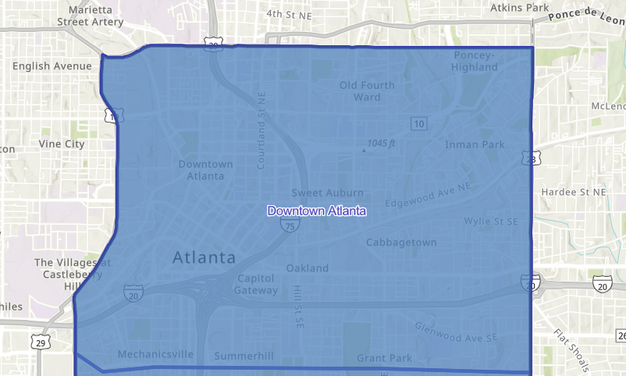

Downtown CBD:

North: North Avenue NW (Route 29) to North Ave NE
East: Moreland Ave SE (Route 23)
South: Berne St SE to Ralph David Abernathy Blvd SW
West: Route 19 and Northside Drive SW/NW

