1. Purpose and Control
This attachment establishes the states, territories, District of Columbia, and other geographic areas assigned to each Region Coverage Area under this solicitation and any resulting IDIQ contract. The Regions align with supporting the Veterans Integrated Service Networks (VISNs).
Before award, the Region Coverage Areas Table identifies the geographic areas for which an Offeror may submit a proposal. Upon award, this attachment becomes part of the resulting IDIQ contract and governs:
- The geographic area for which the Contractor is awarded a Region Coverage Area;
- The jurisdictions in which the Contractor must maintain applicable broker licensure or other lawful authority to operate;
- The Task Orders for which the Contractor is eligible to compete; and
- The Region Coverage Area assigned to each Task Order for reporting and performance-management purposes.
In the event of any discrepancy between the map and the table below, the table controls.
The Government may update this attachment by solicitation amendment before award or by contract modification after award, if necessary to reflect changes to VA VISN geographic assignments. If a post-award modification changes the geographic area assigned to a Region Coverage Area, the modification will identify the effective date of the change and any resulting requirements for licensure or other lawful authority to operate. The Government will not require performance in a newly added jurisdiction before the effective date stated in the modification.
2. Region Coverage Area Table
Region | States, District of Columbia, Territories, and Other Geographic Areas
Region 1 | Connecticut; Delaware; District of Columbia; Maine; Maryland; Massachusetts; New Hampshire; New Jersey; New York; Pennsylvania; Rhode Island; Vermont; and West Virginia.
Region 2 | Alabama; Florida; Georgia; North Carolina; South Carolina; Virginia; Puerto Rico; and the U.S. Virgin Islands.
Region 3 | Illinois; Indiana; Iowa; Kentucky; Michigan; Minnesota; North Dakota; Ohio; South Dakota; Tennessee; and Wisconsin.
Region 4 | Arkansas; Colorado; Kansas; Louisiana; Mississippi; Missouri; Nebraska; Oklahoma; Texas; Utah; and Wyoming.
Region 5 | Alaska; Arizona; California; Hawaii; Idaho; Montana; Nevada; New Mexico; Oregon; Washington; American Samoa; Guam; and the Northern Mariana Islands.

3. Region Coverage-Area Map
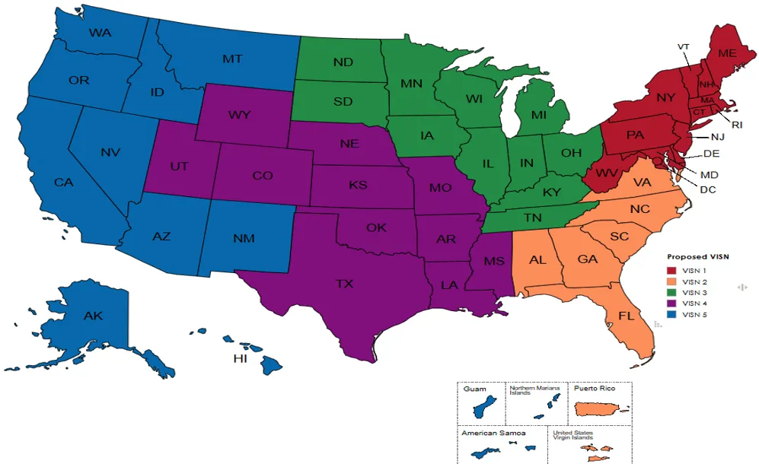

The map is provided for visual reference. In the event of a discrepancy between the map and the Region Coverage-Area Table, the table governs.

