PROJECT NO. 520-27-102
INSTALL CATWALKS, ACCESS STAIRS, AND SAFETY RAILINGS FOR ABOVEGROUND FUEL TANKS, BILOXI
VA GULF COAST VETERANS HEALTH CARE SYSTEM
400 VETERANS AVENUE
BILOXI, MS 39531

SCOPE OF WORK

- General Description
The Contractor shall furnish all labor, materials, tools, equipment, transportation, supervision, and incidentals required to complete the installation of Project No. 520-27-102, Install Catwalks, Access Stairs and Safety Railings for Aboveground Fuel Tanks, at the VA Gulf Coast Veterans Health Care System in Biloxi, Mississippi
- Project Overview
This project includes the installation of catwalks, access stairs, and safety railings for ten (10) aboveground generator fuel tanks of varying sizes. In addition, the contractor shall furnish and install a fuel level monitoring system for each of the fuel tanks. All work shall comply with applicable codes, VA standards, and manufacturer specifications.
- Detailed Scope of Work
Fuel Tank Locations
Refer to Attachment A for detailed fuel tank locations and dimensions.
- Tank #31 – 4,000-gallon tank – located on the North side of building 31 (install ladder and catwalks on West side of tank)
- Tank #35 – 6,000-gallon tank – located on the North side of building 31, between buildings 31 and 35. (install ladder and catwalk on east side of tank)
- Tank #25 – 6,000-gallon tank – located on the North side of building 25 (install ladder & catwalks on side closest to building 25)
- Tank #74 – 3,000-gallon tank – located in the alcove of buildings 1and 3 (re-use existing stairs and install catwalks on South side of tank)
- Tank for Building 15 – 4,000-gallon tank – located on the South side of building 15 near the dock scissor lift (re-use/re-locate existing stairs, install ladder to height of new catwalks, locate catwalks on East side of tank)
- Tank #1 – 10,000-gallon tank – located in the Graceland compound (re-use existing stairs, see Graceland Site Plan for Generator Yard details)
- Tank #2 – 10,000-gallon tank – located in the Graceland compound (re-use existing stairs, see Graceland Site Plan for Generator Yard details)
- Tank #3 – 10,000-gallon tank – located in the Graceland compound (re-use existing stairs, see Graceland Site Plan for Generator Yard details)
- Tank #4 – 10,000-gallon tank – located in the Graceland compound (re-use existing stairs, see Graceland Site Plan for Generator Yard details)
- Tank #27 – 8,000-gallon tank – located on the East side of building 27 (re-use existing stairs, install ladder to height of new catwalks, locate catwalk on East side of tank)
Installation Requirements
- Catwalks shall be installed along one side of each tank and should run the full length of the tank except in cases where conduit runs or other obstructions would interfere with catwalk placement.
- Each catwalk shall be a minimum of 40 inches wide to allow for safe and efficient access.
- Catwalks to have at least one spring gate closure for access to top of tank unless otherwise stated or indicated in plans.
- Walking surfaces of the stairs and catwalks shall be made of (serrated galvanized steel grating) to ensure safety and slip resistance.
- All catwalks and stairs shall be fully supported from the ground. No components may be mounted directly to the fuel tanks.
- All components (catwalks, stairs, and railings) are to be made of hot-dipped galvanized steel.
- Safety railings shall be removable to allow for equipment access or maintenance.
- At the top of each set of access stairs, there shall be a swing-type safety gate.
- All components must meet OSHA and VA safety standards.
- Provide and install two anchor points rated at 5,000 pounds for each of the ten tank locations. Install concrete screw/D-ring anchor for each of the four tanks in the Graceland Compound. Attach anchors to the catwalk system for the remaining tanks of this project.
- Gap between top of tank and catwalk surface should be no greater than 2 inches.
- Surface of catwalk and top of tank are to be at the same elevation where practicable.
- Each footplate must be attached to concrete slab/footing with (2) 3/8” x 3 ¾” wedge anchor in accordance with Specification 055000. Where no concrete slab is existing install a reinforced sonotube footing 16 inch diameter and 48 inch deep for each leg.
- Catwalks and steps and ladders are to be painted safety yellow. Surface areas to be cleaned, primed and painted with paint suitable for use on galvanized steel for exterior use in accordance with Specification 099100.
- Tanks 1,2,3,4, and 31 require electrical rigid conduits to be modified to all for adjusting location of stairs (tanks 1,2,3,and 4) and allow for catwalk installation for tank #31. In doing this, all exposed conduits to be rigid metallic conduit and fittings need to be metallic and with seal offs as required by Specification 260533. All materials are to be made in America.
- See Graceland Compound site plan drawing for further information and relocation of existing light pole.
Fuel Level Monitoring System
- System must be able to continuously monitor fuel levels in real time.
- System must allow for remote viewing from a VA computer.
- All components must be compliant with VA standards.
- Install a continuous capacitance level transmitter at each diesel fuel storage tank. Tie into nearest Siemens field panel to communicate to future VA BMS computer located at building 27 GM Shop Supervisor.
- Continuous capacitance level transmitters shall be compatible with diesel fuel/gasoline and rated for exterior use.
- Continuous fuel monitoring system for each tank to be field verified by COR for proper operation prior acceptance and final payment.
- See Fuel Tank Info Excel Spread Sheet for additional information pertaining to the continuous fuel measuring system.

- Installation Timeline
All work is to be completed within 120 calendar days after the notice to proceed is issued.
- Submittal review for each catwalk and stairs or ladder installs, and fuel measuring system, 10 each. The VA will review and respond to submittals within 14 calendar days.
- Shop Drawings (required for each catwalk and stair/ladder install). The VA will review and respond to shop drawings within 14 calendar days

- Safety Considerations
Contractors shall comply with OSHA and VA Biloxi Engineering safety policies during all phases of work. Contractors are expected to maintain clean work areas daily.
Notes:
Work is to be performed during the hours of 8:00 AM and 4:30 PM, Monday through Friday, excluding Federal holidays.
The CAD drawing included in Attachment A is for reference purposes only. It is intended to illustrate general design intent.

Note: The C & A requirements do not apply, and a Security Accreditation Package is not required.

ATTACHMENT A
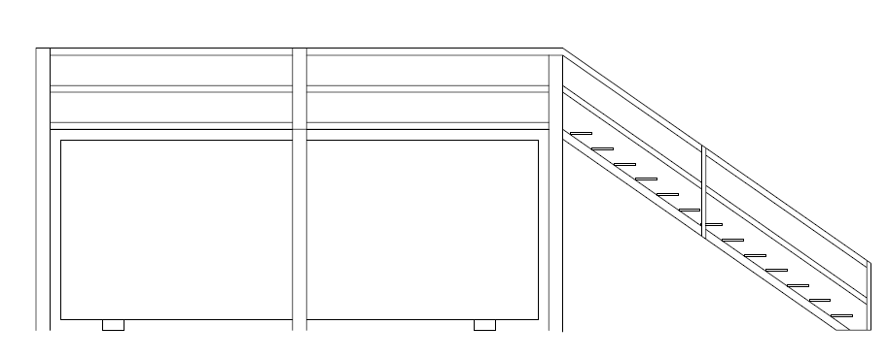
Example Catwalk Illustration

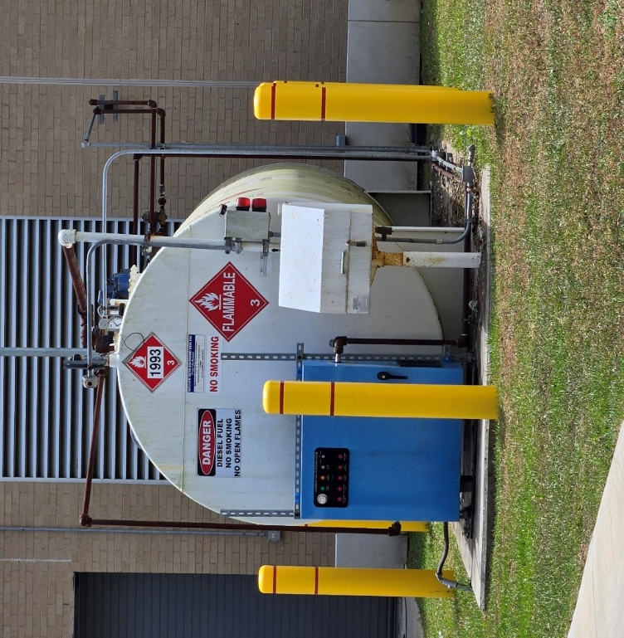
Fuel Tank #31
- Location: North side of Building 31
- 4,000-gallon tank
- Dimensions: 20’ length, 7.5’ height from ground, 80” diameter
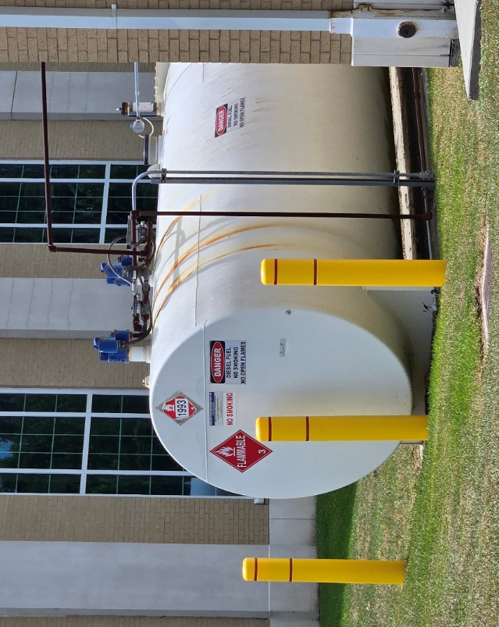
Fuel Tank #35
- Location: North side of Building 31
- 6,000-gallon tank
- Dimensions: 29.5’ length, 7.5’ height from ground, 80” diameter
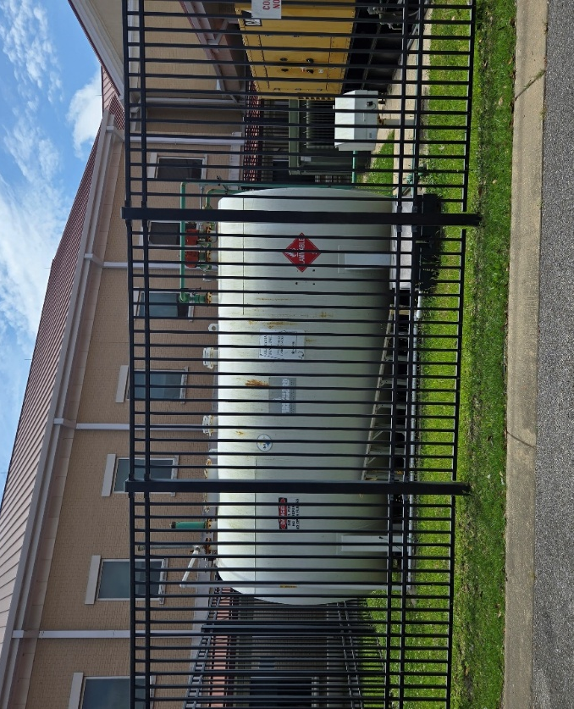
Fuel Tank #25
- Location: North side of Building 25
- 6,000-gallon tank
- Dimensions: 208” length, 9’ height from ground, 103” diameter
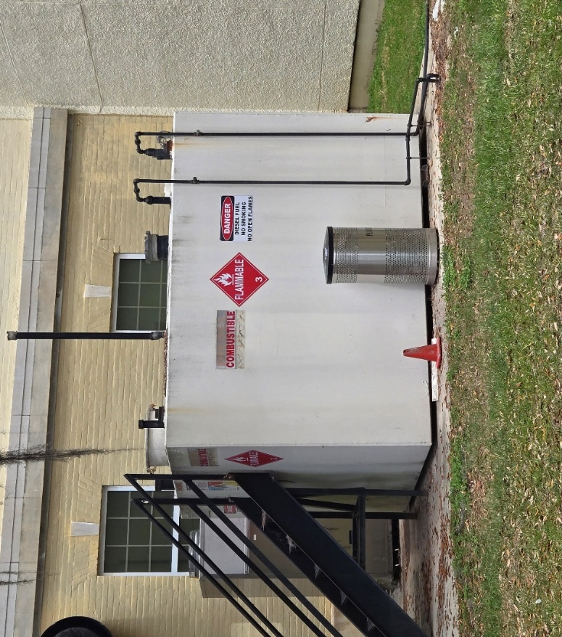
Fuel Tank #74
- Location: Alcove of Buildings 1 and 3
- 3,000-gallon tank
- Dimensions: 9’10” length, 7’1” height from ground, 8’ width
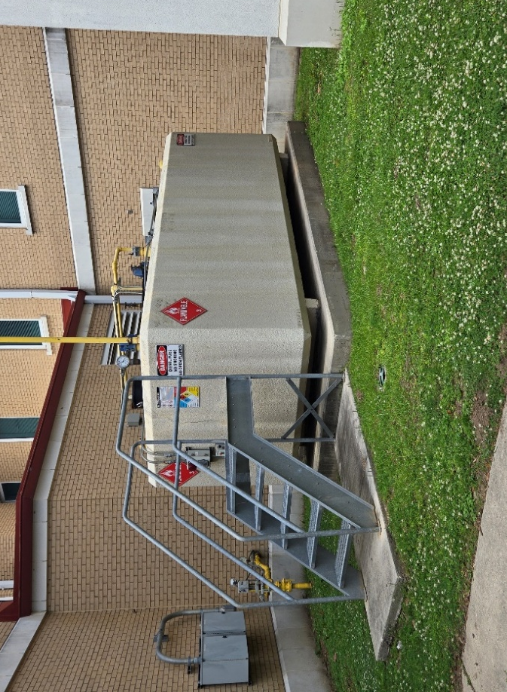
Building 15 Fuel Tank
- Location: South side of Building 15
- 4,000-gallon tank
- Dimensions: 17.5’ length, 80” height from ground, 7.5’ width

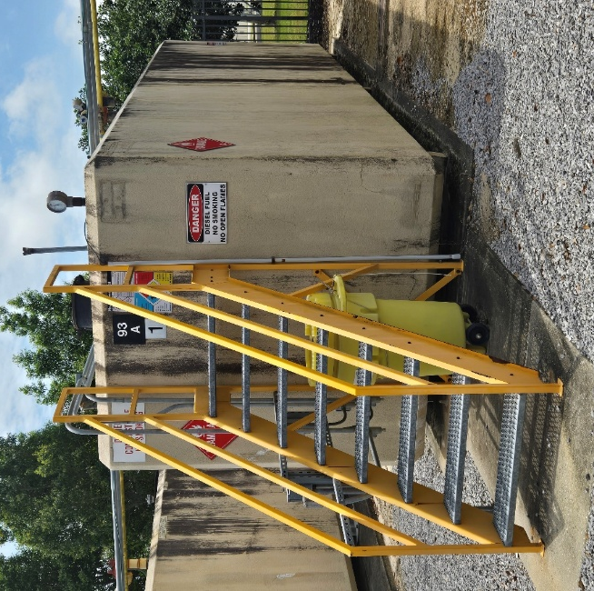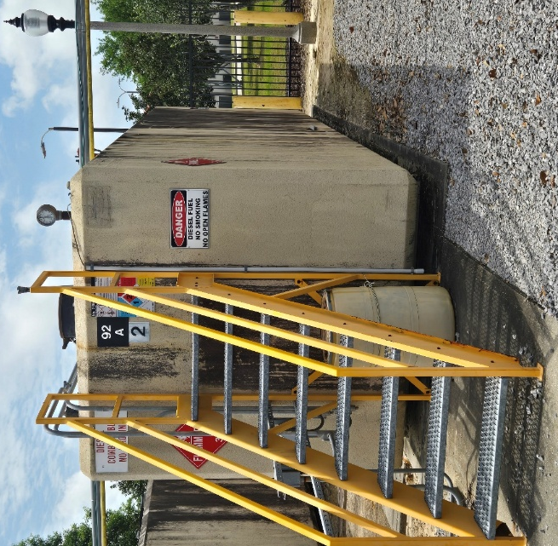
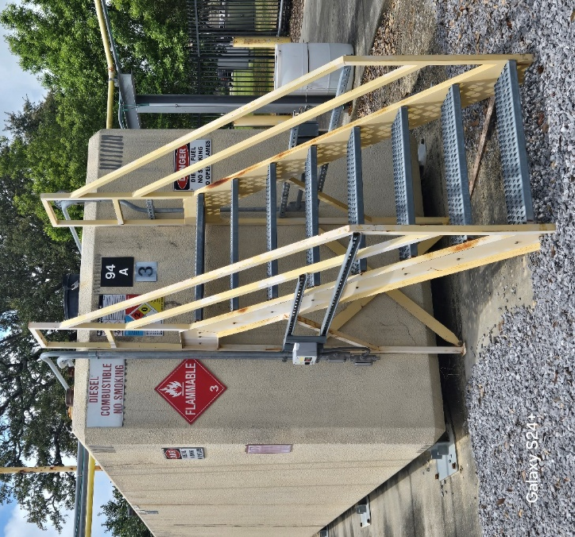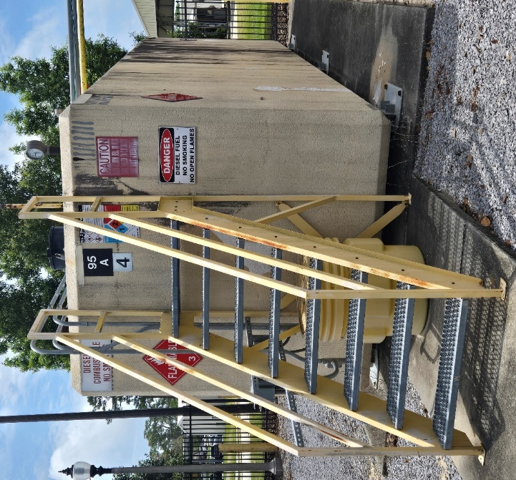
Fuel Tanks #1,2,3 & 4
- Location: Graceland Compound
- 10,000-gallon tank
- Dimensions: 26’ length, 8.5’ height from ground, 8’ width
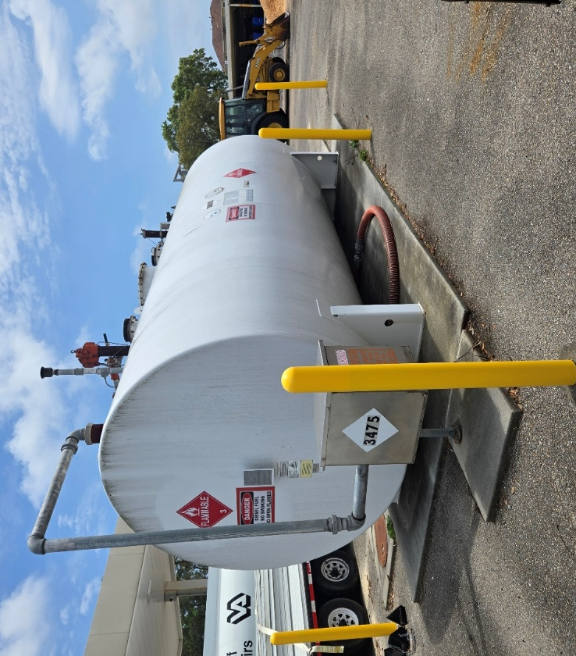
Fuel Tank #27
- Location: East side of Building 27
- 8,000-gallon tank
- Dimensions: 22.5’ length, 9’ height from ground, 8.5’ diameter

