SUBJECT* | NEW HILO VET CENTER

GENERAL INFORMATION
CONTRACTING OFFICE’S ZIP CODE* | 96720
SOLICITATION NUMBER* | 36C24W23R0031
RESPONSE DATE/TIME/ZONE | 11-15-2023 5:00 PM HONOLULU, HAWAII, USA
ARCHIVE | 3 DAYS AFTER THE RESPONSE DATE
RECOVERY ACT FUNDS | N
SET-ASIDE
PRODUCT SERVICE CODE* | X1AA
NAICS CODE* | 531120
CONTRACTING OFFICE ADDRESS | HILO, HI 96720
POINT OF CONTACT* | LEASE CONTRACTING OFFICER  MELINDA THOME  melinda.thome@va.gov  (808) 539-1309

PLACE OF PERFORMANCE
ADDRESS
 | HILO HI
POSTAL CODE
COUNTRY | USA

ADDITIONAL INFORMATION
AGENCY’S URL
URL DESCRIPTION
AGENCY CONTACT’S EMAIL ADDRESS | melinda.thome@va.gov
EMAIL DESCRIPTION

DESCRIPTION
The U.S. Department of Veterans Affairs Seeks Expressions of Interest for
3,844 to 4,036 ANSI/BOMA (ABOA) of Space in the area of Hilo, HI

Notice: This advertisement is a notice of a potential opportunity. This advertisement is not a solicitation for offers, nor is it a request for proposals. The purpose of this advertisement is to identify potential sources and suitable locations and is not intended to pre-qualify or disqualify any potential offers. The Government will not pay for any costs incurred as a result of this advertisement. The Government cannot provide any warranty, expressed or implied, as to the accuracy, reliability or completeness of contents of the furnished information found within this advertisement; Government is under no responsibility to respond to and is unable to answer any inquiries regarding this advertisement. Respondents are advised that the Government assumes no responsibility to award a lease based upon responses to this advertisement.

Contracting Office Address: Melinda Thome, Lease Contracting Officer (LCO), U.S. Department of Veterans Affairs (VA), Regional Procurement Office West (RPOW), VA Pacific Islands Health Care System (VAPIHCS) Hilo, HI 96720.

Description: VA seeks to lease approximately 3,844 to 4,036 ANSI/BOMA (ABOA) Square Feet (a maximum of 5,448 rentable square feet) of office space and 20 onsite parking spaces, including 5 designated ADA compliant spaces for use by VA in the delineated area explained below within greater Hilo, HI for use as a VA Vet Center. There is a requirement for an easy entrance and exit to the parking area to accommodate special needs transportation. VA will only consider leased space located in an existing building.

Lease Term: 20 years / 5 years firm. VA reserves the right to request other lease structures and may request multiple lease structures.

Delineated Area: To receive consideration, submitted properties must be located within the following area described below, which is bound by the following roads; properties fronting any of the following boundary lines will also be considered but not to exceed 50 miles in any direction from the current Vet Center unless approved to deviate by the LCO:

- North Boundary: Wailuku River
- South Boundary: Haihai St
- East Boundary: Mamalahoa Hwy
- West Boundary: Komohana St / Alu St

The attached map of the delineated area is provided for further clarification of the boundaries of the delineated area:

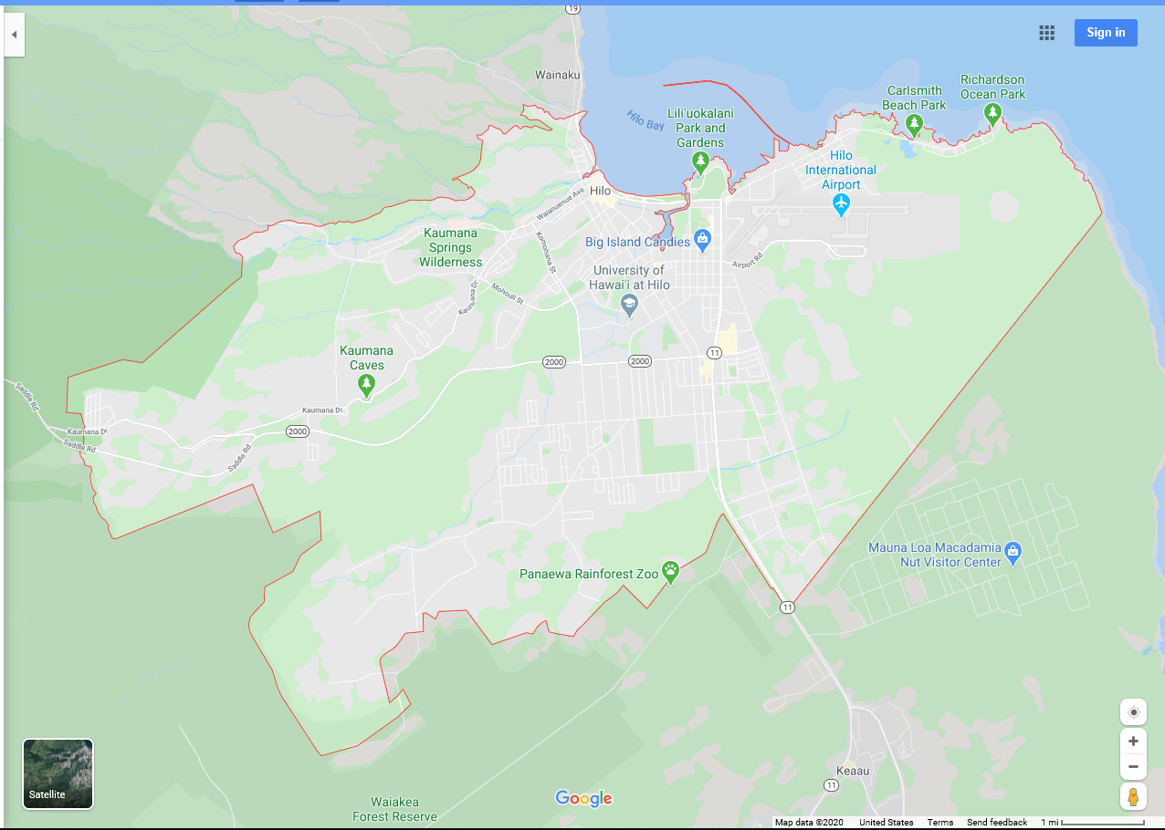

Additional Requirements:
(1) Offered space shall be contiguous and located on the first floor.
(2) The following space configurations will not be considered: Space with atriums or other areas interrupting contiguous space, extremely long or narrow runs of space (more than twice as long as wide), irregularly shaped space configurations or other unusual building features adversely affecting usage.
(3) Offered space cannot be in the FEMA 100-year flood plain.
(4) Offered space must be zoned for VA’s intended use (counseling offices).
(5) Offered space will not be considered if located in close proximity to gun stores, pawn shops, adult entertainment clubs, liquor stores, medical (or otherwise) marijuana distributors or methadone clinics within a walkable ¼ mile.
(6) Space will not be considered where apartment space or other living quarters are located within the same building.
(7) Offered space must be located in close proximity to public transportation. Access to public transportation shall be located within the immediate vicinity of the building, but generally not to exceed a walkable one mile as determined by the Contracting Officer. Alternatively, two or more public or campus bus lines usable by Veterans shall be located within the immediate vicinity of the building, but generally not to exceed a walkable ¼ mile.
(8) Offered space must meet Federal and Local Government requirements for fire safety, physical security, accessibility, seismic, and sustainability standards per the terms of the solicitation for offers or request for proposals.
(9) Fully serviced lease at the discretion of the Government.
(10) Offered space must be compatible for VA’s intended use.
(11) Not a sublease.

All submissions should include the following information:

- Name of current owner;
- Address or described location of building or land;
- Location on map, demonstrating the building lies within the Delineated Area;
- Description of ingress/egress to the building or land from a public right-of-way;
- Description of the uses of adjacent properties;
- FEMA map evidencing floodplain status;
- A narrative and map describing proximity of the building or land to the nearest bus stop, and major transportation routes, and
- A description of any planned land development or construction that will affect the site, including neighboring projects and road/utility line construction.
- Site plan depicting the property boundaries, building, and parking; and
(10) Floor plan and ABOA and rentable square footage of proposed space;
(11) If you are qualified as a small business, Veteran Owned Small Business (VOSB), or Service-Disabled Veteran Owned Small Business (SDVOSB) under NAICS Code 531120 Lessors of Nonresidential Buildings (except Miniwarehouses) with a small business size standard of $34 million, you are invited, but not required to submit a Capabilities Statement;
(12) A document indicating the type of zoning and that VA’s intended use is permissible for the proposed space;
(13) A description of any changes to the property necessary to be compatible with VA’s intended use;
(14) A statement indicating the current availability of utilities serving the proposed space or property.
All Interested parties (owners, brokers, or their legal representatives) should submit Expressions of Interest by email only no later than 5:00 p.m. HST on November 15, 2023 to:

Melinda Thome, Lease Contracting Officer
US Department of Veterans Affairs (VA)
melinda.thome@va.gov

Market Survey (Estimated): January 2024

