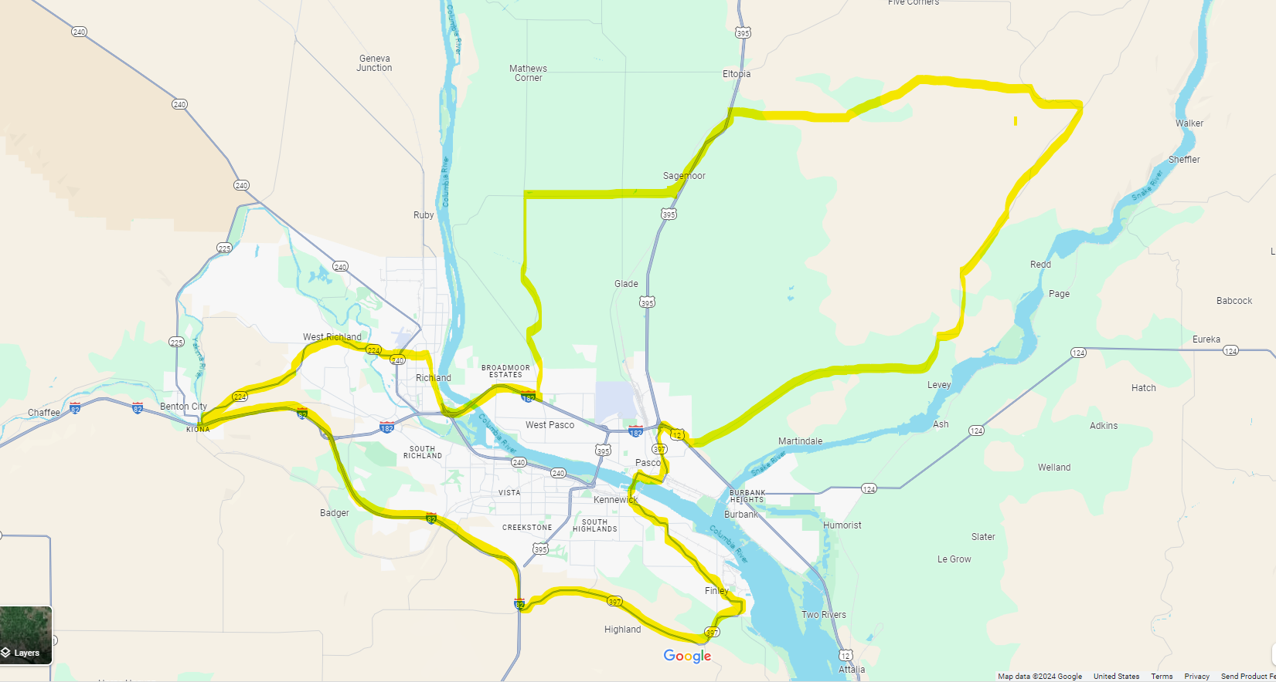
Delineated Area (City, State)- Greater Tri-cities area (Pasco/Richland/Kennewick), WA
Northern Boundary- W Sagemoor Rd to HWY 395 to E Elm Rd/Rye Grass Coulee Rd/E Blackman Ridge Rd to Snake River Rd
Southern Boundary- HWY 82 running east to HWY 397
Eastern Boundary- HWY 397 to HWY 12 to Pasco Kahlotus Rd
Western Boundary- HWY 82 to HWY 224 running east into Van Gieson St to George Washington Way running into HWY 182 to N Rd 68 to Taylor Flats Rd

