1. SOLICITATION NUMBER
2. TYPE OF SOLICITATION
3. DATE ISSUED
PAGE OF PAGES
4. CONTRACT NUMBER
5. REQUISITION/PURCHASE REQUEST NUMBER
6. PROJECT NUMBER
7. ISSUED BY
CODE
8. ADDRESS OFFER TO
a. NAME
b. TELEPHONE NUMBER (Include area code) (NO COLLECT CALLS)
10. THE GOVERNMENT REQUIRES PERFORMANCE OF THE WORK DESCRIBED IN THESE DOCUMENTS (Title, identifying number, date)
12a. THE CONTRACTOR MUST FURNISH ANY REQUIRED PERFORMANCE AND PAYMENT BONDS?
(If "YES," indicate within how many calendar days after award in Item 12B.)
12b. CALENDAR DAYS
13. ADDITIONAL SOLICITATION REQUIREMENTS:
STANDARD FORM 1442 (REV. 8/2014)
STANDARD FORM 1442
Prescribed by GSA-FAR (48 CFR) 52.236-1(d)
SOLICITATION, OFFER,
AND AWARD
(Construction, Alteration, or Repair)
SOLICITATION
SOLICITATION
IMPORTANT - The "offer" section on the reverse must be fully completed by offeror.
9. FOR INFORMATION
CALL:
NOTE: In sealed bid solicitations "offer" and "offeror" mean "bid" and "bidder".
SEALED BID (IFB)
NEGOTIATED (RFP)
11. The Contractor shall begin performance within ____________ calendar days and complete it within
____________
calendar days after receiving
award,
notice to proceed. This performance period is
mandatory
negotiable. (See _____________________________).
YES
NO
a.
Sealed offers in original and ___________________copies to perform the work required are due at the place specified in Item 8 by _____________
(hour) local time _____________________ (date). If this is a sealed bid solicitation, offers must be publicly opened at that time. Sealed
envelopes containing offers shall be marked to show the offeror's name and address, the solicitation number, the date and time offers are due.
b.
An offer guarantee
is,
is not required.
c.
All offers are subject to the (1) work requirements, and (2) other provisions and clauses incorporated in the solicitation in full text or by reference.
.
d.
Offers providing less than _______________________ calendar days for Government acceptance after the date offers are due will not be
considered and will be rejected.

1
97

36C24226B0065
X

10-19-2026

528-CSI-102
36C528
Department of Veterans Affairs
Network Contracting Office (NCO) 2
3495 Bailey Avenue
Building 3, 2nd floor
Buffalo NY 14215
Department of Veterans Affairs
Network Contracting Office (NCO) 2
3495 Bailey Avenue
Building 3, 2nd floor
Buffalo NY 14215
WINNE,NICHOLAS
716 364-0931
The Contractor shall furnish all materials, supplies, equipment, personnel and supervision for Project
528-CSI-102 Urology in accordance with the drawings and specifications at the Buffalo VA Medical Center

Completion Time: (720) Calendar Days from the Notice to Proceed

This is a 100% Service-Disabled Veteran Owned Small Business (SDVOSB) set aside procurement
In order to be eligible for award, Contractor must be registered in SAM (www.sam.gov) with a Unique Entity Identifier
and verified/certified as SDVOSB in the Small Business Search https://search.certifications.sba.gov/ at the time of
bid/offer submission and before award of this procurement. Offerors must submit their annual Vets4212 Report. The North
American Industry Classification System Code (NAICS) is 236220 - Business Size is $45 Million
Magnitude of Construction: Between $5,000,000 and $10,000,000.

Contractor will be responsible to coordinate and schedule work and shall be expected to plan work typically during
duty hours of 7 AM to 5:00 PM eastern time except as noted in the general conditions and as approved by the CO. Work
shall comply with VA Specifications and regulations, all applicable Federal, State and Local codes, including specific
regulations related to working at the Buffalo VA Campus.

A pre-bid site visit is scheduled for Tuesday 10-29-2026 2pm. Prospective bidders shall meet
at MAIN LOBBY, MAIN ENTRANCE
NOTE: NO OTHER SITE VISITS WILL BE ALLOWED. INTERESTED BIDDERS ARE STRONGLY ENCOURAGED TO ATTEND.

To preserve the integrity of the procurement process, all questions and requests for information (RFIs) must be
submitted in writing to Nicholas Winne nicholas.winne@va.gov
Questions must be received no later than 11-30-2026 12pm

The bid opening will be held online via Microsoft Teams on 12-07-2026 10AM EST. Details are on page ___. ONLY EMAILED
BIDS to nicholas.winne@va.gov will be accepted. The bids shall include copies of the original bid bond. The bid
opening shall take place on Monday December 7th 2026 10am .
VAAR 852.219-75 Limitations on Subcontracting Certificate is a separate requirement Attached or Page Numbers.
FAR 52.225-2 Buy American Act Certificate is a separate requirement attached in the solicitation.
The signed certificates must be received with the bid
FAR Part 36.209 Construction contracts with architect-engineer firms. No contract for the construction of a project
shall be awarded to Paradigm or its subsidiaries or affiliates.
NOTE: CONTRACTORS MUST ACKNOWLEDGE ALL SOLICIATION AMENDMENTS
10
720

x

52.211-10
X

10
1
10:00 AM
EDT
12-07-2026
X

120

14. NAME AND ADDRESS OF OFFEROR
15. TELEPHONE NUMBER
16. REMITTANCE ADDRESS
CODE
FACILITY CODE
17. The offeror agrees to perform the work required at the prices specified below in strict accordance with the terms of the solicitation, if this offer is
accepted by the Government in writing within __________ calendar days after the date offers are due.
AMOUNTS
18. The offeror agrees to furnish any required performance and payment bonds.
19. ACKNOWLEDGMENT OF AMENDMENTS
AMENDMENT
NUMBER
DATE.
20a. NAME AND TITLE OF PERSON AUTHORIZED TO SIGN OFFER
20b. SIGNATURE
20c. OFFER DATE
21. ITEMS ACCEPTED:
22. AMOUNT
23. ACCOUNTING AND APPROPRIATION DATA
24. SUBMIT INVOICES TO ADDRESS SHOWN IN
ITEM
25. OTHER THAN FULL AND OPEN COMPETITION PURSUANT TO
10 U.S.C. 2304(c)(
)
41 U.S.C. 3304(a) (
)
26. ADMINISTERED BY
27. PAYMENT WILL BE MADE BY
PHONE:
FAX:
28. NEGOTIATED AGREEMENT
29. AWARD
Your
Contractor agrees
offer on this solicitation is hereby accepted as to the items listed. This
to furnish and deliver all items or perform all work requirements identified
award consummates the contract, which consists of (a) the Government
on this form and any continuation sheets for the consideration stated in
solicitation and your offer, and (b) this contract award. No further cont-
this contract. The rights and obligations of the parties to this contract
ractual document is necessary.
shall be governed by (a) this contract award, (b) the solicitation, and (c)
the clauses, representations, certifications, and specifications incorporated
by reference in or attached to this contract.
30a. NAME AND TITLE OF CONTRACTOR OR PERSON AUTHORIZED
31a. NAME OF CONTRACTING OFFICER
TO SIGN
30b. SIGNATURE
30c. DATE
31b. UNITED STATES OF AMERICA
31c. AWARD DATE
BY
OFFER
AWARD
STANDARD FORM 1442 (REV. 8/2014) BACK
(Include ZIP Code)
(Include area code)
(Include only if different than Item 14.)
(Insert any number equal to or greater than
the minimum requirement stated in Item 13d. Failure to insert any number means the offeror accepts the minimum in Item 13d.)
(The offeror acknowledges receipt of amendments to the solicitation -- give number and date of each)
(Type or print)
(4 copies unless otherwise specified)
(Type or print)
(Type or print)
(Contractor is required to sign this
document and return _______ copies to issuing office.)
(Contractor is not required to sign this document.)
(Must be fully completed by offeror)
(To be completed by Government)
CONTRACTING OFFICER WILL COMPLETE ITEM 28 OR 29 AS APPLICABLE

36C528
Department of Veterans Affairs
Network Contracting Office (NCO) 2
3495 Bailey Avenue
Building 3, 2nd floor
Buffalo NY 14215

Tungsten Network
https://www.tungsten-network.com/
customer-campaigns/veteransaffairs/

NICHOLAS WINNE

Table of Contents
PART I - THE SCHEDULE 1
SECTION A - SOLICITATION/CONTRACT FORM 1
A.1 SF 1442 SOLICITATION, OFFER, AND AWARD (Construction, Alteration, or Repair) 1
A.2 SF 1442 SOLICITATION, OFFER, AND AWARD (CONSTRUCTION, ALTERATION, OR REPAIR)– BACK 2
INFORMATION REGARDING BIDDING MATERIAL, BID GUARANTEE AND BONDS 6
1.1 BID PRICING SHEET 7
INSTRUCTIONS, CONDITIONS AND OTHER STATEMENTS TO BIDDERS/OFFERORS 10
INSTRUCTIONS, CONDITIONS AND OTHER STATEMENTS TO BIDDERS/OFFERORS 10
2.1 BID OPENING INFORMATION 10
2.2 Special Notes regarding FAR 52.229-3: Federal, State and Local Taxes: 10
2.1 52.216-1 TYPE OF CONTRACT (NOV 2025) (DEVIATION) 11
2.2 52.222-5 CONSTRUCTION WAGE RATE REQUIREMENTS—SECONDARY SITE OF THE WORK (NOV 2025) (DEVIATION) 11
2.3 52.225-10 NOTICE OF BUY AMERICAN REQUIREMENT—CONSTRUCTION MATERIALS (MAY 2014) 11
2.4 52.228-1 BID GUARANTEE (SEP 1996) 12
2.5 52.228-17 INDIVIDUAL SURETY—PLEDGE OF ASSETS (BID GUARANTEE) (FEB 2021) 13
2.6 52.233-2 SERVICE OF PROTEST. (SEP 2006) (DEVIATION NOV 2025) 13
2.7 52.219-27 NOTICE OF SET-ASIDE FOR, OR SOLE-SOURCE AWARD TO, SERVICE-DISABLED VETERAN-OWNED SMALL BUSINESS (SDVOSB) CONCERNS ELIGIBLE UNDER THE SDVOSB PROGRAM (NOV 2025) (DEVIATION) 13
2.8 VAAR 852.204-72 PERSONNEL VETTING AND CREDENTIALING (DEVIATION) (MAR 2026) 15
2.9 VAAR 852.219-75 VA NOTICE OF LIMITATIONS ON SUBCONTRACTING—CERTIFICATE OF COMPLIANCE FOR SERVICES AND CONSTRUCTION (NOV 2022) 18
2.10 52.240-90 SECURITY PROHIBITIONS AND EXCLUSIONS REPRESENTATIONS AND CERTIFICATIONS (NOV 2025) (DEVIATION) 20
2.11 52.252-1 SOLICITATION PROVISIONS INCORPORATED BY REFERENCE (FEB 1998) 24
2.12 VAAR 852.233-71 ALTERNATE PROTEST PROCEDURE (OCT 2018) 24
REPRESENTATIONS AND CERTIFICATIONS 26
3.1 52.209-13 Violation of Arms Control Treaties or Agreements-Certification. (DEVIATION NOV 2025) 27
GENERAL CONDITIONS 30
4.1 52.219-28 POSTAWARD SMALL BUSINESS PROGRAM REREPRESENTATION (NOV 2025) (DEVIATION) 30
4.2 52.222-19 CHILD LABOR—COOPERATION WITH AUTHORITIES AND REMEDIES (MAR 2026) 32
4.3 52.222-15 CERTIFICATION OF ELIGIBILITY (MAY 2014) 33
4.4 52.222-40 NOTIFICATION OF EMPLOYEE RIGHTS UNDER THE NATIONAL LABOR RELATIONS ACT (NOV 2025) (DEVIATION) 33
4.5 52.222-90 ADDRESSING DEI DISCRIMINATION BY FEDERAL CONTRACTORS (DEVIATION APR 2026) 35
4.6 52.225-9 BUY AMERICAN—CONSTRUCTION MATERIALS (DEVIATION) (NOV 2025) 36
4.7 SUPPLEMENTAL INSURANCE REQUIREMENTS 40
4.8 52.240-91 SECURITY PROHIBITIONS AND EXCLUSIONS (NOV 2025) (DEVIATION) 41
4.9 52.252-2 CLAUSES INCORPORATED BY REFERENCE (FEB 1998) 50
4.10 52.248-3 VALUE ENGINEERING—CONSTRUCTION (OCT 2025) 53
4.11 VAAR 852.211-72 TECHNICAL INDUSTRY STANDARDS (NOV 2018) 56
4.12 VAAR 852.228-72 ASSISTING SERVICE-DISABLED VETERAN-OWNED AND VETERAN-OWNED SMALL BUSINESSES IN OBTAINING BONDS (DEC 2009) 57
4.13 VAAR 852.236-71 SPECIFICATIONS AND DRAWINGS FOR CONSTRUCTION (APR 2019) 57
4.14 VAAR 852.236-72 PERFORMANCE OF WORK BY THE CONTRACTOR (APR 2019) 58
4.15 VAAR 852.236-79 CONTRACTOR PRODUCTION REPORT (APR 2019) 59
4.16 VAAR 852.236-80 SUBCONTRACTS AND WORK COORDINATION (APR 2019) 59
4.17 VAAR 852.242-70 GOVERNMENT CONSTRUCTION CONTRACT ADMINISTRATION (OCT 2020) 59
4.18 VAAR 852.243-70 CONSTRUCTION CONTRACT CHANGES—SUPPLEMENT (SEP 2019) 61
4.19 MANDATORY WRITTEN DISCLOSURES 62
1 General Information 78
1.1 Location 78
1.2 Background 78
1.3 Purpose 78
1.4 Scope 78
1.4.1 Site Conditions, As-Built and Record Documents 82
1.4.2 Quality Assurance/Quality Control Plan 82
1.4.3 Hazardous Materials 82
1.4.4 Personal Protective Equipment (PPE) 82
1.5 Privacy 83
1.6 Records Management 83
1.7 Approach 84
1.7.1 Phasing 84
1.7.1.1 Phasing and Hours of Work 84
1.8 Site Information 85
1.8.1 Safety 85
1.8.2 Infection Control 85
1.8.3 Access 85
1.8.4 Photography 86
1.8.5 Security 86
2 Applicable Documents 87
2.1 Government Documents 87
2.2 Veterans Health Administration Western New York Documents 87
2.3 Non-Government Publications 88
2.4 Order of Precedence 88
3 Requirements 89
3.1 General 89
3.1.1 Construction Management Software 89
3.1.2 Status Reports 90
3.1.3 Meetings 91
3.1.3.1 Meeting Agenda 91
3.1.3.2 Meeting Presentation Materials 92
3.1.3.3 Meeting Minutes 92
3.2 Construction 92
3.2.1 Kick-off Meeting and Site Survey 92
3.2.2 Submittals 93
3.2.3 Preconstruction Conference 93
3.2.4 General Construction 94
3.2.5 Construction Inspections 94
4 Verification 95
5 Commissioning 96
6 Delivery 96
6.1 Technical POC 96
6.2 Schedule and Submittals 96
7 Government Furnished Information, Materials, & Equipment 97

INFORMATION REGARDING BIDDING MATERIAL, BID GUARANTEE AND BONDS
(a) Bidding materials consisting of Invitation for Bids, drawings, specifications and contract forms will be available on http://www.SAM.gov in electronic format only. All interested parties (subs & primes) should register at http://www.SAM.gov as an “Interested Vendor” so that others will know of your interest in participating in this procurement. A Bidder’s mailing list WILL NOT BE prepared by the Contract Specialist. SOLICITATION AMENDMENTS: Amendments to the solicitation will be posted at http://www.SAM.gov. Paper copies of the amendments will NOT be individually mailed. By registering to “Receive Notification”, you will be notified by e-mail of any new amendments that have been issued and posted. No other notification of amendments will be provided. Offerors are reminded that they are responsible for obtaining and acknowledging all amendments to this solicitation prior to the time for receipt of offers.
(b) If bid exceeds $150,000 a bid bond must be submitted. A bid guarantee is required in an amount not less than 20 percent of the bid price but shall not exceed $3,000,000. Failure to furnish the required bid guarantee in the proper form and amount, by the time set for opening of bids, will require rejection of the bid in all cases except those listed in FAR 28.101-4, and may be cause for rejection even then.
(c) If the contract will exceed $150,000 (see FAR 28.102-1 for lesser amount), the bidder to whom award is made will be required to furnish two bonds, a Payment Bond, SF 25A, and a Performance Bond, SF 25, each in the penal sum as noted in the General Conditions of the Specification. Copies of SFs 25 and 25A may be obtained upon application to the issuing office.
(d) If the bid/offer is between $30,000 - $150,000 The bidder/offeror to whom award is made will be required to furnish a Payment Bond, Standard Form 25A or alternative payment protection which conforms to the requirements set forth in FAR Clause 52.228-13, Alternative Payment Protections, as noted in the General Conditions of this Specification. Copies of the Standard Form of Payment Bond may be obtained upon application to the Issuing Office.
Reference Federal Acquisition (FAR) 28.106-1 for a list of Bond and Bond Related Forms. Copies of the Standard Forms referenced above may be obtained in the Standard Form section at https://www.gsa.gov/reference/forms#.
DESCRIPTION OF WORK: Work performed under this scope will be for and conducted within the Buffalo VA Medical Center (VAMC) located at 3495 Bailey Ave, Buffalo, NY 14215. Normal working hours are Monday – Friday 7:00am – 5:00pm. The Bufalo VAMC campus needs to Urology 2th floor in accordance with the construction documents developed by the Buffalo VAMC.
The Buffalo VAMC requires a Contractor to perform construction work necessary to accomplish this goal.
Cost Range: Between $5,000,000 and $10,000,000

1.1 BID PRICING SHEET
IFB No.: 36C24226B0065
Project No.: 528-CSI-102
Bids providing less that 120 Calendar Days of Government Acceptance after the date bids are due will not be considered and will be rejected.
The bidder agrees to perform the work required at the price specified below in strict accordance with the terms of the solicitation, if this bid is accepted by the Government in writing within 120 calendar days after the date bidders are due.

BASE BID
A. ITEM I, GENERAL CONSTRUCTION: BASE BID: Work includes all items that Renovate the Urology 2nd floor at the Buffalo VAMC in accordance with the construction documents developed by the Buffalo VAMC

The Contract period of performance for Base Bid construction shall be 720 calendar days from Notice to Proceed (NTP).

The following bid is to be submitted in lieu of completing block 17 on the attached SF 1442:

Base Bid $ : ___________________________________________

Offers shall provide a complete package to include the completed bid sheet along with the following to be determined responsive, responsible, and considered for award:

- Bid Bond and associated documents on correct forms;
- Acknowledgement of all amendments;
- Completed 52.225-2 Buy America Certificate
- Completed 852.219-75 VA Notice of Limitations in Subcontractors Compliance Certificate
- Verified/visible/certified on the Small Business Administration Certification SBA Small Business Search
- Proof of compliance with VETS 4212 Federal Contractor Reporting.
- Safety or Environmental Violation and Experience Modification Rate (EMR) (See further information next page)

Safety or Environmental Violations and Experience Modification Rate:
All Bidders/Offerors shall submit the following information pertaining to their past Safety and Environmental record. The information shall contain, at a minimum, a certification that the bidder/offeror has no more than three (3) serious, or one (1) repeat or one (1) willful OSHA or any EPA violation(s) in the past three years.

All Bidders/Offerors shall submit information regarding their current Experience Modification Rate (EMR). This information will be obtained from the bidder’s/offeror’s insurance company and be furnished on the insurance carrier’s letterhead.

Self-insured contractors or other contractors that cannot provide their EMR rating on insurance letterhead may obtain a rating from the National Council on Compensation Insurance, Inc. (NCCI) by completing/submitting form ERM-6 and providing the rating on letterhead from NCCI. Note: Self-insured contractors or other contractors that cannot provide EMR rating on insurance letterhead from the states or territories of CA, DE, MI, NJ, ND, OH, PA, WA, WY, and PR will obtain their EMR rating from their state-run worker’s compensation insurance rating bureau.

RESPONSIBILITY REQUIREMENTS
A Determination of Responsibility will be accomplished for the apparent awardee prior to processing the award. The above information, along with other information obtained from Government systems, such as the OSHA and EPA online inspection history databases will be used to make the Determination of Responsibility. Failure to affirm being within the guidelines above or submit this information may result in a determination of “non-responsibility” for the bidder/offeror.
NOTE: Any information received by the Government that would cause for a negative Determination of Responsibility may make the bidder/offeror ineligible for award.
This requirement is applicable to all subcontracting tiers, and prospective prime contractors are responsible for determining the responsibility of their prospective subcontractors.

INSTRUCTIONS, CONDITIONS AND OTHER STATEMENTS TO BIDDERS/OFFERORS

2.1 BID OPENING INFORMATION
In accordance with FAR 14.202-8, the government is authorizing electronic bids on this solicitation. ALL bids shall be emailed to Nicholas Winne Contracting Officer, at nicholas.winne@va.gov and timestamped by Monday, December 7th , 2026 @ 930 AM EST prior to the bid opening time. The bids shall include copies of a bid bond. The bid opening shall take place on Monday, December 7th , 2026 @ 10:00 AM EST. No hand-carried or mailed bids will be accepted.
The bid opening will take place via Microsoft Teams conference call. To access the conference, please access:
To join by phone please dial 1-347-566-4838
Phone conference ID: 237 354 567#

2.2 Special Notes regarding FAR 52.229-3: Federal, State and Local Taxes:
Offerors are hereby notified that under New York Consolidated Laws, Chapter 60 - Tax, Article 28 - Sales and Compensating Use Taxes, Part 3 – 1116 (2), the United States of America, any of its agencies and instrumentalities, is immune from taxation when it is the purchaser, user, or consumer, or when it sells services or property of a kind not ordinarily sold by private persons.
Pursuant to Chapter 60, Article 28, Part 3-1115(17), a contractor’s purchase of such building and construction materials within New York to be incorporated into the real property belonging to the U.S. Department of Veterans Affairs (VA) is subject to the exemption from the New York State sales and compensating use taxes. To take advantage of the tax exemption the successful offeror under this solicitation must complete ST-120.1 “Contractor Exempt Purchase Certificate” when it purchases construction materials for this contract and keep on file as required by the state of New York tax laws.
Notwithstanding FAR 52.229-3, all bids received in response to this solicitation are presumed to reflect this tax exemption, and therefore should not include the New York’s state sales and compensating use taxes on sales of materials for incorporation into VA real estate under this contract.

2.1 52.216-1 TYPE OF CONTRACT (NOV 2025) (DEVIATION)
The Government contemplates award Firm Fixed price contract resulting from this solicitation.
(End of Provision)

2.2 52.222-5 CONSTRUCTION WAGE RATE REQUIREMENTS—SECONDARY SITE OF THE WORK (NOV 2025) (DEVIATION)
(a)(1) The offeror must notify the Government if the offeror intends to perform work at any secondary site of the work, as defined in paragraph (a)(1)(ii) of the FAR clause at 52.222-6, Construction Wage Rate Requirements, of this solicitation.
(2) If the offeror is unsure if a planned work site satisfies the criteria for a secondary site of the work, the offeror must request a determination from the Contracting Officer.
(b)(1) If the wage determination provided by the Government for work at the primary site of the work is not applicable to the secondary site of the work, the offeror must request a wage determination from the Contracting Officer.
(2) The due date for receipt of offers will not be extended as a result of an offeror's request for a wage determination for a secondary site of the work.
(End of Provision)

2.3 52.225-10 NOTICE OF BUY AMERICAN REQUIREMENT—CONSTRUCTION MATERIALS (MAY 2014)
(a) Definitions. "Commercially available off-the-shelf (COTS) item," "construction material," "domestic construction material," and "foreign construction material," as used in this provision, are defined in the clause of this solicitation entitled "Buy American—Construction Materials" (Federal Acquisition Regulation (FAR) clause 52.225-9).
(b) Requests for determinations of inapplicability. An offeror requesting a determination regarding the inapplicability of the Buy American statute should submit the request to the Contracting Officer in time to allow a determination before submission of offers. The offeror shall include the information and applicable supporting data required by paragraphs (c) and (d) of the clause at FAR 52.225-9 in the request. If an offeror has not requested a determination regarding the inapplicability of the Buy American statute before submitting its offer, or has not received a response to a previous request, the offeror shall include the information and supporting data in the offer.
(c) Evaluation of offers.
(1) The Government will evaluate an offer requesting exception to the requirements of the Buy American statute, based on claimed unreasonable cost of domestic construction material, by adding to the offered price the appropriate percentage of the cost of such foreign construction material, as specified in paragraph (b)(3)(i) of the clause at FAR 52.225-9.
(2) If evaluation results in a tie between an offeror that requested the substitution of foreign construction material based on unreasonable cost and an offeror that did not request an exception, the Contracting Officer will award to the offeror that did not request an exception based on unreasonable cost.
(d) Alternate offers.
(1) When an offer includes foreign solicitation in paragraph (b)(2) of the clause at FAR 52.225-9, the offeror also may submit an alternate offer based on use of equivalent domestic construction material.
(2) If an alternate offer is submitted, the offeror shall submit a separate Standard Form 1442 for the alternate offer, and a separate price comparison table prepared in accordance with paragraphs (c) and (d) of the clause at FAR 52.225-9 for the offer that is based on the use of any foreign construction material for which the Government has not yet determined an exception applies.
(3) If the Government determines that a particular exception requested in accordance with paragraph (c) of the clause at FAR 52.225-9 does not apply, the Government will evaluate only those offers based on use of the equivalent domestic construction material, and the offeror shall be required to furnish such domestic construction material. An offer based on use of the foreign construction material for which an exception was requested—
(i) Will be rejected as nonresponsive if this acquisition is conducted by sealed bidding; or
(ii) May be accepted if revised during negotiations.
(End of Provision)

2.4 52.228-1 BID GUARANTEE (SEP 1996)
(a) Failure to furnish a bid guarantee in the proper form and amount, by the time set for opening of bids, may be cause for rejection of the bid.
(b) The bidder shall furnish a bid guarantee in the form of a firm commitment, e.g., bid bond supported by good and sufficient surety or sureties acceptable to the Government, postal money order, certified check, cashier's check, irrevocable letter of credit, or, under Treasury Department regulations, certain bonds or notes of the United States. The Contracting Officer will return bid guarantees, other than bid bonds—
(1) To unsuccessful bidders as soon as practicable after the opening of bids; and
(2) To the successful bidder upon execution of contractual documents and bonds (including any necessary coinsurance or reinsurance agreements), as required by the bid as accepted.
(c) The amount of the bid guarantee shall be 20 percent of the bid price or 3,000,000, whichever is less.
(d) If the successful bidder, upon acceptance of its bid by the Government within the period specified for acceptance, fails to execute all contractual documents or furnish executed bond(s) within 10 days after receipt of the forms by the bidder, the Contracting Officer may terminate the contract for default.
(e) In the event the contract is terminated for default, the bidder is liable for any cost of acquiring the work that exceeds the amount of its bid, and the bid guarantee is available to offset the difference.
(End of Provision)

2.5 52.228-17 INDIVIDUAL SURETY—PLEDGE OF ASSETS (BID GUARANTEE) (FEB 2021)
(a) Offerors shall obtain from each person acting as an individual surety on a bid guarantee—
(1) A pledge of assets that meets the eligibility, valuation, and security requirements described in the Federal Acquisition Regulation (FAR) 28.203–1; and
(2) Standard Form 28, Affidavit of Individual Surety.
(b) The Offeror shall include with its offer the information required at paragraph (a) of this provision within the timeframe specified in the provision at FAR 52.228–1, Bid Guarantee, or as otherwise established by the Contracting Officer.
(c) The Contracting Officer may release the security interest on the individual surety’s assets in support of a bid guarantee based upon evidence that the offer supported by the individual surety will not result in contract award.
(End of Provision)

2.6 52.233-2 SERVICE OF PROTEST. (SEP 2006) (DEVIATION NOV 2025)
(a) Protests, (as defined in FAR 33.102), that are filed directly with an agency, and copies of any protests that are filed with the Government Accountability Office (GAO), must be served on the Contracting Officer identified in the solicitation by obtaining written and dated acknowledgment of receipt from them.
(b) The copy of any protest must be received in the office designated above within one day of filing a protest with the GAO.
(End of provision)

2.7 52.219-27 NOTICE OF SET-ASIDE FOR, OR SOLE-SOURCE AWARD TO, SERVICE-DISABLED VETERAN-OWNED SMALL BUSINESS (SDVOSB) CONCERNS ELIGIBLE UNDER THE SDVOSB PROGRAM (NOV 2025) (DEVIATION)
(a) Definition.
Service-disabled veteran-owned small business (SDVOSB) concern means a small business concern—
(1)(i) Not less than 51 percent of which is owned and controlled by one or more service-disabled veterans or, in the case of any publicly owned business, not less than 51 percent of the stock of which is owned by one or more service-disabled veterans; and
(ii) The management and daily business operations of which are controlled by one or more service-disabled veterans or, in the case of a service-disabled veteran with permanent and severe disability, the spouse or permanent caregiver of such veteran; or
(2) A small business concern eligible under the SDVOSB Program in accordance with 13 CFR part 128 (see FAR 19.106).
(3) Service-disabled veteran, as used in this definition, means a veteran as defined in 38 U.S.C. 101(2), with a disability that is service-connected, as defined in 38 U.S.C. 101(16) and who is registered in the Beneficiary Identification and Records Locator Subsystem, or successor system that is maintained by the Department of Veterans Affairs’ Veterans Benefits Administration, as a service-disabled veteran.
Service-disabled veteran-owned small business (SDVOSB) concern eligible under the SDVOSB Program means an SDVOSB concern that is designated in the System for Award Management (SAM) as certified by the Small Business Administration (SBA) in accordance with 13 CFR 128.300.
Service-disabled veteran-owned small business (SDVOSB) Program means a program that authorizes contracting officers to limit competition, including award on a sole-source basis, to SDVOSB concerns eligible under the SDVOSB Program.
(b) Applicability. This clause applies only to—
(1) Contracts that have been set aside for, or awarded on a sole-source basis to, SDVOSB concerns eligible under the SDVOSB Program;
(2) Part or parts of a multiple-award contract that have been set aside for SDVOSB concerns eligible under the SDVOSB Program; and
(3) Orders set aside for SDVOSB concerns eligible under the SDVOSB Program, under multiple-award contracts as described in 8.4 and 16.5.
(c) General.
(1) Offers are solicited only from concerns designated in SAM as SDVOSB concerns certified by SBA. Offers received from concerns that are not SDVOSB concerns certified by SBA will not be considered.
(2) Any award resulting from this solicitation will be made only to a concern designated in SAM as an SDVOSB certified by SBA.
(d) A joint venture may be considered an SDVOSB concern if the managing partner of the joint venture complies with the criteria defined in paragraph (a) of this clause and 13 CFR 128.402.
(e) In a joint venture that complies with paragraph (d) of this clause, the SDVOSB party or parties to the joint venture shall perform at least 40 percent of the work performed by the joint venture. Work performed by the SDVOSB party or parties to the joint venture must be more than administrative functions.
(End of Clause)

2.8 VAAR 852.204-72 PERSONNEL VETTING AND CREDENTIALING (DEVIATION) (MAR 2026)
(a) Definitions. As used in this clause –
VA Information system is the same as information system and means, pursuant to 38 U.S.C. 5727, a discrete set of information resources organized for the collection, processing, maintenance, use, sharing, dissemination, or disposition of information whether automated or manual.
VA sensitive information means all VA data, on any storage media or in any form or format, which requires protection due to the risk of harm that could result from inadvertent or deliberate disclosure, alteration, or destruction of the information and includes sensitive personal information. The term includes information where improper use or disclosure could adversely affect the ability of VA to accomplish its mission, proprietary information, records about individuals requiring protection under various confidentiality provisions such as the Privacy Act and the HIPAA Privacy Rule, and information that can be withheld under the Freedom of Information Act. Examples of VA sensitive information include the following: individually-identifiable medical, benefits, and personnel information; financial, budgetary, research, quality assurance, confidential commercial, critical infrastructure, investigatory, and law enforcement information; information that is confidential and privileged in litigation such as information protected by the deliberative process privilege, attorney work-product privilege, and the attorney client privilege; and other information which, if released, could result in violation of law or harm or unfairness to any individual or group, or could adversely affect the national interest or the conduct of Federal programs.
(b) General. Contractor personnel assigned to work for or on behalf of VA must undergo a background investigation commensurate with the risk and sensitivity level designation associated with the work to be performed at the level indicated in the contract. The Contractor and subcontractors shall comply with VA Directive/Handbook 0710, Personnel Security and Suitability Program, which can be accessed at: https://vaww.va.gov/vapubs/index.cfm.
(c) Risk and Sensitivity Levels. The following table identifies the risk and sensitivity levels that apply to any personnel providing services under this contract. *VA Administrations, organizations and staff offices will use the OPM Position Designation Tool.

Positions/Tasks Designated as Non-Sensitive Positions – Tier 1/Low Risk
ALL CONTRACTORS ARE DESIGNATED AS LOW RISK
Security clearances are granted to individuals with a specific requirement for access to classified material (for example, Confidential, Secret and Top Secret). Contractor personnel that are required to obtain a security clearance will be subject to a Tier 3 or Tier 5 investigation. The following sensitivity designations have been assigned for the identified Tier 3 and Tier 5 required by this contract:
Tier 3: N/A
Tier 5: N/A
(d) Fitness. The results from a background investigation are used to determine if an individual’s fitness is sufficient for that individual to perform work for or on behalf of VA in the position identified in this contract. Contractor fitness determinations are made in accordance with 5 CFR Part 731.202.
Fitness requirements for employment are separate and distinct from job qualifications. If a Contractor or subcontractor employee is found to be unsuitable or unfit to provide services under this contract, the Contractor shall immediately remove the employee from working on this contract and take those necessary steps that restrict the employee’s logical access to VA data, information, VA sensitive information, or information technology or VA information systems containing such data or information.
The Contractor shall advise the employee that they are not permitted to access any VA controlled building or real property in relation to this contract. The removal of an unfit Contractor or subcontractor employee does not alleviate the Contractor from satisfying the requirements of this contract. The Government will not reimburse the Contractor for any costs associated with the recruitment/replacement of an employee or subcontractor employee who is found to be unfit.
(e) Identification Cards. The Government will provide a Personal Identification Verification (PIV) card or other identification card, as necessary, to fit Contractor personnel who require physical access to VA facilities and/or logical access to VA data, information, VA sensitive information, or information technology or VA information systems containing such data or information. Contractor and subcontractor personnel shall prominently display their PIV/identification card on their persons while working at a VA facility and shall present their PIV/identification card for inspection upon request by a VA official. The Contractor must surrender the employee or subcontractor employee’s PIV/identification card in accordance with the requirements set forth in Directive/Handbook 0735 when any of the following events occur:
1. When no longer needed for contract performance.
2. Upon completion of the Contractor/subcontractor employee’s employment.
3. Upon contract completion or termination.
(f) Lost/stolen. Immediately upon detection, the Contractor shall report a lost or stolen PIV/identification card to the Government authorities as identified in Directive/Handbook 0735. Within 48 hours of reporting the lost/stolen PIV/identification card, the Contractor shall submit to the Program Manager an incident report that describes the relevant facts and circumstances regarding the loss/theft. If the loss/theft was reported by the Contractor to the local police, the Contractor shall further submit a copy of the final police report to the Program Manager within 48 hours of the report being made available by the local police department. The Government will not reimburse the Contractor for any costs that result from lost/stolen PIV/identification card(s).
(g) Regular Reporting. The Contractor shall submit a status report to PIV Sponsor within 5 working days after the end of each calendar quarter and as requested by the Government in order to initiate contract closeout procedures. The report must provide the status of each contractor/subcontractor employee who is required to have a PIV/identification card during the performance of the contract. The report shall identify the Contractor and the contract number, and list the following status for each contractor/subcontractor employee who holds a PIV/identification card under this contract:
1. Contractor/subcontractor employee name.
2. Name of VA facility where Contractor/subcontractor employee works, if applicable.
3. Date background check submitted for Contractor/subcontractor employee.
4. Date PIV/identification card issued to Contractor/subcontractor employee.
5. Contractor/subcontractor employee’s PIV/identification card number, as applicable.
6. Date Contractor/subcontractor employee no longer has need for PIV/identification card.
7. Date Contractor notified VA that PIV/identification card is no longer required.
8. Date Contractor returned PIV/identification card was returned to VA.
(h) Flow down of clause. The Contractor shall include the substance of this clause in subcontracts, third-party agreements, and BAA’s, in which subcontractors, third-party servicers/employees, and business associates will perform functions where they will have physical access to a VA facility or logical access to VA data, information, VA sensitive information, or information technology or VA information system containing such data or information.
(End of Clause)

2.9 VAAR 852.219-75 VA NOTICE OF LIMITATIONS ON SUBCONTRACTING—CERTIFICATE OF COMPLIANCE FOR SERVICES AND CONSTRUCTION (NOV 2022)
(a) Pursuant to 38 U.S.C. 8127(k)(2), the offeror certifies that—
(1) If awarded a contract (see FAR 2.101 definition), it will comply with the limitations on subcontracting requirement as provided in the solicitation and the resultant contract, as follows:
(i) [] Services. In the case of a contract for services (except construction), the contractor will not pay more than 50% of the amount paid by the government to it to firms that are not VIP-listed SDVOSBs as set forth in 852.219–73 or VOSBs as set forth in 852.219–74. Any work that a similarly situated VIP-listed subcontractor further subcontracts will count towards the 50% subcontract amount that cannot be exceeded. Other direct costs may be excluded to the extent they are not the principal purpose of the acquisition and small business concerns do not provide the service as set forth in 13 CFR 125.6.
(ii) [] General construction. In the case of a contract for general construction, the contractor will not pay more than 85% of the amount paid by the government to it to firms that are not VIP-listed SDVOSBs as set forth in 852.219–73or VOSBs as set forth in 852.219–74. Any work that a similarly situated VIP-listed subcontractor further subcontracts will count towards the 85% subcontract amount that cannot be exceeded. Cost of materials are excluded and not considered to be subcontracted.
(iii) [] Special trade construction contractors. In the case of a contract for special trade contractors, the contractor will not pay more than 75% of the amount paid by the government to it to firms that are not VIP-listed SDVOSBs as set forth in 852.219–73 or VOSBs as set forth in 852.219–74. Any work that a similarly situated subcontractor further subcontracts will count towards the 75% subcontract amount that cannot be exceeded. Cost of materials are excluded and not considered to be subcontracted.
(2) The offeror acknowledges that this certification concerns a matter within the jurisdiction of an Agency of the United States. The offeror further acknowledges that this certification is subject to Title 18, United States Code, Section 1001, and, as such, a false, fictitious, or fraudulent certification may render the offeror subject to criminal, civil, or administrative penalties, including prosecution.
(3) If VA determines that an SDVOSB/ VOSB awarded a contract pursuant to 38 U.S.C. 8127 did not act in good faith, such SDVOSB/VOSB shall be subject to any or all of the following:
(i) Referral to the VA Suspension and Debarment Committee;
(ii) A fine under section 16(g)(1) of the Small Business Act (15 U.S.C. 645(g)(1)); and
(iii) Prosecution for violating section 1001 of title 18.
(b) The offeror represents and understands that by submission of its offer and award of a contract it may be required to provide copies of documents or records to VA that VA may review to determine whether the offeror complied with the limitations on subcontracting requirement specified in the contract. Contracting officers may, at their discretion, require the contractor to demonstrate its compliance with the limitations on subcontracting at any time during performance and upon completion of a contract if the information regarding such compliance is not already available to the contracting officer. Evidence of compliance includes, but is not limited to, invoices, copies of subcontracts, or a list of the value of tasks performed.
(c) The offeror further agrees to cooperate fully and make available any documents or records as may be required to enable VA to determine compliance with the limitations on subcontracting requirement. The offeror understands that failure to provide documents as requested by VA may result in remedial action as the Government deems appropriate.
(d) Offeror completed certification/fill-in required. The formal certification must be completed, signed and returned with the offeror’s bid, quotation, or proposal. The Government will not consider offers for award from offerors that do not provide the certification, and all such responses will be deemed ineligible for evaluation and award.
Certification
I hereby certify that if awarded the contract, [insert name of offeror] will comply with the limitations on subcontracting specified in this clause and in the resultant contract. I further certify that I am authorized to execute this certification on behalf of [insert name of offeror].
Printed Name of Signee: ___________
Printed Title of Signee: _____________
Signature: ____________
Date: ______________
Company Name and Address: _______________
(End of Clause)

2.10 52.240-90 SECURITY PROHIBITIONS AND EXCLUSIONS REPRESENTATIONS AND CERTIFICATIONS (NOV 2025) (DEVIATION)
(a) Definitions. As used in this provision—
Backhaul, covered article, covered telecommunications equipment or services, critical technology, FASCSA order, Intelligence community, interconnection arrangements, national security system, roaming, sensitive compartmented information, sensitive compartmented information system, source, and substantial or essential component have the meanings provided in the clause 52.240-91, Security Prohibitions and Exclusions.
Business operations means engaging in commerce in any form, including by acquiring, developing, maintaining, owning, selling, possessing, leasing, or operating equipment, facilities, personnel, products, services, personal property, real property, or any other apparatus of business or commerce.
Marginalized populations of Sudan means—
(1) Adversely affected groups in regions authorized to receive assistance under section 8(c) of the Darfur Peace and Accountability Act (Pub. L. 109-344) (50 U.S.C. 1701 note); and
(2) Marginalized areas in Northern Sudan described in section 4(9) of such Act.
Restricted business operations means business operations in Sudan that include power production activities, mineral extraction activities, oil-related activities, or the production of military equipment, as those terms are defined in the Sudan Accountability and Divestment Act of 2007 (Pub. L. 110-174). Restricted business operations do not include business operations that the person (as that term is defined in Section 2 of the Sudan Accountability and Divestment Act of 2007) conducting the business can demonstrate—
(1) Are conducted under contract directly and exclusively with the regional government of southern Sudan;
(2) Are conducted under specific authorization from the Office of Foreign Assets Control in the Department of the Treasury, or are expressly exempted under Federal law from the requirement to be conducted under such authorization;
(3) Consist of providing goods or services to marginalized populations of Sudan;
(4) Consist of providing goods or services to an internationally recognized peacekeeping force or humanitarian organization;
(5) Consist of providing goods or services that are used only to promote health or education; or
(6) Have been voluntarily suspended.
Sensitive technology—
(1) Means hardware, software, telecommunications equipment, or any other technology that is to be used specifically—
(i) To restrict the free flow of unbiased information in Iran; or
(ii) To disrupt, monitor, or otherwise restrict speech of the people of Iran; and
(2) Does not include information or informational materials the export of which the President does not have the authority to regulate or prohibit pursuant to section 203(b)(3) of the International Emergency Economic Powers Act (50 U.S.C. 1702(b)(3)).
(b) Procedures.
(1) Covered telecommunications and video surveillance. The Offeror shall review the list of excluded parties in the System for Award Management (SAM) at https://www.sam.gov for entities excluded from receiving federal awards for “covered telecommunications equipment or services.”
(2) FASCSA Orders.
(i) The Offeror shall search in SAM for the phrase “FASCSA order” for any covered article, or any products or services produced or provided by a source, if there is an applicable FASCSA order described in paragraph (e) of FAR 52.240-91, Security Prohibitions and Exclusions.
(ii) The Offeror shall review the solicitation for any FASCSA orders that are not in SAM but are effective and apply to the solicitation and resultant contract (see FAR 40.204-1(c)(2)).
(iii) FASCSA orders issued after the date of solicitation do not apply unless added by an amendment to the solicitation.
(c) Covered telecommunications equipment or services representations. By submission of its offer, the Offeror represents that, after conducting a reasonable inquiry (that looks at any information in the Offeror’s possession but does not need to include an internal or third-party audit)—
(1) It will not provide covered telecommunications equipment or services to the Government in the performance of any contract, subcontract or other contractual instrument resulting from this solicitation, except as waived by the solicitation, or as disclosed in paragraph (g); and
(2) It does not use covered telecommunications equipment or services, or use any equipment, system, or service that uses covered telecommunications equipment or services, except as waived by the solicitation, or as disclosed in paragraph (g).
(d) FASCSA Representation. By submission of this offer, the offeror represents that it has conducted a reasonable inquiry, and that the offeror does not propose to provide or use in response to this solicitation any covered article, or any products or services produced or provided by a source, if the covered article or the source is prohibited by an applicable FASCSA order in effect on the date the solicitation was issued, except as waived by the solicitation, or as disclosed in paragraph (g). A reasonable inquiry will look at any information in the offeror’s possession but does not need to include an internal or third-party audit.
(e) Sudan certification. By submission of its offer, the offeror certifies, after conducting a reasonable inquiry (that looks at any information in the offeror’s possession but does not need to include an internal or third-party audit), that the offeror does not conduct any restricted business operations in Sudan.
(f) Iran Representation and Certifications.
(1) Except as provided in paragraph (f)(2) of this provision or if a waiver has been granted in accordance with FAR 40.203-3, the offeror, after conducting a reasonable inquiry (that looks at any information in the offeror’s possession but does not need to include an internal or third-party audit), by submission of its offer—
(i) Represents, to the best of its knowledge and belief, that the offeror does not export any sensitive technology to the government of Iran or any entities or individuals owned or controlled by, or acting on behalf or at the direction of, the government of Iran;
(ii) Certifies that the offeror, or any person (as defined at section 15 of the Iran Sanctions Act of 1996, Pub. L. 104-172, 50 U.S.C. 1701 note) owned or controlled by the offeror, does not engage in any activities for which sanctions may be imposed under section 5 of the Act. These sanctioned activities are in the areas of development of the petroleum resources of Iran, production of refined petroleum products in Iran, sale and provision of refined petroleum products to Iran, and contributing to Iran’s ability to acquire or develop certain weapons or technologies; and
(iii) Certifies that the offeror, and any person owned or controlled by the offeror, does not knowingly engage in any transaction that exceeds $15,000 with Iran’s Revolutionary Guard Corps or any of its officials, agents, or affiliates, the property and interests in property of which are blocked pursuant to the International Emergency Economic Powers Act (50 U.S.C. 1701 et seq.) (see OFAC’s Specially Designated Nationals and Blocked Persons List at https://www.treasury.gov/resource-center/sanctions/SDN-List/Pages/default.aspx)
(2) Exception for trade agreements. The representation and certification requirements of paragraph (f)(1) of this provision do not apply if—
(i) This solicitation includes a trade agreements notice or certification (e.g., 52.225-6, Trade Agreements Certificate); and
(ii) The offeror has certified that all the offered products to be supplied are designated country end products or designated country construction material.
(iii) The offeror shall email questions concerning sensitive technology to the Department of State at CISADA106@state.gov.
(g) Disclosure.
(1) If the Offeror is not able to represent compliance with the prohibitions in paragraphs (c) or (d), then the Offeror shall disclose within 72 hours to the contracting office identified in paragraph (g)(2) the following information for each product or service not compliant:
(i) Contract number and order number, if applicable;
(ii) Identification of whether this disclosure relates to paragraph (c) on covered telecommunication equipment or services, or to paragraph (d) on FASCSA orders;
(iii) A description of the products or services that the Contractor identifies or has reason to suspect is prohibited (include brand; model number, such as the original equipment manufacturer (OEM) number, manufacturer part number, or wholesaler number; and item description, as applicable);
(iv) The entity that produced the product or service (include entity name, unique entity identifier, Contractor and Government Entity (CAGE) code, facilities responsible for design, fabrication, assembly, packaging, and test of the product, and whether the entity was the OEM or a distributor (provide manufacturer codes and distributor codes used for the product));
(v) Description of the functionality of the product or service and how that functionality impacts the risk to the product or service;
(vi) An explanation of any factors relevant to determining if the product or service should be permitted by an applicable exception, exemption, or waiver (if the offeror would like the Government to consider a waiver);
(vii) Whether alternative products or services are available that would be compliant with the prohibition;
(viii) If the product or service is related to item maintenance, include the following information on the item being maintained:
(A) Brand;
(B) Model number, OEM number, manufacturer part number, or wholesaler number; and
(C) Item description, as applicable.
(ix) Any readily available information about mitigation actions undertaken or recommended.
(2) If a disclosure is required to be submitted to a contracting office, the offeror shall submit the disclosure as follows:
(i) If a Department of Defense contracting office, the offeror shall submit the disclosure to the website at https://dibnet.dod.mil.
(ii) For all other contracting offices, the Offeror shall submit the disclosure to the Contracting Officer.
(3) If the disclosure provided does not contain any of the information required by paragraph (1), and the Offeror later discovers new information that is required by paragraph (1), then the Offeror shall submit a subsequent disclosure within 72 hours of discovering the new information.
(h) Executive agency review of disclosures. The Contracting Officer will review disclosures provided in paragraph (g) to determine if any applicable waiver may be sought. The Contracting Officer may choose not to pursue a waiver and may instead make an award to an Offeror that does not require a waiver.
(End of Provision)

2.11 52.252-1 SOLICITATION PROVISIONS INCORPORATED BY REFERENCE (FEB 1998)
This solicitation incorporates one or more solicitation provisions by reference, with the same force and effect as if they were given in full text. Upon request, the Contracting Officer will make their full text available. The offeror is cautioned that the listed provisions may include blocks that must be completed by the offeror and submitted with its quotation or offer. In lieu of submitting the full text of those provisions, the offeror may identify the provision by paragraph identifier and provide the appropriate information with its quotation or offer. Also, the full text of a solicitation provision may be accessed electronically at this/these address(es):
https://www.acquisition.gov/browse/index/far
https://www.va.gov/oal/library/vaar/

(End of Provision)
FAR Number | Title | Date
52.204-7 | SYSTEM FOR AWARD MANAGEMENT—REGISTRATION (DEVIATION) | NOV 2025
52.214-3 | AMENDMENTS TO INVITATIONS FOR BIDS (DEVIATION) | NOV 2025
52.214-4 | FALSE STATEMENTS IN BIDS | APR 1984
52.214-5 | SUBMISSION OF BIDS (DEVIATION) | NOV 2025
52.214-6 | EXPLANATION TO PROSPECTIVE BIDDERS | APR 1984
52.214-7 | LATE SUBMISSIONS, MODIFICATIONS, AND WITHDRAWALS OF BIDS (DEVIATION) | NOV 2025
52.214-18 | PREPARATION OF BIDS—CONSTRUCTION | APR 1984
52.214-19 | CONTRACT AWARD—SEALED BIDDING—CONSTRUCTION | AUG 1996
52.214-34 | SUBMISSION OF OFFERS IN THE ENGLISH LANGUAGE | APR 1991
52.214-35 | SUBMISSION OF OFFERS IN U.S. CURRENCY | APR 1991

2.12 VAAR 852.233-71 ALTERNATE PROTEST PROCEDURE (OCT 2018)
(a) As an alternative to filing a protest with the Contracting Officer, an interested party may file a protest by mail or electronically with: Executive Director, Office of Acquisition and Logistics, Risk Management and Compliance Service (003A2C), Department of Veterans Affairs, 810 Vermont Avenue NW, Washington, DC 20420 or Email: EDProtests@va.gov.
(b) The protest will not be considered if the interested party has a protest on the same or similar issue(s) pending with the Contracting Officer.
(End of Provision)
PLEASE NOTE: The correct mailing information for filing alternate protests is as follows:

Deputy Assistant Secretary for Acquisition and Logistics,
Risk Management Team, Department of Veterans Affairs
810 Vermont Avenue, N.W.
Washington, DC 20420
Or for solicitations issued by the Office of Construction and Facilities Management:

Director, Office of Construction and Facilities Management
811 Vermont Avenue, N.W.
Washington, DC 20420

FAR Number | Title | Date
852.233-70 | PROTEST CONTENT/ALTERNATIVE DISPUTE RESOLUTION | OCT 2018
852.239-75 | INFORMATION AND COMMUNICATION TECHNOLOGY ACCESSIBILITY NOTICE | FEB 2023

REPRESENTATIONS AND CERTIFICATIONS

52.209-7 Information Regarding Responsibility Matters.
As prescribed at 9.104-7(b), insert the following provision:
Information Regarding Responsibility Matters (Oct 2018) (DEVIATION Nov 2025)
(a) Definitions. As used in this provision—
Administrative proceeding means a non-judicial process that is adjudicatory in nature in order to make a determination of fault or liability (e.g., Securities and Exchange Commission Administrative Proceedings, Civilian Board of Contract Appeals Proceedings, and Armed Services Board of Contract Appeals Proceedings). This includes administrative proceedings at the Federal and State level but only in connection with performance of a Federal contract or grant. It does not include agency actions such as contract audits, site visits, corrective plans, or inspection of deliverables.
Federal contracts and grants with total value greater than $10,000,000 means—
(1) The total value of all current, active contracts and grants, including all priced options; and
(2) The total value of all current, active orders including all priced options under indefinite- delivery, indefinite-quantity, 8(a), or requirements contracts (including task and delivery and multiple-award Schedules).
Principal means an officer, director, owner, partner, or a person having primary management or supervisory responsibilities within a business entity (e.g., general manager; plant manager; head of a division or business segment; and similar positions).
(b) The offeror □ has □ does not have current active Federal contracts and grants with total value greater than $10,000,000.
(c) If the offeror checked "has" in paragraph (b) of this provision, the offeror represents, by submission of this offer, that the information it has entered in the Federal Awardee Performance and Integrity Information System (FAPIIS) is current, accurate, and complete as of the date of submission of this offer with regard to the following information:
(1) Whether the offeror, and/or any of its principals, has or has not, within the last five years, in connection with the award to or performance by the offeror of a Federal contract or grant, been the subject of a proceeding, at the Federal or State level that resulted in any of the following dispositions:
(i) In a criminal proceeding, a conviction.
(ii) In a civil proceeding, a finding of fault and liability that results in the payment of a monetary fine, penalty, reimbursement, restitution, or damages of $5,000 or more.
(iii) In an administrative proceeding, a finding of fault and liability that results in–
(A) The payment of a monetary fine or penalty of $5,000 or more; or
(B) The payment of a reimbursement, restitution, or damages in excess of $100,000.
(iv) In a criminal, civil, or administrative proceeding, a disposition of the matter by consent or compromise with an acknowledgment of fault by the Contractor if the proceeding could have led to any of the outcomes specified in paragraphs (c)(1)(i), (c)(1)(ii), or (c)(1)(iii) of this provision.
(2) If the offeror has been involved in the last five years in any of the occurrences listed in (c)(1) of this provision, whether the offeror has provided the requested information with regard to each occurrence.
(d) The offeror shall post the information in paragraphs (c)(1)(i) through (c)(1)(iv) of this provision in FAPIIS as required through maintaining an active registration in the System for Award Management, which can be accessed via https://www.sam.gov (see 52.204-7).
(End of provision)

3.1 52.209-13 Violation of Arms Control Treaties or Agreements-Certification. (DEVIATION NOV 2025)

(a) This provision does not apply to acquisitions at or below the simplified acquisition threshold or to acquisitions of commercial products and commercial services as defined in Federal Acquisition Regulation 2.101.
(b) Certification. [Offeror shall check either (1) or (2).]
__ (1) The Offeror certifies that–
(i) It does not engage and has not engaged in any activity that contributed to or was a significant factor in the President's or Secretary of State's determination that a foreign country is in violation of its obligations undertaken in any arms control, nonproliferation, or disarmament agreement to which the United States is a party, or is not adhering to its arms control, nonproliferation, or disarmament commitments in which the United States is a participating state. The determinations are described in the most recent unclassified annual report provided to Congress pursuant to section 403 of the Arms Control and Disarmament Act (22 U.S.C. 2593a). The report is available at https://www.state.gov/bureaus-offices/under-secretary-for-arms-control-and-international-security-affairs/bureau-of-arms-control-verification-and-compliance/; and
(ii) No entity owned or controlled by the Offeror has engaged in any activity that contributed to or was a significant factor in the President's or Secretary of State's determination that a foreign country is in violation of its obligations undertaken in any arms control, nonproliferation, or disarmament agreement to which the United States is a party, or is not adhering to its arms control, nonproliferation, or disarmament commitments in which the United States is a participating state. The determinations are described in the most recent unclassified annual report provided to Congress pursuant to section 403 of the Arms Control and Disarmament Act (22 U.S.C. 2593a). The report is available at https://www.state.gov/bureaus-offices/under-secretary-for-arms-control-and-international-security-affairs/bureau-of-arms-control-verification-and-compliance/; or
__ (2) The Offeror is providing separate information with its offer in accordance with paragraph (d)(2) of this provision.
(c) Procedures for reviewing the annual unclassified report (see paragraph (b)(1) of this provision). For clarity, references to the report in this section refer to the entirety of the annual unclassified report, including any separate reports that are incorporated by reference into the annual unclassified report.
(1) Check the table of contents of the annual unclassified report and the country section headings of the reports incorporated by reference to identify the foreign countries listed there. Determine whether the Offeror or any person owned or controlled by the Offeror may have engaged in any activity related to one or more of such foreign countries.
(2) If such activity might have occurred, review all findings in the report associated with those foreign countries to determine whether or not each such foreign country was determined to be in violation of its obligations undertaken in an arms control, nonproliferation, or disarmament agreement to which the United States is a party, or to be not adhering to its arms control, nonproliferation, or disarmament commitments in which the United States is a participating state. For clarity, in the annual report an explicit certification of non-compliance is equivalent to a determination of violation. However, the following statements in the annual report are not equivalent to a determination of violation:
(i) An inability to certify compliance.
(ii) An inability to conclude compliance.
(iii) A statement about compliance concerns.
(3) If so, determine whether the Offeror or any person owned or controlled by the Offeror has engaged in any activity that contributed to or is a significant factor in the determination in the report that one or more of these foreign countries is in violation of its obligations undertaken in an arms control, nonproliferation, or disarmament agreement to which the United States is a party, or is not adhering to its arms control, nonproliferation, or disarmament commitments in which the United States is a participating state. Review the narrative for any such findings reflecting a determination of violation or non-adherence related to those foreign countries in the report, including the finding itself, and to the extent necessary, the conduct giving rise to the compliance or adherence concerns, the analysis of compliance or adherence concerns, and efforts to resolve compliance or adherence concerns.
(4) The Offeror may submit any questions with regard to this report by email to NDAA1290Cert@state.gov. To the extent feasible, the Department of State will respond to such email inquiries within 3 business days.
(d) Do not submit an offer unless—
(1) A certification is provided in paragraph (b)(1) of this provision and submitted with the offer; or
(2) In accordance with paragraph (b)(2) of this provision, the Offeror provides with its offer information that the President of the United States has
(i) Waived application under 22 U.S.C. 2593e(d) or (e); or
(ii) Determined under 22 U.S.C. 2593e(g)(2) that the entity has ceased all activities for which measures were imposed under 22 U.S.C. 2593e(b).
(e) Remedies. The certification in paragraph (b)(1) of this provision is a material representation of fact upon which reliance was placed when making award. If the Government later determines that the Offeror knowingly submitted a false certification, in addition to other remedies available to the Government, such as suspension or debarment, the Contracting Officer may terminate any contract resulting from the false certification.
(End of provision)

GENERAL CONDITIONS

4.1 52.219-28 POSTAWARD SMALL BUSINESS PROGRAM REREPRESENTATION (NOV 2025) (DEVIATION)
(a) Definitions. As used in this clause—
Long-term contract means a contract of more than five years in duration, including options. However, the term does not include contracts that exceed five years in duration because the period of performance has been extended for a cumulative period not to exceed six months under the clause at 52.217-8, Option to Extend Services, or other appropriate authority.
Small business concern—
(1) Means a concern, including its affiliates, that is independently owned and operated, not dominant in its field of operation, and qualified as a small business under the criteria in 13 CFR part 121 and the size standard in paragraph (c) of this clause.
(2) Affiliates, as used in this definition, means business concerns, one of whom directly or indirectly controls or has the power to control the others, or a third party or parties control or have the power to control the others. In determining whether affiliation exists, consideration is given to all appropriate factors including common ownership, common management, and contractual relationships. SBA determines affiliation based on the factors set forth at 13 CFR 121.103.
(b) If the Contractor represented that it was a small business concern, a small disadvantaged business concern, or a joint venture that was any of the small business concerns identified in 19.000(a)(3) prior to award of this contract, the Contractor shall rerepresent its size and socioeconomic status according to paragraph (e) of this clause or, if applicable, paragraph (g) of this clause, upon occurrence of any of the following:
(1) Within 30 days after execution of a novation agreement or within 30 days after modification of the contract to include this clause, if the novation agreement was executed prior to inclusion of this clause in the contract.
(2) Within 30 days after a merger or acquisition that does not require a novation or within 30 days after modification of the contract to include this clause, if the merger or acquisition occurred prior to inclusion of this clause in the contract.
(3) For long-term contracts-
(i) Within 60 to 120 days prior to the end of the fifth year of the contract; and
(ii) Within 60 to 120 days prior to the date specified in the contract for exercising any option thereafter.
(c) The Contractor shall rerepresent its size status in accordance with the size standard in effect at the time of this rerepresentation that corresponds to the North American Industry Classification System (NAICS) code(s) assigned to this contract. The small business size standard corresponding to this NAICS code(s) can be found at https://www.sba.gov/document/support--table-size-standards.
(d) The small business size standard for a Contractor providing an end item that it does not manufacture, process, or produce itself, for a contract other than a construction or service contract, is 500 employees, or 150 employees for information technology value-added resellers under NAICS code 541519, if the acquisition—
(1) Was set aside for small business and has a value above the simplified acquisition threshold;
(2) Used the HUBZone price evaluation preference regardless of dollar value, unless the Contractor waived the price evaluation preference; or
(3) Was an 8(a), HUBZone, service-disabled veteran-owned, economically disadvantaged women-owned, or women-owned small business set-aside or sole-source award regardless of dollar value.
(e) Except as provided in paragraph (g) of this clause, the Contractor shall make the representation(s) required by paragraph (b) of this clause by validating or updating all its representations in the Representations and Certifications section of the System for Award Management (SAM) and its other data in SAM, as necessary, to ensure that they reflect the Contractor's current status. The Contractor shall notify the contracting officer in writing within the timeframes specified in paragraph (b) of this clause, that the data have been validated or updated, and provide the date of the validation or update.
(f) If the Contractor represented that it was other than a small business concern prior to award of this contract, the Contractor may, but is not required to, take the actions required by paragraphs (e) or (g) of this clause.
(g) If the Contractor does not have representations and certifications in SAM, or does not have a representation in SAM for the NAICS code applicable to this contract, the Contractor is required to complete the following rerepresentation and submit it to the contracting office, along with the contract number and the date on which the rerepresentation was completed:
(1) The Contractor represents that it [ ] is, [ ] is not a small business concern under NAICS Code 236220 assigned to contract number .
(2) [Complete only if the Contractor represented itself as a small business concern in paragraph (g)(1) of this clause.] The Contractor represents that it [ ] is, [ ] is not, a small disadvantaged business concern as defined in 13 CFR 124.1001.
(3) Women-owned small business (WOSB) joint venture eligible under the WOSB Program. The Contractor represents that it [ ] is, [ ] is not a joint venture that complies with the requirements of 13 CFR 127.506(a) through (c). [The Contractor shall enter the name and unique entity identifier of each party to the joint venture: _____.]
(4) Economically disadvantaged women-owned small business (EDWOSB) joint venture. The Contractor represents that it [ ] is, [ ] is not a joint venture that complies with the requirements of 13 CFR 127.506(a) through (c). [The Contractor shall enter the name and unique entity identifier of each party to the joint venture: _____.]
(5) Service-disabled veteran-owned small business (SDVOSB) joint venture eligible under the SDVOSB Program. The Contractor represents that it [ ] is, [ ] is not an SDVOSB joint venture eligible under the SDVOSB Program that complies with the requirements of 13 CFR 128.402. [The Contractor shall enter the name and unique entity identifier of each party to the joint venture: _____.]
(6) HUBZone joint venture eligible under the HUBZone Program. [Complete only if the offeror is a HUBZone small business concern.] The offeror represents, as part of its offer, that It [ ] is, [ ] is not a HUBZone joint venture that complies with the requirements of 13 CFR 126.616(a) through (c). [The Contractor shall enter the name and unique entity identifier of each party to the joint venture: _____.] Each HUBZone small business concern participating in the HUBZone joint venture must be certified as a HUBZone concern.
[Contractor to sign and date and insert authorized signer's name and title. ______________________]
(End of Clause)

4.2 52.222-19 CHILD LABOR—COOPERATION WITH AUTHORITIES AND REMEDIES (MAR 2026)
(a) Applicability. This clause does not apply to the extent that the Contractor is supplying end products mined, produced, or manufactured in—
(1) Israel, and the anticipated value of the acquisition is $50,000 or more;
(2) Mexico, and the anticipated value of the acquisition is $105,767 or more; or
(3) Armenia, Aruba, Australia, Austria, Belgium, Bulgaria, Canada, Croatia, Cyprus, Czech Republic, Denmark, Estonia, Finland, France, Germany, Greece, Hong Kong, Hungary, Iceland, Ireland, Italy, Japan, Korea, Latvia, Liechtenstein, Lithuania, Luxembourg, Malta, Moldova, Montenegro, Netherlands, New Zealand, North Macedonia, Norway, Poland, Portugal, Romania, Singapore, Slovak Republic, Slovenia, Spain, Sweden, Switzerland, Taiwan, Ukraine, or the United Kingdom and the anticipated value of the acquisition is $174,000 or more.
(b) Cooperation with Authorities. To enforce the laws prohibiting the manufacture or importation of products mined, produced, or manufactured by forced or indentured child labor, authorized officials may need to conduct investigations to determine whether forced or indentured child labor was used to mine, produce, or manufacture any product furnished under this contract. If the solicitation includes the provision 52.222-18, Certification Regarding Knowledge of Child Labor for Listed End Products, or the equivalent at 52.212-3(i), the Contractor agrees to cooperate fully with authorized officials of the contracting agency, the Department of the Treasury, or the Department of Justice by providing reasonable access to records, documents, persons, or premises upon reasonable request by the authorized officials.
(c) Violations. The Government may impose remedies set forth in paragraph (d) for the following violations:
(1) The Contractor has submitted a false certification regarding knowledge of the use of forced or indentured child labor for listed end products.
(2) The Contractor has failed to cooperate, if required, in accordance with paragraph (b) of this clause, with an investigation of the use of forced or indentured child labor by an Inspector General, Attorney General, or the Secretary of the Treasury.
(3) The Contractor uses forced or indentured child labor in its mining, production, or manufacturing processes.
(4) The Contractor has furnished under the contract end products or components that have been mined, produced, or manufactured wholly or in part by forced or indentured child labor. (The Government will not pursue remedies at paragraph (d)(2) or paragraph (d)(3) of this clause unless sufficient evidence indicates that the Contractor knew of the violation.)
(d) Remedies.
(1) The Contracting Officer may terminate the contract.
(2) The suspending and debarring official may suspend the Contractor in accordance with procedures in FAR subpart 9.4.
(3) The suspending and debarring official may debar the Contractor for a period not to exceed 3 years in accordance with the procedures in FAR subpart 9.4.
(End of Clause)

4.3 52.222-15 CERTIFICATION OF ELIGIBILITY (MAY 2014)
(a) By entering into this contract, the Contractor certifies that neither it nor any person or firm who has an interest in the Contractor's firm is a person or firm ineligible to be awarded Government contracts by virtue of 40 U.S.C. 3144(b)(2) or 29 CFR 5.12(a)(1).
(b) No part of this contract shall be subcontracted to any person or firm ineligible for award of a Government contract by virtue of 40 U.S.C. 3144(b)(2) or 29 CFR 5.12(a)(1).
(c) The penalty for making false statements is prescribed in the U.S. Criminal Code, 18 U.S.C. 1001.
(End of Clause)

4.4 52.222-40 NOTIFICATION OF EMPLOYEE RIGHTS UNDER THE NATIONAL LABOR RELATIONS ACT (NOV 2025) (DEVIATION)
(a) During the term of this contract, the Contractor must post an employee notice, of such size and in such form, and containing such content as prescribed by the Secretary of Labor, in conspicuous places in and about its plants and offices where employees covered by the National Labor Relations Act engage in activities relating to the performance of the contract, including all places where notices to employees are customarily posted both physically and electronically, in the languages employees speak, in accordance with 29 CFR 471.2(d) and (f).
(1) Physical posting of the employee notice must be in conspicuous places in and about the Contractor's plants and offices so that the notice is prominent and readily seen by employees who are covered by the National Labor Relations Act and engage in activities related to the performance of the contract.
(2) If the Contractor customarily posts notices to employees electronically, then the Contractor must also post the required notice electronically by displaying prominently, on any Web site that is maintained by the Contractor and is customarily used for notices to employees about terms and conditions of employment, a link to the Department of Labor's Web site that contains the full text of the poster. The link to the Department's Web site, as referenced in (b)(3) of this section, must read, "Important Notice about Employee Rights to Organize and Bargain Collectively with Their Employers."
(b) This required employee notice, printed by the Department of Labor, may be—
(1) Obtained from the Division of Interpretations and Standards, Office of Labor-Management Standards, U.S. Department of Labor, 200 Constitution Avenue, NW., Room N-5609, Washington, DC 20210, (202) 693-0123, or from any field office of the Office of Labor-Management Standards or Office of Federal Contract Compliance Programs;
(2) Provided by the Federal contracting agency if requested;
(3) Downloaded from the Office of Labor-Management Standards Web site at http://www.dol.gov/olms/regs/compliance/EO13496.htm; or
(4) Reproduced and used as exact duplicate copies of the Department of Labor's official poster.
(c) The required text of the employee notice referred to in this clause is located at Appendix A, Subpart A, 29 CFR Part 471.
(d) The Contractor must comply with all provisions of the employee notice and related rules, regulations, and orders of the Secretary of Labor.
(e) In the event that the Contractor does not comply with the requirements set forth in paragraphs (a) through (d) of this clause, this contract may be terminated or suspended in whole or in part, and the Contractor may be suspended or debarred in accordance with 29 CFR 471.14 and subpart 9.4. Such other sanctions or remedies may be imposed as are provided by 29 CFR part 471, which implements Executive Order 13496 or as otherwise provided by law.
(f) Subcontracts.
(1) The Contractor must include the substance of this clause, including this paragraph (f), in every subcontract that exceeds $10,000 and will be performed wholly or partially in the United States, unless exempted by the rules, regulations, or orders of the Secretary of Labor issued pursuant to section 3 of Executive Order 13496 of January 30, 2009, so that such provisions will be binding upon each subcontractor.
(2) The Contractor must not procure supplies or services in a way designed to avoid the applicability of Executive Order 13496 or this clause.
(3) The Contractor must take such action with respect to any such subcontract as may be directed by the Secretary of Labor as a means of enforcing such provisions, including the imposition of sanctions for noncompliance.
(4) However, if the Contractor becomes involved in litigation with a subcontractor, or is threatened with such involvement, as a result of such direction, the Contractor may request the United States, through the Secretary of Labor, to enter into such litigation to protect the interests of the United States.
(End of Clause)

4.5 52.222-90 ADDRESSING DEI DISCRIMINATION BY FEDERAL CONTRACTORS (DEVIATION APR 2026)
(a)Definitions. As used in this clause—
Program participation means membership or participation in, or access or admission to: training, mentoring, or leadership development programs; educational opportunities; clubs; associations; or similar opportunities that are sponsored or established by the contractor or subcontractor.
Racially discriminatory diversity, equity, and inclusion (DEI) activities means disparate treatment based on race or ethnicity in the recruitment, employment (e.g., hiring, promotions), contracting (e.g., vendor agreements), program participation, or allocation or deployment of an entity's resources.
(b) In connection with the performance of work under this contract, the Contractor agrees as follows:
(1) The Contractor will not engage in any racially discriminatory DEI activities;
(2) The Contractor will furnish all information and reports, including providing access to books, records, and accounts, as required by the Contracting Officer, for purposes of ascertaining compliance with this clause;
(3) In the event of the Contractor's or a subcontractor's noncompliance with this clause, this contract may be canceled, terminated, or suspended in whole or in part, and the Contractor or subcontractor may be declared ineligible for further Government contracts;
(4) The Contractor will report any subcontractor's known or reasonably knowable conduct that may violate this clause to the Contracting Officer and take any appropriate remedial actions directed by the Contracting Officer; and
(5) The Contractor will inform the Contracting Officer if a subcontractor sues the Contractor and the suit puts at issue, in any way, the validity of this clause.
(6) The Contractor recognizes that compliance with the requirements of this clause are material to the Government's payment decisions for purposes of 31 U.S.C. 3729(b)(4).
(c) The Contractor must include the substance of this clause, including this paragraph (c), in subcontracts at any tier, including those for commercial products and commercial services, except those where the place of delivery or performance is outside the United States.
(End of Clause)

4.6 52.225-9 BUY AMERICAN—CONSTRUCTION MATERIALS (DEVIATION) (NOV 2025)
(a) Definitions. As used in this clause—
Commercially available off-the-shelf (COTS) item—
(1) Means any item of supply (including construction material) that is–
(i) A commercial product (as defined in paragraph (1) of the definition of ‘‘commercial product’’ at Federal Acquisition Regulation (FAR) 2.101);
(ii) Sold in substantial quantities in the commercial marketplace; and
(iii) Offered to the Government, under a contract or subcontract at any tier, without modification, in the same form in which it is sold in the commercial marketplace; and
(2) Does not include bulk cargo, as defined in 46 U.S.C. 40102(4), such as agricultural products and petroleum products.
“Construction material” means an article, material, or supply brought to the construction site by the Contractor or a subcontractor for incorporation into the building or work. The term also includes an item brought to the site preassembled from articles, materials, or supplies. However, emergency life safety systems, such as emergency lighting, fire alarm, and audio evacuation systems, that are discrete systems incorporated into a public building or work and that are produced as complete systems, are evaluated as a single and distinct construction material regardless of when or how the individual parts or components of those systems are delivered to the construction site. Materials purchased directly by the Government are supplies, not construction material.
Cost of components means—
(1) For components purchased by the Contractor, the acquisition cost, including transportation costs to the place of incorporation into the construction material (whether or not such costs are paid to a domestic firm), and any applicable duty (whether or not a duty-free entry certificate is issued); or
(2) For components manufactured by the Contractor, all costs associated with the manufacture of the component, including transportation costs as described in paragraph (1) of this definition, plus allocable overhead costs, but excluding profit. Cost of components does not include any costs associated with the manufacture of the construction material.
Critical component means a component that is mined, produced, or manufactured in the United States and deemed critical to the U.S. supply chain. The list of critical components is at FAR 25.105.
Critical item means a domestic construction material or domestic end product that is deemed critical to U.S. supply chain resiliency. The list of critical items is at FAR 25.105.
Domestic construction material means—
(1) For construction material that does not consist wholly or predominantly of iron or steel or a combination of both—
(i) An unmanufactured construction material mined or produced in the United States; or
(ii) A construction material manufactured in the United States, if–
(A) The cost of its components mined, produced, or manufactured in the United States exceeds 60 percent of the cost of all its components, except that the percentage will be 65 percent for items delivered in calendar years 2024 through 2028 and 75 percent for items delivered starting in calendar year 2029. Components of foreign origin of the same class or kind for which nonavailability determinations have been made are treated as domestic. Components of unknown origin are treated as foreign; or
(B) The construction material is a COTS item; or
(2) For construction material that consists wholly or predominantly of iron or steel or a combination of both, a construction material manufactured in the United States if the cost of foreign iron and steel constitutes less than 5 percent of the cost of all components used in such construction material. The cost of foreign iron and steel includes but is not limited to the cost of foreign iron or steel mill products (such as bar, billet, slab, wire, plate, or sheet), castings, or forgings utilized in the manufacture of the construction material and a good faith estimate of the cost of all foreign iron or steel components excluding COTS fasteners. Iron or steel components of unknown origin are treated as foreign. If the construction material contains multiple components, the cost of all the materials used in such construction material is calculated in accordance with the definition of ‘‘cost of components’’.
Fastener means a hardware device that mechanically joins or affixes two or more objects together. Examples of fasteners are nuts, bolts, pins, rivets, nails, clips, and screws.
Foreign construction material means a construction material other than a domestic construction material.
Foreign iron and steel means iron or steel products not produced in the United States. Produced in the United States means that all manufacturing processes of the iron or steel must take place in the United States, from the initial melting stage through the application of coatings, except metallurgical processes involving refinement of steel additives. The origin of the elements of the iron or steel is not relevant to the determination of whether it is domestic or foreign.
Predominantly of iron or steel or a combination of both means that the cost of the iron and steel content exceeds 50 percent of the total cost of all its components. The cost of iron and steel is the cost of the iron or steel mill products (such as bar, billet, slab, wire, plate, or sheet), castings, or forgings utilized in the manufacture of the product and a good faith estimate of the cost of iron or steel components excluding COTS fasteners.
Steel means an alloy that includes at least 50 percent iron, between 0.02 and 2 percent carbon, and may include other elements.
“United States” means the 50 States, the District of Columbia, and outlying areas.
(b) Domestic preference.
(1) This clause implements 41 U.S.C. chapter 83, Buy American, by providing a preference for domestic construction material. In accordance with 41 U.S.C. 1907, the domestic content test of the Buy American statute is waived for construction material that is a COTS item, except that for construction material that consists wholly or predominantly of iron or steel or a combination of both, the domestic content test is applied only to the iron and steel content of the construction materials, excluding COTS fasteners. The Contractor shall use only domestic construction material in performing this contract, except as provided in paragraphs (b)(2) and (b)(3) of this clause.
(2) This requirement does not apply to information technology that is a commercial product or to the construction materials or components listed by the Government as follows:

(3) The Contracting Officer may add other foreign construction material to the list in paragraph (b)(2) of this clause if the Government determines that-
(i) The cost of domestic construction material would be unreasonable.
(A) For domestic construction material that is not a critical item or does not contain critical components.
(1) The cost of a particular domestic construction material subject to the requirements of the Buy American statute is unreasonable when the cost of such material exceeds the cost of foreign material by more than 20 percent;
(2) For construction material that is not a COTS item and does not consist wholly or predominantly of iron or steel or a combination of both, if the cost of a particular domestic construction material is determined to be unreasonable or there is no domestic offer received, and the low offer is for foreign construction material that is manufactured in the United States and does not exceed 55 percent domestic content, the Contracting Officer will treat the lowest offer of foreign construction material that exceeds 55 percent domestic content as a domestic offer and determine whether the cost of that offer is unreasonable by applying the evaluation factor listed in paragraph (b)(3)(i)(A)(1) of this clause.
(3) The procedures in paragraph (b)(3)(i)(A)(2) of this clause will no longer apply as of January 1, 2030.
(B) For domestic construction material that is a critical item or contains critical components.
(1) The cost of a particular domestic construction material that is a critical item or contains critical components, subject to the requirements of the Buy American statute, is unreasonable when the cost of such material exceeds the cost of foreign material by more than 20 percent plus the additional preference factor identified for the critical item or construction material containing critical components listed at FAR 25.105.
(2) For construction material that does not consist wholly or predominantly of iron or steel or a combination of both, if the cost of a particular domestic construction material is determined to be unreasonable or there is no domestic offer received, and the low offer is for foreign construction material that does not exceed 55 percent domestic content, the Contracting Officer will treat the lowest foreign offer of construction material that is manufactured in the United States and exceeds 55 percent domestic content as a domestic offer, and determine whether the cost of that offer is unreasonable by applying the evaluation factor listed in paragraph (b)(3)(i)(B)(1) of this clause.
(3) The procedures in paragraph (b)(3)(i)(B)(2) of this clause will no longer apply as of January 1, 2030.
(ii) The application of the restriction of the Buy American statute to a particular construction material would be impracticable or inconsistent with the public interest; or
(iii) The construction material is not mined, produced, or manufactured in the United States in sufficient and reasonably available commercial quantities of a satisfactory quality.
(c) Request for determination of inapplicability of the Buy American statute.
(1)(i) Any Contractor request to use foreign construction material in accordance with paragraph (b)(3) of this clause shall include adequate information for Government evaluation of the request, including-
(A) A description of the foreign and domestic construction materials;
(B) Unit of measure;
(C) Quantity;
(D) Price;
(E) Time of delivery or availability;
(F) Location of the construction project;
(G) Name and address of the proposed supplier; and
(H) A detailed justification of the reason for use of foreign construction materials cited in accordance with paragraph (b)(3) of this clause.
(ii) A request based on unreasonable cost shall include a reasonable survey of the market and a completed price comparison table in the format in paragraph (d) of this clause.
(iii) The price of construction material shall include all delivery costs to the construction site and any applicable duty (whether or not a duty-free certificate may be issued).
(iv) Any Contractor request for a determination submitted after contract award shall explain why the Contractor could not reasonably foresee the need for such determination and could not have requested the determination before contract award. If the Contractor does not submit a satisfactory explanation, the Contracting Officer need not make a determination.
(2) If the Government determines after contract award that an exception to the Buy American statute applies and the Contracting Officer and the Contractor negotiate adequate consideration, the Contracting Officer will modify the contract to allow use of the foreign construction material. However, when the basis for the exception is the unreasonable price of a domestic construction material, adequate consideration is not less than the differential established in paragraph (b)(3)(i) of this clause.
(3) Unless the Government determines that an exception to the Buy American statute applies, use of foreign construction material is noncompliant with the Buy American statute or Balance of Payments Program.
(d) Data. To permit evaluation of requests under paragraph (c) of this clause based on unreasonable cost, the Contractor shall include the following information and any applicable supporting data based on the survey of suppliers:

Foreign and Domestic Construction Materials Price Comparison
Construction material description | Unit of measure | Quantity | Price (dollars)*
Item 1:
Foreign construction material.
Domestic construction material.
Item 2:
Foreign construction material.
Domestic construction material.

(End of Clause)

4.7 SUPPLEMENTAL INSURANCE REQUIREMENTS
In accordance with FAR 28.307-2 and FAR 52.228-5, the following minimum coverage shall apply to this contract:
(a) Workers' compensation and employers liability: Contractors are required to comply with applicable Federal and State workers' compensation and occupational disease statutes. If occupational diseases are not compensable under those statutes, they shall be covered under the employer's liability section of the insurance policy, except when contract operations are so commingled with a Contractor's commercial operations that it would not be practical to require this coverage. Employer's liability coverage of at least $100,000 is required, except in States with exclusive or monopolistic funds that do not permit workers' compensation to be written by private carriers.
(b) General Liability: $500,000.00 per occurrences.
(c) Automobile liability: $200,000.00 per person; $500,000.00 per occurrence and $20,000.00 property damage.
(d) The successful bidder must present to the Contracting Officer, prior to award, evidence of general liability insurance without any exclusionary clauses for asbestos that would void the general liability coverage.
(End of Clause)

4.8 52.240-91 SECURITY PROHIBITIONS AND EXCLUSIONS (NOV 2025) (DEVIATION)
(a) Definitions. As used in this clause—
American Security Drone Act-covered foreign entity means an entity included on a list that the Federal Acquisition Security Council (FASC) develops and maintains and publishes in the System for Award Management (SAM) at https://www.sam.gov (section 1822 of Pub. L. 118-31, 41 U.S.C. 3901 note prec.).
Backhaul means intermediate links between the core network, or backbone network, and the small subnetworks at the edge of the network (e.g., connecting cell phones/towers to the core telephone network). Backhaul can be wireless (e.g., microwave) or wired (e.g., fiber optic, coaxial cable, Ethernet).
Covered application means the social networking service TikTok or any successor application or service developed or provided by ByteDance Limited or an entity owned by ByteDance Limited.
Covered article, as defined in 41 U.S.C. 4713(k), means:
(1) Information technology, as defined in 40 U.S.C. 11101, including cloud computing services of all types;
(2) Telecommunications equipment or telecommunications service, as those terms are defined in section 3 of the Communications Act of 1934 (47 U.S.C. 153);
(3) The processing of information on a Federal or non-Federal information system, subject to the requirements of the Controlled Unclassified Information program (see 32 CFR part 2002); or
(4) Hardware, systems, devices, software, or services that include embedded or incidental information technology.
Covered foreign country means The People’s Republic of China.
Covered telecommunications equipment or services means—
(1) Telecommunications equipment produced by Huawei Technologies Company or ZTE Corporation (or any subsidiary or affiliate of such entities);
(2) For the purpose of public safety, security of Government facilities, physical security surveillance of critical infrastructure, and other national security purposes, video surveillance and telecommunications equipment produced by Hytera Communications Corporation, Hangzhou Hikvision Digital Technology Company, or Dahua Technology Company (or any subsidiary or affiliate of such entities);
(3) Telecommunications or video surveillance services provided by such entities or using such equipment; or
(4) Telecommunications or video surveillance equipment or services produced or provided by an entity that the Secretary of Defense, in consultation with the Director of National Intelligence or the Director of the Federal Bureau of Investigation, reasonably believes to be an entity owned or controlled by, or otherwise connected to, the government of a covered foreign country.
Critical technology means—
(1) Defense articles or defense services included on the United States Munitions List set forth in the International Traffic in Arms Regulations under subchapter M of chapter I of title 22, Code of Federal Regulations;
(2) Items included on the Commerce Control List set forth in Supplement No. 1 to part 774 of the Export Administration Regulations under subchapter C of chapter VII of title 15, Code of Federal Regulations, and controlled—
(i) Pursuant to multilateral regimes, including for reasons relating to national security, chemical and biological weapons proliferation, nuclear nonproliferation, or missile technology; or
(ii) For reasons relating to regional stability or surreptitious listening;
(3) Specially designed and prepared nuclear equipment, parts and components, materials, software, and technology covered by part 810 of title 10, Code of Federal Regulations (relating to assistance to foreign atomic energy activities);
(4) Nuclear facilities, equipment, and material covered by part 110 of title 10, Code of Federal Regulations (relating to export and import of nuclear equipment and material);
(5) Select agents and toxins covered by part 331 of title 7, Code of Federal Regulations, part 121 of title 9 of such Code, or part 73 of title 42 of such Code; or
(6) Emerging and foundational technologies controlled pursuant to section 1758 of the Export Control Reform Act of 2018 (50 U.S.C. 4817).
FASC-prohibited unmanned aircraft system means an unmanned aircraft system manufactured or assembled by an American Security Drone Act—covered foreign entity.
FASCSA order means any of the following orders issued under the Federal Acquisition Supply Chain Security Act (FASCSA) requiring removing covered articles from executive agency information systems or excluding one or more named sources or named covered articles from executive agency procurement actions, as described in 41 CFR 201-1.303(d) and (e):
(1) The Secretary of Homeland Security may issue FASCSA orders that apply to civilian agencies, to the extent not covered by paragraph (2) or (3) of this definition. This type of FASCSA order may be referred to as a Department of Homeland Security (DHS) FASCSA order.
(2) The Secretary of Defense may issue FASCSA orders that apply to the Department of Defense (DoD) and national security systems other than sensitive compartmented information systems. This type of FASCSA order may be referred to as a DoD FASCSA order.
(3) The Director of National Intelligence (DNI) may issue FASCSA orders that apply to the intelligence community and sensitive compartmented information systems, to the extent not covered by paragraph (2) of this definition. This type of FASCSA order may be referred to as a DNI FASCSA order.
Information technology, as defined in 40 U.S.C. 11101(6)—
(1) Means any equipment or interconnected system or subsystem of equipment, used in the automatic acquisition, storage, analysis, evaluation, manipulation, management, movement, control, display, switching, interchange, transmission, or reception of data or information by the executive agency, if the equipment is used by the executive agency directly or is used by a contractor under a contract with the executive agency that requires the use—
(i) Of that equipment; or
(ii) Of that equipment to a significant extent in the performance of a service or the furnishing of a product;
(2) Includes computers, ancillary equipment (including imaging peripherals, input, output, and storage devices necessary for security and surveillance), peripheral equipment designed to be controlled by the central processing unit of a computer, software, firmware and similar procedures, services (including support services), and related resources; but
(3) Does not include any equipment acquired by a Federal contractor incidental to a Federal contract.
Intelligence community, as defined by 50 U.S.C. 3003(4), means the following—
(1) The Office of the Director of National Intelligence;
(2) The Central Intelligence Agency;
(3) The National Security Agency;
(4) The Defense Intelligence Agency;
(5) The National Geospatial-Intelligence Agency;
(6) The National Reconnaissance Office;
(7) Other offices within the Department of Defense for the collection of specialized national intelligence through reconnaissance programs;
(8) The intelligence elements of the Army, the Navy, the Air Force, the Marine Corps, the Coast Guard, the Federal Bureau of Investigation, the Drug Enforcement Administration, and the Department of Energy;
(9) The Bureau of Intelligence and Research of the Department of State;
(10) The Office of Intelligence and Analysis of the Department of the Treasury;
(11) The Office of Intelligence and Analysis of the Department of Homeland Security; or
(12) Such other elements of any department or agency as may be designated by the President, or designated jointly by the Director of National Intelligence and the head of the department or agency concerned, as an element of the intelligence community.
Interconnection arrangement means arrangements governing the physical connection of two or more networks to allow the use of another’s network to hand off traffic where it is ultimately delivered (e.g., connecting a customer of telephone provider A to a customer of telephone company B) or sharing data and other information resources.
Kaspersky Lab-covered article means any hardware, software, or service that—
(1) Is developed or provided by a Kaspersky Lab-covered entity;
(2) Includes any hardware, software, or service developed or provided in whole or in part by a Kaspersky Lab-covered entity; or
(3) Contains components using any hardware or software developed in whole or in part by a Kaspersky Lab-covered entity.
Kaspersky Lab-covered entity means—
(1) Kaspersky Lab;
(2) Any successor entity to Kaspersky Lab, including any change in name, e.g., “Kaspersky”;
(3) Any entity that controls, is controlled by, or is under common control with Kaspersky Lab; or
(4) Any entity of which Kaspersky Lab has a majority ownership.
National security system, as defined in 44 U.S.C. 3552, means any information system (including any telecommunications system) used or operated by an agency or by a contractor of an agency, or other organization on behalf of an agency—
(1) The function, operation, or use of which involves intelligence activities; involves cryptologic activities related to national security; involves command and control of military forces; involves equipment that is an integral part of a weapon or weapons system; or is critical to the direct fulfillment of military or intelligence missions, but does not include a system that is to be used for routine administrative and business applications (including payroll, finance, logistics, and personnel management applications); or
(2) Is protected at all times by procedures established for information that have been specifically authorized under criteria established by an Executive order or an Act of Congress to be kept classified in the interest of national defense or foreign policy.
Roaming means cellular communications services (e.g., voice, video, data) received from a visited network when unable to connect to the facilities of the home network either because signal coverage is too weak or because traffic is too high.
Sensitive compartmented information means classified information concerning or derived from intelligence sources, methods, or analytical processes, which is required to be handled within formal access control systems established by the Director of National Intelligence.
Sensitive compartmented information system means a national security system authorized to process or store sensitive compartmented information.
Source means a non-Federal supplier, or potential supplier, of products or services, at any tier.
Subsidiary means an entity in which more than 50 percent of the entity is owned directly by a parent corporation or through another subsidiary of a parent corporation.
Substantial or essential component means any component necessary for the proper function or performance of a piece of equipment, system, or service.
Unmanned aircraft means an aircraft that is operated without the possibility of direct human intervention from within or on the aircraft (49 U.S.C. 44801(11)).
Unmanned aircraft system means an unmanned aircraft and associated elements (including communication links and the components that control the unmanned aircraft) that are required for the operator to operate safely and efficiently in the national airspace system (49 U.S.C. 44801(12)).
(b) Prohibitions on providing or using specific products or services in performance of contract. Unless a waiver or exception applies, the Contractor is prohibited from providing any products or services to the Government or using in the performance of the contract any of the following:
(1) A covered application on any information technology owned or managed by the Government, or on any information technology used or provided by the Contractor under this contract, including equipment provided by the Contractor’s employees (section 102 of Division R of the Consolidated Appropriations Act, 2023 (Pub. L. 117-328));
(2) A Kaspersky Lab-covered article (Section 1634 of Division A of the National Defense Authorization Act for Fiscal Year 2018 (Pub. L. 115-91));
(3) Covered telecommunications equipment or services used as a substantial or essential component of any system, or as critical technology as part of any system (paragraphs (a)(1)(A) of section 889 of the John S. McCain National Defense Authorization Act for Fiscal Year 2019 (Pub. L. 115-232)). This does not prohibit contractors from providing—
(i) A service that connects to the facilities of a third-party, such as backhaul, roaming, or interconnection arrangements; or
(ii) Telecommunications equipment that cannot route or redirect user data traffic or cannot permit visibility into any user data or packets that such equipment transmits or otherwise handles.
(c) Prohibition on unmanned aircraft systems manufactured or assembled by American Security Drone Act—covered foreign entities.
(1) Prohibition. The Contractor is prohibited from—
(i) Delivering any FASC-prohibited unmanned aircraft system, which includes unmanned aircraft (i.e., drones) and associated elements (sections 1823 and 1826 of American Security Drone Act of 2023, within the National Defense Authorization Act for Fiscal Year 2024, Pub. L. 118-31, Div. A, Title XVIII, Subtitle B, 41 U.S.C. 3901 note prec.);
(ii) On or after December 22, 2025, operating a FASC-prohibited unmanned aircraft system in the performance of the contract (section 1824 of Pub. L. 118-31); and
(iii) On or after December 22, 2025, using Federal funds to procure or operate a FASC-prohibited unmanned aircraft system (section 1825 of Pub. L. 118-31).
(2) Procedures. The Contractor shall search SAM for the FASC-maintained list of American Security Drone Act—covered foreign entities before proposing, or using in performance of the contract, any unmanned aircraft system. Also, the Contractor shall ensure any effort or expenditure associated with a FASC-prohibited unmanned aircraft system is consistent with a corresponding exemption, exception, or waiver determination expressly stated in the contract.
(3) Exemptions, exceptions, and waivers. The prohibitions in paragraph (c) of this clause do not apply where the agency has determined an exemption, exception, or waiver applies, and the contract indicates that such a determination has been made. See sections 1823 through 1825 and 1832 of Public Law 118-31 for statutory requirements pertaining to exemptions, exceptions, and waivers.
(d) Prohibition on using or providing specific products or services or conducting certain transactions regardless of connection to contract.
(1) Certain telecommunications and video surveillance equipment, systems, or services.
(i) Unless an applicable waiver has been issued by the Government, the Contractor cannot use any equipment, systems, or services that uses covered telecommunications equipment or services as a substantial or essential component of any system, or as critical technology as part of any system (paragraph (a)(1)(B) of section 889 of the John S. McCain National Defense Authorization Act for Fiscal Year 2019 (Pub. L. 115-232)).
(ii) This prohibition applies to using covered telecommunications equipment or services, regardless of whether that use is in performance of work under a Federal contract. This does not prohibit the contractor from using—
(A) A service that connects to the facilities of a third party, such as backhaul, roaming, or interconnection arrangements; or
(B) Telecommunications equipment that cannot route or redirect user data traffic or cannot permit visibility into any user data or packets that such equipment transmits or otherwise handles.
(2) Office of Foreign Assets Control Restrictions.
(i) Except as authorized by the Office of Foreign Assets Control (OFAC) in the Department of the Treasury, the Contractor shall not acquire, for use in the performance of this contract, any supplies or services if any proclamation, Executive order, or statute administered by OFAC, or if OFAC’s implementing regulations at 31 CFR chapter V, would prohibit such a transaction by a person subject to the jurisdiction of the United States.
(ii) Except as authorized by OFAC, most transactions involving Cuba, Iran, and Sudan are prohibited, as are most imports from Burma or North Korea, into the United States or its outlying areas.
(A) For lists of entities and individuals subject to economic sanctions, see OFAC’s List of Specially Designated Nationals and Blocked Persons at https://home.treasury.gov/policy-issues/financial-sanctions/specially-designated-nationals-and-blocked-persons-list-sdn-human-readable-lists.
(B) For more information about these restrictions, as well as updates, see OFAC’s regulations at 31 CFR chapter V and at https://home.treasury.gov/policy-issues/office-of-foreign-assets-control-sanctions-programs-and-information.
(C) To conduct electronic screens of potential parties to regulated transactions, see the consolidated screening list at https://www.trade.gov/consolidated-screening-list, which consolidates multiple export screening lists of the Departments of Commerce, State, and the Treasury.
(3) Sudan prohibition. The Contractor is prohibited from conducting any restricted business operations in Sudan in accordance with Accountability and Divestment Act of 2007 (Pub. L. 110-174).
(4) Iran prohibitions.
(i) Unless an exception applies according to paragraph (d)(4)(iii) or the Government grants a waiver, the contractor shall not engage in certain activities or transactions relating to Iran (section 6(b)(1)(A) of Iran Sanctions Act (50 U.S.C. 1701 note).
(ii) Unless an exception applies according to paragraph (d)(4)(iii) or the Government grants a waiver, contractor shall not export certain sensitive technology to Iran, as determined by the President, and has an active exclusion in SAM (22 U.S.C. 8515).
(iii) The prohibition in paragraphs (d)(4)(i) and (d)(4)(ii) do not apply if the acquisition is subject to trade agreements and the offeror certifies that all the offered products are designated country end products or designated country construction material (see part 25).
(iv) Unless an exception applies or the Government grants a waiver, contractors are prohibited from knowingly engaging in any significant transaction (i.e., over $15,000) with Iran’s Revolutionary Guard Corps or any of its officials, agents, or affiliates, the property and interests in property of which are blocked according to the International Emergency Economic Powers Act (section 6(b)(1)(B) of Iran Sanctions Act (50 U.S.C. 1701 note)).
(e) Governmentwide exclusion and removal orders.
(1) Unless the Government has issued an applicable waiver, contractors shall not provide or use as part of the performance of the contract any covered article, or any products or services produced or provided by a source, if the covered article or the source is prohibited by an applicable FASCSA order as follows:
(i) For solicitations and contracts awarded by a Department of Defense contracting office, DoD FASCSA orders apply.
(ii) For all other solicitations and contracts, DHS FASCSA orders apply.
(2) The Contractor shall search for the phrase “FASCSA order” in the System for Award Management (SAM) at https://www.sam.gov to locate applicable FASCSA orders.
(3) The Government may identify in the solicitation other FASCSA orders that are not in SAM, which are effective and apply to the solicitation and resulting contract.
(4) A FASCSA order issued after the date of solicitation applies to this contract only if added by an amendment to the solicitation or modification to the contract (see FAR 40.204-1(c)).
(f)Reasonable inquiry. The contractor shall conduct a reasonable inquiry to determine if there are any prohibited products or services. The inquiry will look at any information in the entity’s possession but does not need to include an internal or third-party audit.
(g) Removal of prohibited products and services. For Federal Supply Schedules, Governmentwide acquisition contracts, multi-agency contracts or any other procurement instrument intended for use by multiple agencies, upon notification from the Contracting Officer, during the performance of the contract, the Contractor shall promptly make any necessary changes or modifications to remove any product or service produced or provided by a source that this clause prohibits.
(h) General report.
(1) If the Contractor identifies or is notified by any source, (including a subcontractor at any tier), that any product or service provided or used (or to be provided or used) during contract performance does not comply with any prohibition in this clause, then the Contractor shall report the following information, or as much information is known, in writing to the contracting office as identified in paragraph (h)(2) within 72 hours:
(i) Contract number and order number, if applicable;
(ii) The specific prohibition the product or service is not complying with;
(iii) A description of the products or services that the Contractor identifies or has reason to suspect is prohibited (include brand; model number, such as the original equipment manufacturer (OEM) number, manufacturer part number, or wholesaler number; and item description, as applicable);
(iv) The entity that produced the product or service (include entity name, unique entity identifier, Contractor and Government Entity (CAGE) code, facilities responsible for design, fabrication, assembly, packaging, and test of the product, and whether the entity was the OEM or a distributor (provide manufacturer codes and distributor codes used for the product));
(v) Description of the functionality of the product or service and how that functionality impacts the risk to the product or service;
(vi) An explanation of any factors relevant to determining if the product or service should be permitted by an applicable exception, exemption, or waiver (if the contractor would like the Government to consider a waiver, and asks for such a waiver);
(vii) Whether alternative products or services are available that would comply with the prohibition;
(viii) If the product or service is related to item maintenance, include the following information on the item being maintained:
(A) Brand;
(B) Model number, OEM number, manufacturer part number, or wholesaler number; and
(C) Item description, as applicable.
(ix) Any readily available information about mitigation actions implemented or recommended.
(2) If a report must be submitted to a contracting office, the Contractor shall submit the report as follows:
(i) If a Department of Defense contracting office, the Contractor shall report to the website at https://dibnet.dod.mil.
(ii) For all other contracting offices, the Contractor shall report to the Contracting Officer.
(iii) For indefinite delivery contracts, the Contractor shall report to both the contracting office for the indefinite delivery contract and the contracting office for any affected order.
(3) If the report provided does not contain any of the information required by paragraph (h)(1) of this clause, and the contractor later discovers new information that is required by paragraph (h)(1) of this clause, then the contractor shall submit a subsequent report within 72 hours of discovering the new information.
(4) The contractor shall also report the information in paragraph (h)(1) if the contractor wishes to ask for a waiver of the requirements of a new FASCSA order being applied through modification.
(i) New FASCSA orders report.
(1) During contract performance, the Contractor shall review SAM at least once every three months, or as advised by the Contracting Officer, to check for covered articles subject to FASCSA order(s), or for products or services produced by a source subject to FASCSA order(s) not currently identified under paragraph (e) of this clause.
(2) If the Contractor identifies a new FASCSA order(s) that could impact their supply chain, then the Contractor shall conduct a reasonable inquiry to identify whether a covered article or product or service produced or provided by a source subject to the FASCSA order(s) was provided to the Government or used during contract performance. The inquiry will look at any information in the entity’s possession but does not need to include an internal or third-party audit.
(3) The Contractor shall submit a report to the contracting office identified in paragraph (h)(2) of this clause if the Contractor identifies, including through any notification by a subcontractor at any tier, that a covered article or product or service produced or provided by a source was provided to the Government or used during contract performance and is subject to a FASCSA order(s). For indefinite delivery contracts, the Contractor shall report to both the contracting office for the indefinite delivery contract and the contracting office for any affected order. The Contractor shall report the following information within 72 hours for each covered article or each product or service produced or provided by a source, where the covered article or source is subject to a FASCSA order:
(i) Contract number and order number, if applicable;
(ii) Name of the covered article or source subject to a FASCSA order;
(iii) The specific FASCSA order the product or service does not comply with;
(iv) The elements of (h)(1)(iii) through (ix) of this clause.
(j) Subcontracts. The Contractor shall insert the substance of this clause, including this paragraph (j) but excluding subparagraphs (d)(1) and (i)(1), in all subcontracts and other contractual instruments, including subcontracts for acquiring commercial products or commercial services.
(End of Provision)

4.9 52.252-2 CLAUSES INCORPORATED BY REFERENCE (FEB 1998)
This contract incorporates one or more clauses by reference, with the same force and effect as if they were given in full text. Upon request, the Contracting Officer will make their full text available. Also, the full text of a clause may be accessed electronically at this/these address(es):
https://www.acquisition.gov/browse/index/far
https://www.va.gov/oal/library/vaar/

(End of Clause)
FAR Number | Title | Date
52.202-1 | DEFINITIONS | JUN 2020
52.203-3 | GRATUITIES | APR 1984
52.203-5 | COVENANT AGAINST CONTINGENT FEES | MAY 2014
52.203-6 | RESTRICTIONS ON SUBCONTRACTOR SALES TO THE GOVERNMENT | JUN 2020
52.203-7 | ANTI-KICKBACK PROCEDURES | JUN 2020
52.203-8 | CANCELLATION, RESCISSION, AND RECOVERY OF FUNDS FOR ILLEGAL OR IMPROPER ACTIVITY | MAY 2014
52.203-10 | PRICE OR FEE ADJUSTMENT FOR ILLEGAL OR IMPROPER ACTIVITY | MAY 2014
52.203-12 | LIMITATION ON PAYMENTS TO INFLUENCE CERTAIN FEDERAL TRANSACTIONS | JUN 2020
52.203-17 | CONTRACTOR EMPLOYEE WHISTLEBLOWER RIGHTS | NOV 2023
52.203-19 | PROHIBITION ON REQUIRING CERTAIN INTERNAL CONFIDENTIALITY AGREEMENTS OR STATEMENTS | JAN 2017
52.204-9 | PERSONAL IDENTITY VERIFICATION OF CONTRACTOR PERSONNEL | JAN 2011
52.204-10 | REPORTING EXECUTIVE COMPENSATION AND FIRST-TIER SUBCONTRACT AWARDS (DEVIATION) | NOV 2025
52.204-13 | SYSTEM FOR AWARD MANAGEMENT—MAINTENANCE (DEVIATION) | NOV 2025
52.204-14 | SERVICE CONTRACT REPORTING REQUIREMENTS (DEVIATION) | NOV 2025
52.204-19 | INCORPORATION BY REFERENCE OF REPRESENTATIONS AND CERTIFICATIONS | DEC 2014
52.209-6 | PROTECTING THE GOVERNMENT'S INTEREST WHEN SUBCONTRACTING WITH CONTRACTORS DEBARRED, SUSPENDED, PROPOSED FOR DEBARMENT, OR VOLUNTARILY EXCLUDED | JAN 2025
52.209-9 | UPDATES OF PUBLICLY AVAILABLE INFORMATION REGARDING RESPONSIBILITY MATTERS | OCT 2018
52.209-10 | PROHIBITION ON CONTRACTING WITH INVERTED DOMESTIC CORPORATIONS | NOV 2015
52.214-26 | AUDIT AND RECORDS—SEALED BIDDING (DEVIATION) | NOV 2025
52.214-27 | PRICE REDUCTION FOR DEFECTIVE CERTIFIED COST OR PRICING DATA—MODIFICATIONS—SEALED BIDDING | JUN 2020
52.214-28 | SUBCONTRACTOR CERTIFIED COST OR PRICING DATA—MODIFICATIONS—SEALED BIDDING (DEVIATION) | NOV 2025
52.219-8 | UTILIZATION OF SMALL BUSINESS CONCERNS (DEVIATION) | NOV 2025
52.222-1 | NOTICE TO THE GOVERNMENT OF LABOR DISPUTES (DEVIATION) | NOV 2025
52.222-3 | CONVICT LABOR (DEVIATION) | NOV 2025
52.222-4 | CONTRACT WORK HOURS AND SAFETY STANDARDS—OVERTIME COMPENSATION (DEVIATION) | NOV 2025
52.222-6 | CONSTRUCTION WAGE RATE REQUIREMENTS (DEVIATION) | NOV 2025
52.222-7 | WITHHOLDING OF FUNDS (DEVIATION) | NOV 2025
52.222-8 | PAYROLLS AND BASIC RECORDS (DEVIATION) | NOV 2025
52.222-9 | APPRENTICES AND TRAINEES (DEVIATION) | NOV 2025
52.222-10 | COMPLIANCE WITH COPELAND ACT REQUIREMENTS (DEVIATION) | NOV 2025
52.222-11 | SUBCONTRACTS (LABOR STANDARDS) (DEVIATION) | NOV 2025
52.222-12 | CONTRACT TERMINATION—DEBARMENT | MAY 2014
52.222-13 | COMPLIANCE WITH CONSTRUCTION WAGE RATE REQUIREMENTS AND RELATED REGULATIONS | MAY 2014
52.222-14 | DISPUTES CONCERNING LABOR STANDARDS (DEVIATION) | NOV 2025
52.222-35 | EQUAL OPPORTUNITY FOR VETERANS (DEVIATION) | NOV 2025
52.222-36 | EQUAL OPPORTUNITY FOR WORKERS WITH DISABILITIES (DEVIATION) | NOV 2025
52.222-37 | EMPLOYMENT REPORTS ON VETERANS (DEVIATION) | NOV 2025
52.222-50 | COMBATING TRAFFICKING IN PERSONS (DEVIATION) | NOV 2025
52.222-55 | MINIMUM WAGES FOR CONTRACTOR WORKERS UNDER EXECUTIVE ORDER 14026 (DEVIATION) | NOV 2025
52.222-62 | PAID SICK LEAVE UNDER EXECUTIVE ORDER 13706 (DEVIATION) | NOV 2025
52.223-1 | BIOBASED PRODUCT CERTIFICATION (DEVIATION) | NOV 2025
52.223-2 | REPORTING OF BIOBASED PRODUCTS UNDER SERVICE AND CONSTRUCTION CONTRACTS (DEVIATION) | NOV 2025
52.223-3 | HAZARDOUS MATERIAL IDENTIFICATION AND SAFETY DATA (DEVIATION) | NOV 2025
52.223-9 | ESTIMATE OF PERCENTAGE OF RECOVERED MATERIAL CONTENT FOR EPA-DESIGNATED ITEMS | MAY 2008
52.223-11 | OZONE-DEPLETING SUBSTANCES (DEVIATION) | NOV 2025
52.223-12 | MAINTENANCE, SERVICE, REPAIR, OR DISPOSAL OF REFRIGERATION EQUIPMENT AND AIR CONDITIONERS (DEVIATION) | NOV 2025
52.223-23 | SUSTAINABLE PRODUCTS (DEVIATION) | NOV 2025
52.232-12 | ADVANCE PAYMENTS (DEVIATION) ALTERNATE IV (APR 1984) | NOV 2025
52.223-5 | POLLUTION PREVENTION AND RIGHT-TO-KNOW INFORMATION | MAY 2024
52.225-11 | BUY AMERICAN—CONSTRUCTION MATERIALS UNDER TRADE AGREEMENTS (DEVIATION) ALTERNATE II (OCT 2022) | NOV 2025
52.226-7 | DRUG-FREE WORKPLACE | MAY 2024
52.226-8 | ENCOURAGING CONTRACTOR POLICIES TO BAN TEXT MESSAGING WHILE DRIVING | MAY 2024
52.227-1 | AUTHORIZATION AND CONSENT | JUN 2020
52.227-2 | NOTICE AND ASSISTANCE REGARDING PATENT AND COPYRIGHT INFRINGEMENT | JUN 2020
52.227-4 | PATENT INDEMNITY—CONSTRUCTION CONTRACTS | DEC 2007
52.228-2 | ADDITIONAL BOND SECURITY | OCT 1997
52.228-5 | INSURANCE—WORK ON A GOVERNMENT INSTALLATION | JAN 1997
52.228-11 | INDIVIDUAL SURETY—PLEDGE OF ASSETS | FEB 2021
52.228-12 | PROSPECTIVE SUBCONTRACTOR REQUESTS FOR BONDS | DEC 2022
52.228-14 | IRREVOCABLE LETTER OF CREDIT | NOV 2014
52.228-15 | PERFORMANCE AND PAYMENT BONDS—CONSTRUCTION | JUN 2020
52.229-3 | FEDERAL, STATE, AND LOCAL TAXES (DEVIATION) | SEP 2025
52.229-11 | TAX ON CERTAIN FOREIGN PROCUREMENTS—NOTICE AND REPRESENTATION | JUN 2020
52.229-12 | TAX ON CERTAIN FOREIGN PROCUREMENTS | FEB 2021
52.232-5 | PAYMENTS UNDER FIXED-PRICE CONSTRUCTION CONTRACTS | MAY 2014
52.232-17 | INTEREST | MAY 2014
52.232-23 | ASSIGNMENT OF CLAIMS | MAY 2014
52.232-27 | PROMPT PAYMENT FOR CONSTRUCTION CONTRACTS | JAN 2017
52.232-33 | PAYMENT BY ELECTRONIC FUNDS TRANSFER—SYSTEM FOR AWARD MANAGEMENT | OCT 2018
52.232-39 | UNENFORCEABILITY OF UNAUTHORIZED OBLIGATIONS | JUN 2013
52.232-40 | PROVIDING ACCELERATED PAYMENTS TO SMALL BUSINESS SUBCONTRACTORS | MAR 2023
52.233-1 | DISPUTES ALTERNATE I (DEC 1991) | MAY 2014
52.233-3 | PROTEST AFTER AWARD | AUG 1996
52.233-4 | APPLICABLE LAW FOR BREACH OF CONTRACT CLAIM | OCT 2004
52.236-2 | DIFFERING SITE CONDITIONS (DEVIATION) | AUG 2025
52.236-3 | SITE INVESTIGATION AND CONDITIONS AFFECTING THE WORK (DEVIATION) | AUG 2025
52.236-5 | MATERIAL AND WORKMANSHIP (DEVIATION) | AUG 2025
52.236-6 | SUPERINTENDENCE BY THE CONTRACTOR (DEVIATION) | AUG 2025
52.236-7 | PERMITS AND RESPONSIBILITIES (DEVIATION) | AUG 2025
52.236-8 | OTHER CONTRACTS (DEVIATION) | AUG 2025
52.236-9 | PROTECTION OF EXISTING VEGETATION, STRUCTURES, EQUIPMENT, UTILITIES, AND IMPROVEMENTS (DEVIATION) | AUG 2025
52.236-10 | OPERATIONS AND STORAGE AREAS (DEVIATION) | AUG 2025
52.236-11 | USE AND POSSESSION PRIOR TO COMPLETION (DEVIATION) | AUG 2025
52.236-12 | CLEANING UP (DEVIATION) | AUG 2025
52.236-13 | ACCIDENT PREVENTION (DEVIATION) | AUG 2025
52.236-15 | SCHEDULES FOR CONSTRUCTION CONTRACTS (DEVIATION) | AUG 2025
52.236-17 | LAYOUT OF WORK (DEVIATION) | AUG 2025
52.236-21 | SPECIFICATIONS AND DRAWINGS FOR CONSTRUCTION (DEVIATION) | AUG 2025
52.242-5 | PAYMENTS TO SMALL BUSINESS SUBCONTRACTORS | JAN 2017
52.240-93 | BASIC SAFEGAURDING OF COVERED CONTRACTOR INFORMATION SYSTEMS (DEVIATION) | NOV 2025
52.242-13 | BANKRUPTCY | JUL 1995
52.242-14 | SUSPENSION OF WORK | APR 1984
52.243-4 | CHANGES | JUN 2007
52.244-6 | SUBCONTRACTS FOR COMMERCIAL PRODUCTS AND COMMERCIAL SERVICES (DEVIATION) | APR 2026
52.246-12 | INSPECTION OF CONSTRUCTION | AUG 1996
52.246-21 | WARRANTY OF CONSTRUCTION | MAR 1994
52.249-2 | TERMINATION FOR CONVENIENCE OF THE GOVERNMENT (FIXED PRICE) ALTERNATE I (SEPT 1996) | APR 2012
52.249-10 | DEFAULT (FIXED-PRICE CONSTRUCTION) | APR 1984
52.253-1 | COMPUTER GENERATED FORMS | JAN 1991

4.10 52.248-3 VALUE ENGINEERING—CONSTRUCTION (OCT 2025)
(a) General. The Contractor is encouraged to develop, prepare, and submit value engineering change proposals (VECP's) voluntarily. The Contractor shall share in any instant contract savings realized from accepted VECP's, in accordance with paragraph (f) of this clause.
(b) Definitions. "Collateral costs," as used in this clause, means agency costs of operation, maintenance, logistic support, or Government-furnished property.
"Collateral savings," as used in this clause, means those measurable net reductions resulting from a VECP in the agency's overall projected collateral costs, exclusive of acquisition savings, whether or not the acquisition cost changes.
"Contractor's development and implementation costs," as used in this clause, means those costs the Contractor incurs on a VECP specifically in developing, testing, preparing, and submitting the VECP, as well as those costs the Contractor incurs to make the contractual changes required by Government acceptance of a VECP.
"Government costs," as used in this clause, means those agency costs that result directly from developing and implementing the VECP, such as any net increases in the cost of testing, operations, maintenance, and logistic support. The term does not include the normal administrative costs of processing the VECP.
"Instant contract savings," as used in this clause, means the estimated reduction in Contractor cost of performance resulting from acceptance of the VECP, minus allowable Contractor's development and implementation costs, including subcontractors' development and implementation costs (see paragraph (h) of this clause).
"Value engineering change proposal (VECP)" means a proposal that—
(1) Requires a change to this, the instant contract, to implement; and
(2) Results in reducing the contract price or estimated cost without impairing essential functions or characteristics; provided, that it does not involve a change—
(i) In deliverable end item quantities only; or
(ii) To the contract type only.
(c) VECP preparation. As a minimum, the Contractor shall include in each VECP the information described in paragraphs (c)(1) through (7) of this clause. If the proposed change is affected by contractually required configuration management or similar procedures, the instructions in those procedures relating to format, identification, and priority assignment shall govern VECP preparation. The VECP shall include the following:
(1) A description of the difference between the existing contract requirement and that proposed, the comparative advantages and disadvantages of each, a justification when an item's function or characteristics are being altered, and the effect of the change on the end item's performance.
(2) A list and analysis of the contract requirements that must be changed if the VECP is accepted, including any suggested specification revisions.
(3) A separate, detailed cost estimate for (i) the affected portions of the existing contract requirement and (ii) the VECP. The cost reduction associated with the VECP shall take into account the Contractor's allowable development and implementation costs, including any amount attributable to subcontracts under paragraph (h) of this clause.
(4) A description and estimate of costs the Government may incur in implementing the VECP, such as test and evaluation and operating and support costs.
(5) A prediction of any effects the proposed change would have on collateral costs to the agency.
(6) A statement of the time by which a contract modification accepting the VECP must be issued in order to achieve the maximum cost reduction, noting any effect on the contract completion time or delivery schedule.
(7) Identification of any previous submissions of the VECP, including the dates submitted, the agencies and contract numbers involved, and previous Government actions, if known.
(d) Submission. The Contractor shall submit VECPs to the Resident Engineer at the worksite, with a copy to the Contracting Officer.
(e) Government action.
(1) The Contracting Officer will notify the Contractor of the status of the VECP within 45 calendar days after the contracting office receives it. If additional time is required, the Contracting Officer will notify the Contractor within the 45-day period and provide the reason for the delay and the expected date of the decision. The Government will process VECPs expeditiously; however, it will not be liable for any delay in acting upon a VECP.
(2) If the VECP is not accepted, the Contracting Officer will notify the Contractor in writing, explaining the reasons for rejection. The Contractor may withdraw any VECP, in whole or in part, at any time before it is accepted by the Government. The Contracting Officer may require that the Contractor provide written notification before undertaking significant expenditures for VECP effort.
(3) Any VECP may be accepted, in whole or in part, by the Contracting Officer's award of a modification to this contract citing this clause. The Contracting Officer may accept the VECP, even though an agreement on price reduction has not been reached, by issuing the Contractor a notice to proceed with the change. Until a notice to proceed is issued or a contract modification applies a VECP to this contract, the Contractor shall perform in accordance with the existing contract. The decision to accept or reject all or part of any VECP is a unilateral decision made solely at the discretion of the Contracting Officer.
(f) Sharing—
(1) Rates. The Government's share of savings is determined by subtracting Government costs from instant contract savings and multiplying the result by—
(i) 45 percent for fixed-price contracts or
(ii) 75 percent for cost-reimbursement contracts.
(2) Payment. Payment of any share due the Contractor for use of a VECP on this contract shall be authorized by a modification to this contract to—
(i) Accept the VECP;
(ii) Reduce the contract price or estimated cost by the amount of instant contract savings; and
(iii) Provide the Contractor's share of savings by adding the amount calculated to the contract price or fee.
(g) Collateral savings. If a VECP is accepted, the Contracting Officer will increase the instant contract amount by 20 percent of any projected collateral savings determined to be realized in a typical year of use after subtracting any Government costs not previously offset. However, the Contractor's share of collateral savings will not exceed the contract's firm-fixed-price or estimated cost, at the time the VECP is accepted, or $100,000, whichever is greater. The Contracting Officer is the sole determiner of the amount of collateral savings.
(h) Subcontracts. The Contractor shall include an appropriate value engineering clause in any subcontract of $90,000 or more and may include one in subcontracts of lesser value. In computing any adjustment in this contract's price under paragraph (f) of this clause, the Contractor's allowable development and implementation costs shall include any subcontractor's allowable development and implementation costs clearly resulting from a VECP accepted by the Government under this contract, but shall exclude any value engineering incentive payments to a subcontractor. The Contractor may choose any arrangement for subcontractor value engineering incentive payments; provided, that these payments shall not reduce the Government's share of the savings resulting from the VECP.
(i) Data. The Contractor may restrict the Government's right to use any part of a VECP or the supporting data by marking the following legend on the affected parts:
"These data, furnished under the Value Engineering—Construction clause of contract______________, shall not be disclosed outside the Government or duplicated, used, or disclosed, in whole or in part, for any purpose other than to evaluate a value engineering change proposal submitted under the clause. This restriction does not limit the Government's right to use information contained in these data if it has been obtained or is otherwise available from the Contractor or from another source without limitations."
If a VECP is accepted, the Contractor hereby grants the Government unlimited rights in the VECP and supporting data, except that, with respect to data qualifying and submitted as limited rights technical data, the Government shall have the rights specified in the contract modification implementing the VECP and shall appropriately mark the data. (The terms "unlimited rights" and "limited rights" are defined in Part 27 of the Federal Acquisition Regulation.)
(End of Clause)
FAR Number | Title | Date
852.219-73 | VA NOTICE OF TOTAL SET-ASIDE FOR VERIFIED SERVICE-DISABLED VETERAN-OWNED SMALL BUSINESSES | NOV 2022

4.11 VAAR 852.211-72 TECHNICAL INDUSTRY STANDARDS (NOV 2018)
(a) The Contractor shall conform to the standards established by: as to .
(b) The Contractor shall submit proof of conformance to the standard. This proof may be a label or seal affixed to the equipment or supplies, warranting that the item(s) have been tested in accordance with the standards and meet the contract requirement. Proof may also be furnished by the organization listed above certifying that the item(s) furnished have been tested in accordance with and conform to the specified standards.
(c) Offerors may obtain the standards cited in this provision by submitting a request, including the solicitation number, title and number of the publication to:
(d) The offeror shall contact the Contracting Officer if response is not received within two weeks of the request.
(End of Clause)

4.12 VAAR 852.228-72 ASSISTING SERVICE-DISABLED VETERAN-OWNED AND VETERAN-OWNED SMALL BUSINESSES IN OBTAINING BONDS (DEC 2009)
Prime contractors are encouraged to assist service-disabled veteran-owned and veteran-owned small business potential subcontractors in obtaining bonding, when required. Mentor firms are encouraged to assist protégé firms under VA's Mentor-Protégé Program in obtaining acceptable bid, payment, and performance bonds, when required, as a prime contractor under a solicitation or contract and in obtaining any required bonds under subcontracts.
(End of Clause)

4.13 VAAR 852.236-71 SPECIFICATIONS AND DRAWINGS FOR CONSTRUCTION (APR 2019)
The clause entitled ‘‘Specifications and Drawings for Construction’’ in FAR 52.236– 21 is supplemented as follows:
(a) The Contracting Officer’s interpretation of the drawings and specifications will be final, subject to the Disputes clause.
(b) The Contractor shall—
(1) Check all drawings and specifications furnished immediately upon receipt;
(2) Compare all drawings and the specifications, and verify the figures before laying out the work;
(3) Promptly notify the Contracting Officer of any discrepancies;
(4) Be responsible for any errors that might have been avoided by complying with this paragraph (b); and
(5) Reproduce and print contract drawings and specifications as needed.
(c) In general—
(1) Drawings of greater detail shall govern over drawings of lesser detail unless specifically noted otherwise; and
(2) Figures and numerical quantities noted on drawings govern over scale measurements.
(d) Omissions from the drawings or specifications or the misdescription of details of work that are manifestly necessary to carry out the intent of the drawings and specifications, or that are customarily performed, shall not relieve the Contractor from performing such omitted or misdescribed details of the work. The Contractor shall perform such details as if fully and correctly set forth and described in the drawings and specifications.
(e) The work shall conform to the specifications and the contract drawings identified on the following index of drawings:

Title | File | Drawing No.
 | P02-SPECS
 | FINAL CONSTRUCTION DRAWINGS
 | P01-SOW

(End of Clause)

4.14 VAAR 852.236-72 PERFORMANCE OF WORK BY THE CONTRACTOR (APR 2019)
(a) In accordance with FAR 52.236–1, the contract work accomplished on the site by laborers, mechanics, and foreman/superintendent on the Contractor’s payroll and under their direct supervision shall be used in establishing the percent of work to be performed by the Contractor. Cost of material and equipment installed by such labor may be included. The work by the Contractor’s executive, administrative and clerical forces shall be excluded in establishing compliance with the requirements of this clause.
(b) The Contractor shall submit, simultaneously with the schedule of costs required by the Payments under Fixed-Price Construction Contracts clause of the contract, a statement designating the portions of contract work to be performed with the Contractor’s own forces. The approved schedule of costs will be used in determining the value of a work activity/event, or portions thereof, of the work for the purpose of this article.
(c) Changes to established activity/event identifiers or responsibility codes for Contractor activities shall not be made without approval from the Contracting Officer.
(d) In the event the Contractor fails to comply with FAR 52.236–1, Performance of Work by the Contractor, the Contracting Officer will withhold retention in the amount of 15% of the value of any work activity/element being invoiced that was not authorized by the Contracting Officer to be performed by someone other than the prime Contractor’s own workforce.
(End of Clause)

4.15 VAAR 852.236-79 CONTRACTOR PRODUCTION REPORT (APR 2019)
(a) The Contractor shall furnish to the resident engineer, for each workday, a consolidated report for the preceding workday. Reporting shall begin from date of mobilization until the date of final acceptance except for authorized holidays. VA Form 10101, Contractor Production Report, or a Contractor generated form containing the same type of information shall be signed, dated and submitted by the Contractor superintendent.
(b) Each report shall include and specifically identify at least one safety topic germane to the jobsite that day.
(End of Clause)

4.16 VAAR 852.236-80 SUBCONTRACTS AND WORK COORDINATION (APR 2019)
(a) Nothing contained in this contract shall be construed as creating any contractual relationship between any subcontractor and the Government. Divisions or sections of specifications are not intended to control the Contractor in dividing work among subcontractors, or to limit work performed by any trade.
(b) The Contractor shall be responsible to the Government for acts and omissions of his/her own employees, and of the subcontractors and their employees. The Contractor shall also be responsible for coordination of the work of the trades, subcontractors, and material suppliers.
(c) The Government or its representatives will not undertake to settle any differences between the Contractor and subcontractors or between subcontractors.
(d) The Government reserves the right to refuse to permit employment on the work, or require dismissal from the work, of any subcontractor or subcontractor employee who, by reason of previous unsatisfactory work on Department of Veterans Affairs projects or for any other reason, is considered by the Contracting Officer to be incompetent, careless, or otherwise objectionable.
(End of Clause)

4.17 VAAR 852.242-70 GOVERNMENT CONSTRUCTION CONTRACT ADMINISTRATION (OCT 2020)
(a) Contract administration functions set forth in FAR 42.302 are hereby delegated to:

Department of Veterans Affairs
Network Contracting Office (NCO) 2
3495 Bailey Avenue
Building 3, 2nd floor
Buffalo, NY 14215
(b) The following functions will be retained by the Contracting Officer or Administrative Contracting Officer (ACO) and are not redelegable to Resident Engineers:
(1) Award of contract modifications either through supplemental agreements or change orders that exceed the ACO’s appointed warrant limitations.
(2) Issuance of default letters.
(3) Issuance of Cure or Show-Cause Notices.
(4) Suspension of work letters and/or modifications.
(5) Issuance of Contracting Officer final determination letters.
(6) Issuance of termination notices.
(7) Authorization of final payment.
(c) The work will be under the direction of a Department of Veterans Affairs Contracting Officer, who may designate another VA employee to act as resident engineer at the construction site who possesses limited warranted authority.
(d) Except as provided below, the resident engineer’s directions will not conflict with or change contract requirements. Within the limits of any specific authority delegated by the Contracting Officer, the resident engineer may, by written direction, make changes in the work. The Contractor shall be advised of the extent of such authority prior to execution of any work under the contract.
(e) The Contracting Officer or an Administrative Contracting Officer identified in paragraph (a) may further delegate limited authority and specialized support services responsibilities below to the following warranted Resident Engineer personnel on site, not to exceed the dollar value and threshold of their warrant:

,
(1) Conduct post-award orientation conferences.
(2) Issue administrative changes (see FAR 43.101) correcting errors or omissions, contractor address, facility or activity code, remittance address, computations which do not required additional contract funds, and other such changes.
(3) For actions not to exceed negotiate and execute supplemental agreements resulting from change orders issued under the Changes clause.
(4) Negotiate and execute supplemental agreements changing contract delivery schedules where the time extension does not exceed calendar days.
(End of Clause)

4.18 VAAR 852.243-70 CONSTRUCTION CONTRACT CHANGES—SUPPLEMENT (SEP 2019)
The FAR clauses 52.236-2, Differing Site Conditions; 52.243-4, Changes; and 52.243-5, Changes and Changed Conditions, are supplemented as follows:
(a) Submission of request for equitable adjustment proposals. When directed by the Contracting Officer or requested by the Contractor, the Contractor shall, in accordance with FAR 15.403-5, submit proposals for changes in the work exceeding $500,000 in writing to the Contracting Officer or Administrative Contracting Officer (ACO), and to the resident engineer.
(1) The Contractor must provide an itemized breakdown for changes exceeding the micro-purchase threshold (see FAR 2.101).
(2) The itemized breakdown shall include materials, quantities, unit prices, labor costs (separated into trades), construction equipment, etc. Labor costs shall be identified with specific material placed or operation performed.
(3) Proposals shall be submitted to the Contracting Officer or ACO and the resident engineer as expeditiously as possible, but not later than 30 calendar days, after receipt of a written change order by the Contracting Officer.
(4) Proposals shall be signed by each subcontractor participating in the change.
(5) The Contracting Officer will consider issuing a settlement by determination to the contract if the Contractor's proposal required by paragraph (a)(3) of this clause is not received within the time period specified in paragraph (a)(3), or if agreement has not been reached.
(b) Paragraphs (a)(1) through (5) of this clause and the following paragraphs (b)(1) and (2) apply to proposals for changes in the work $500,000 or less:
(1) As a basis for negotiation, allowances not to exceed 10 percent each for overhead and profit for the party performing the work will be based on the value of labor, material, and equipment required to accomplish the change. As the value of the change increases, a declining scale will be used in negotiating the percentage of overhead and profit. This declining scale will also be used to negotiate the prime Contractor's or upper-tier subcontractor's fee when work is performed by lower-tier subcontractors (to a maximum of three tiers) and will be based on the net increased cost to the prime or upper-tier subcontractor, as applicable. Profit (fee) shall be computed by multiplying the profit percentage by the sum of the direct costs and computed overhead costs. Allowable percentages on changes will not exceed the following:
(i) 10 percent overhead and/or 10 percent profit (fee) on the first $20,000.
(ii) 7.5 percent overhead and/or 7.5 percent profit (fee) on the next $30,000.
(iii) 5 percent overhead and/or 5 percent profit (fee) on a balance over $50,000.
(2) The Contracting Officer will consider issuing a settlement by determination to the contract if the Contractor's proposal required by paragraph (3) is not received within 30 calendar days, or if agreement has not been reached.
(c)(1) Overhead and Contractor's fee percentages shall be considered to include insurance other than mentioned herein, field and office supervisors and assistants, security police, use of small tools, incidental job burdens, and general home office expenses and no separate allowance will be made. Assistants to office supervisors include all clerical, stenographic and general office help. Incidental job burdens include, but are not necessarily limited to, office equipment and supplies, temporary toilets, telephone and conformance to OSHA requirements. Items such as, but not necessarily limited to, review and coordination, estimating and expediting relative to contract changes are associated with field and office supervision and are considered to be included in the Contractor's overhead and/or fee percentage.
(2) Where the Contractor's or subcontractor's portion of a change involves credit items, such items must be deducted prior to adding overhead and profit for the party performing the work. The Contractor's fee is limited to the net increase to Contractor or subcontractors' portions of cost computed in accordance with this clause.
(3) Where a change involves credit items only, a proper measure of the amount of downward adjustment in the contract price is the reasonable cost to the Contractor if it had performed the deleted work. A reasonable allowance for overhead and profit are properly includable as part of the downward adjustment for a deductive change. The amount of such allowance is subject to negotiation.
(End of Clause)

4.19 MANDATORY WRITTEN DISCLOSURES
Mandatory written disclosures required by FAR clause 52.203-13 to the Department of Veterans Affairs, Office of Inspector General (OIG) must be made electronically through the VA OIG Hotline at https://www.vaoig.gov/hotline/online-forms and clicking on "FAR clause 52.203-13 Reporting." If you experience difficulty accessing the website, call the Hotline at 1-800-488-8244 for further instructions.
FAR Number | Title | Date
852.201-70 | CONTRACTING OFFICER'S REPRESENTATIVE | DEC 2022
852.203-70 | COMMERCIAL ADVERTISING | MAY 2018
852.219-70 | VA SMALL BUSINESS SUBCONTRACTING PLAN MINIMUM REQUIREMENTS (DEVIATION) | JAN 2023
852.222-71 | COMPLIANCE WITH EXECUTIVE ORDER 13899 (DEVIATION) (APR 2025) | APR 2025
852.228-70 | BOND PREMIUM ADJUSTMENT | JAN 2008
852.232-70 | PAYMENTS UNDER FIXED-PRICE CONSTRUCTION CONTRACTS (WITHOUT NAS– CPM) (NOV 2018) | NOV 2018
852.232-72 | ELECTRONIC SUBMISSION OF PAYMENT REQUESTS | NOV 2018
852.242-71 | ADMINISTRATIVE CONTRACTING OFFICER | OCT 2020
852.246-71 | REJECTED GOODS | OCT 2018
Invitation for bids
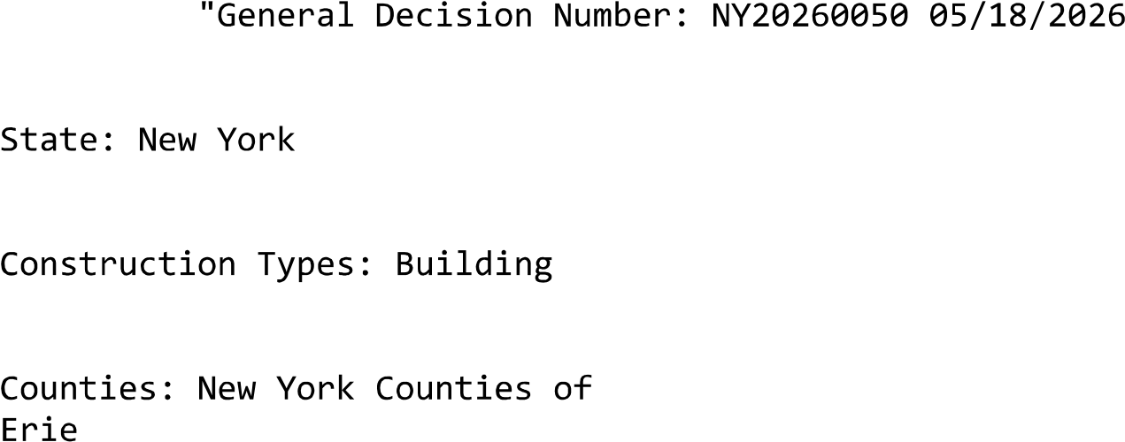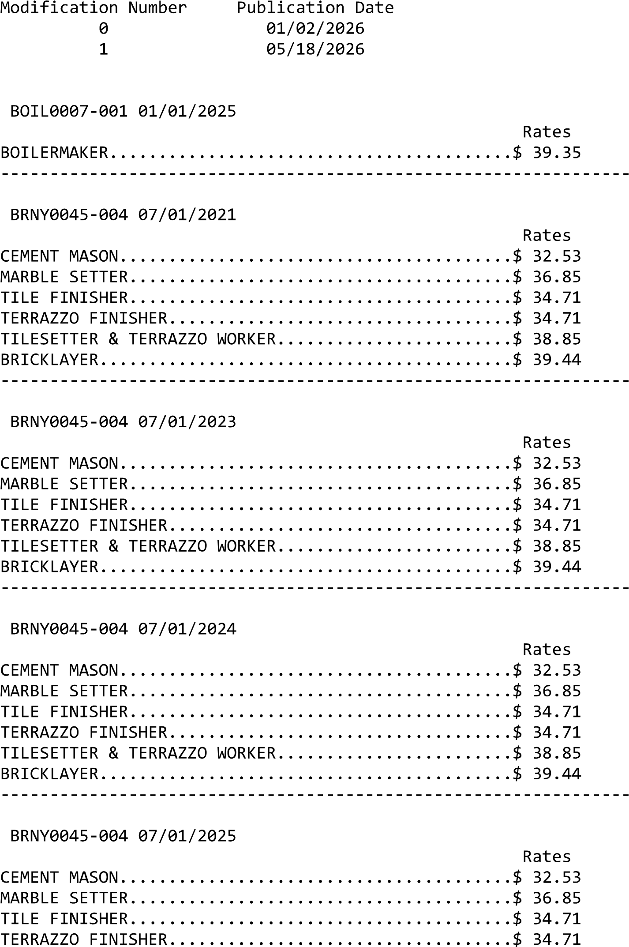
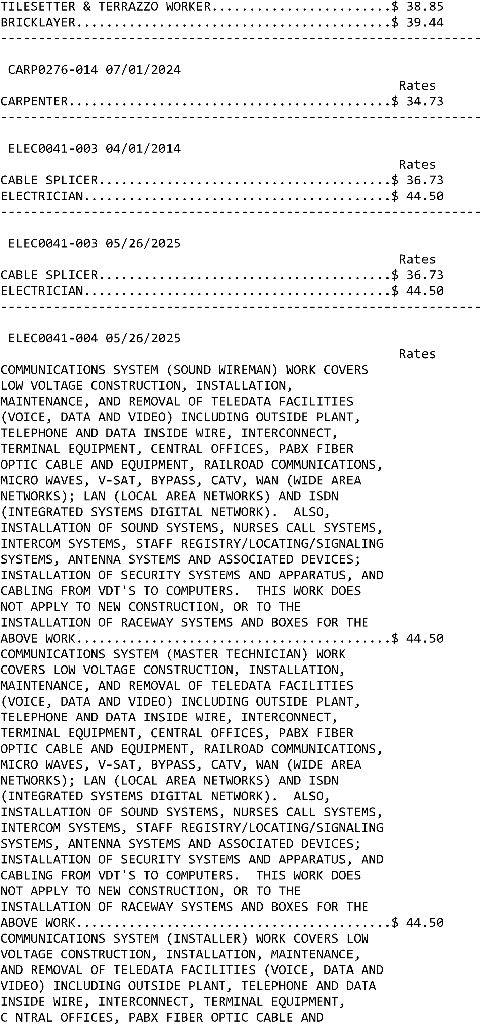
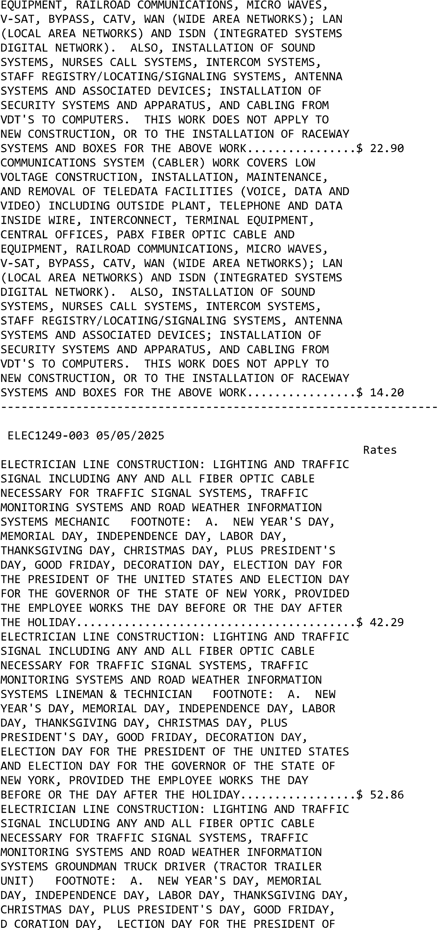
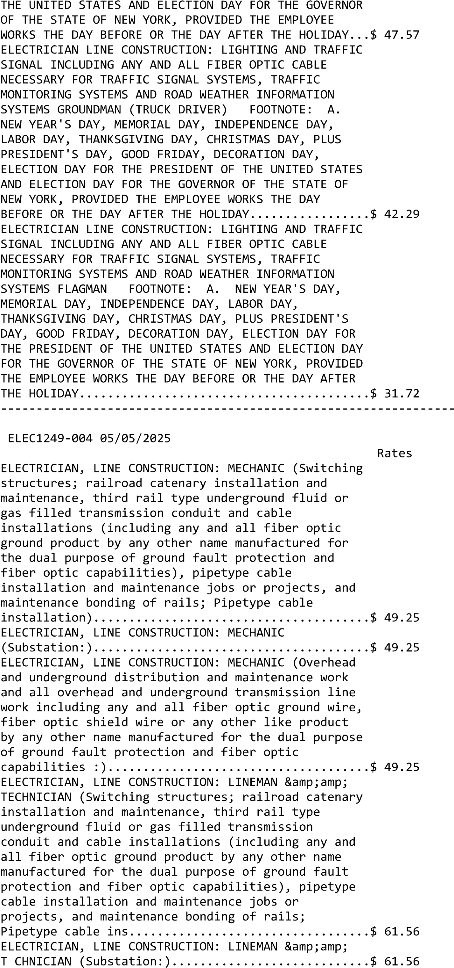

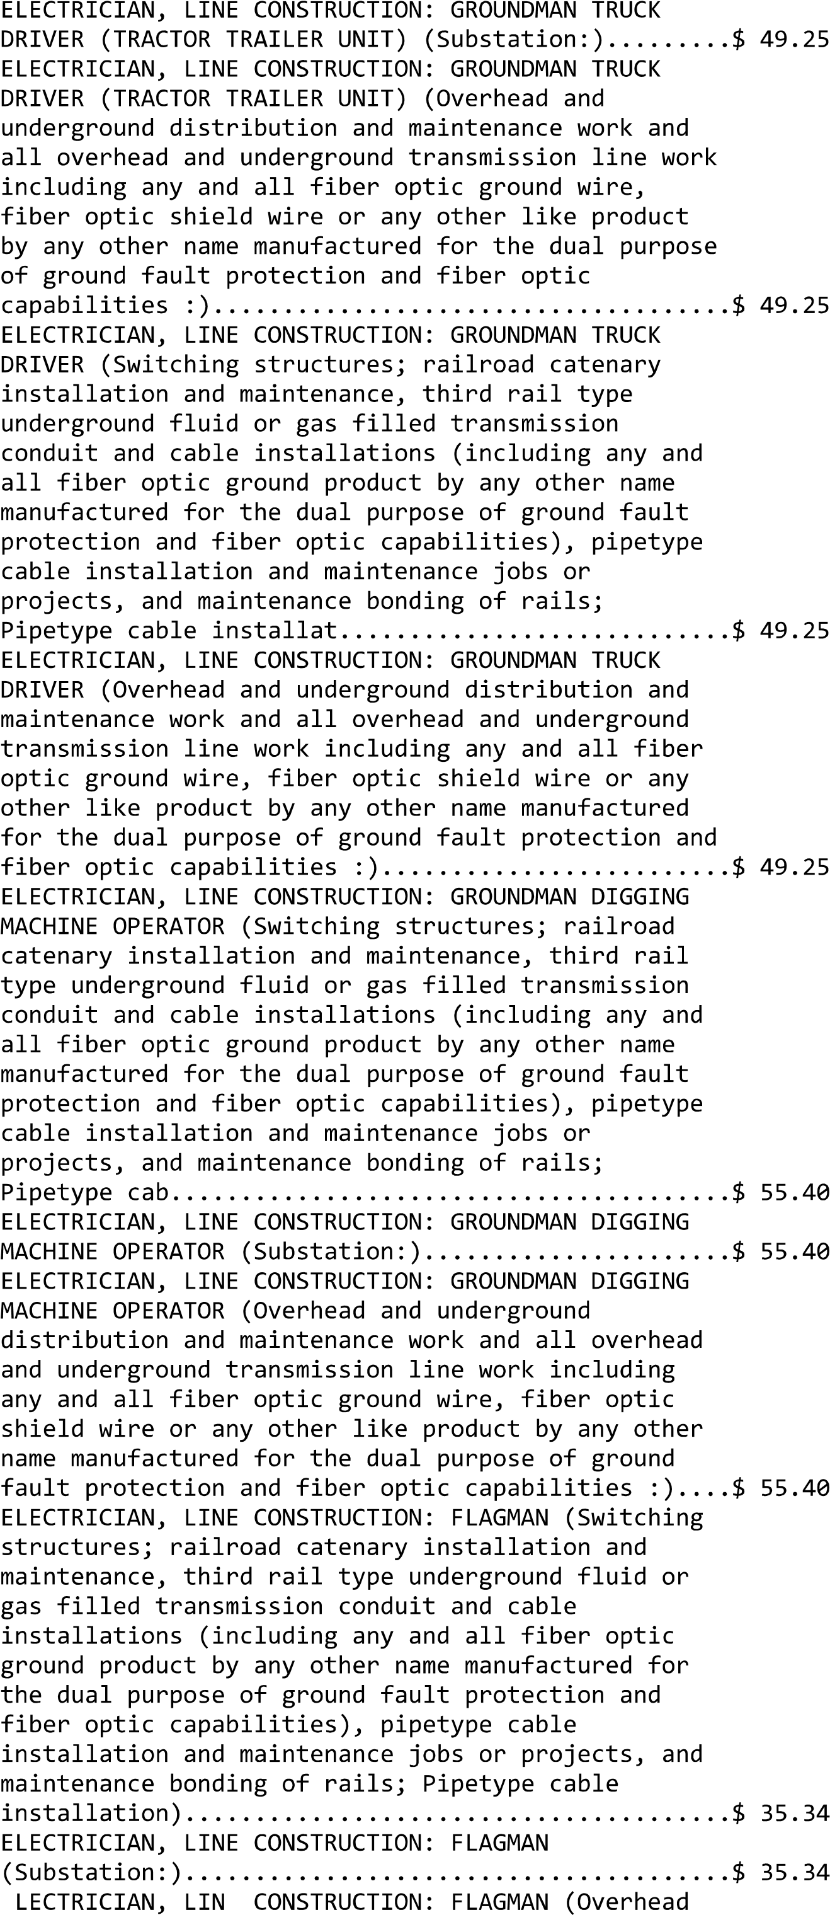
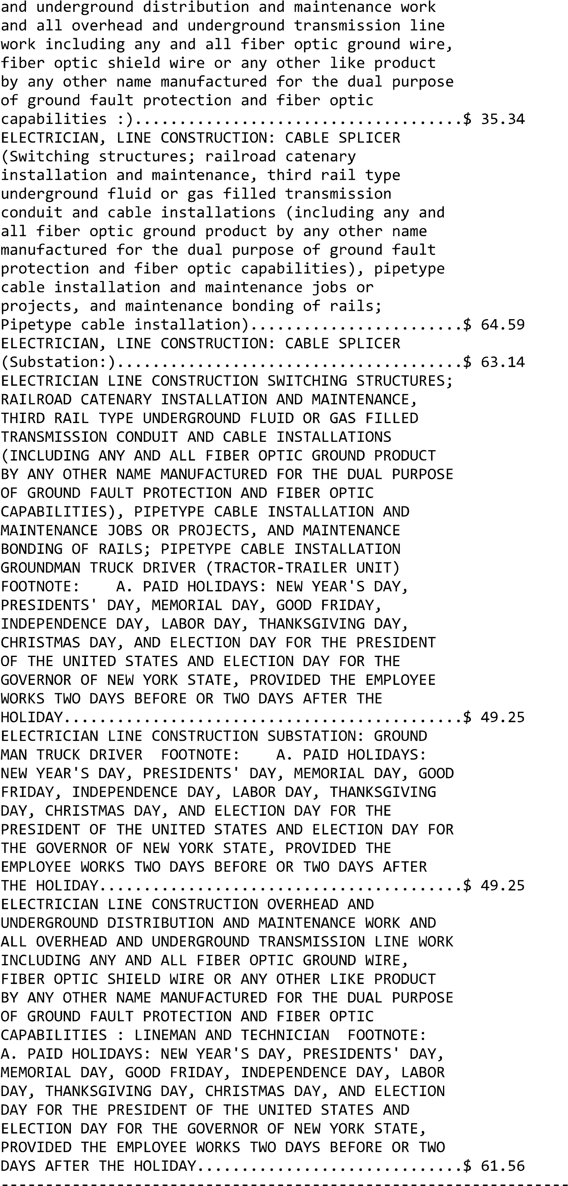
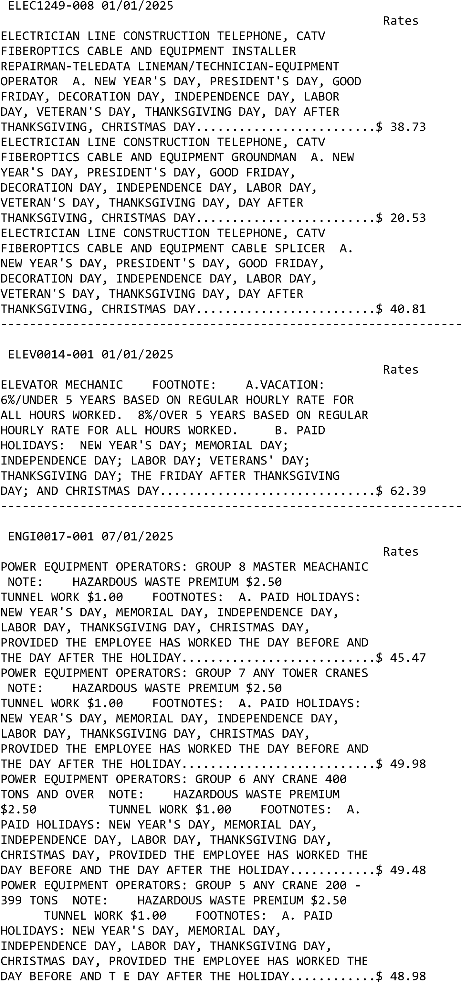
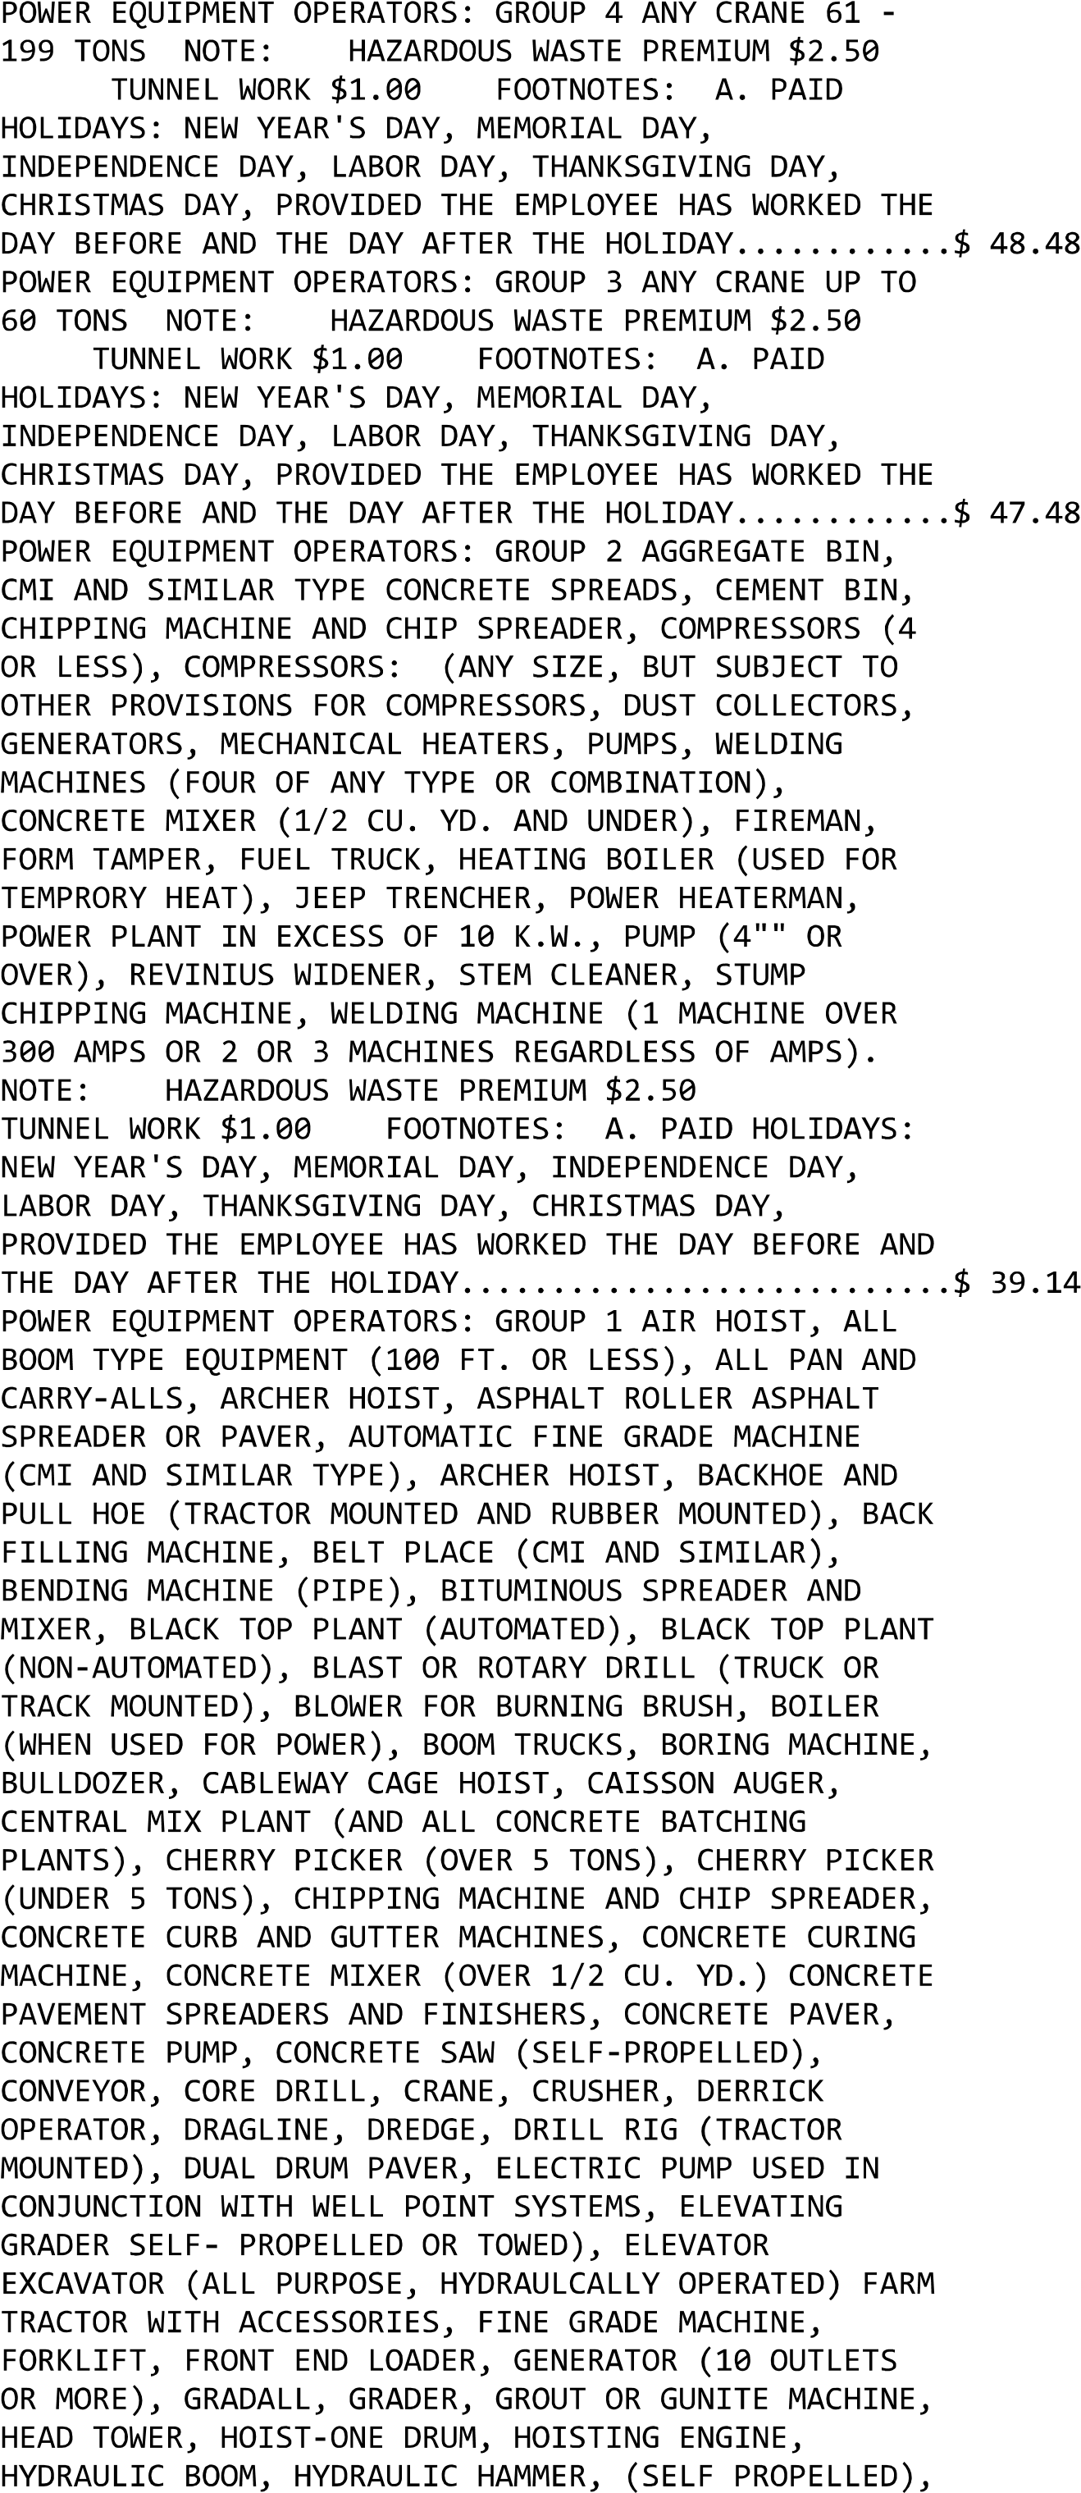

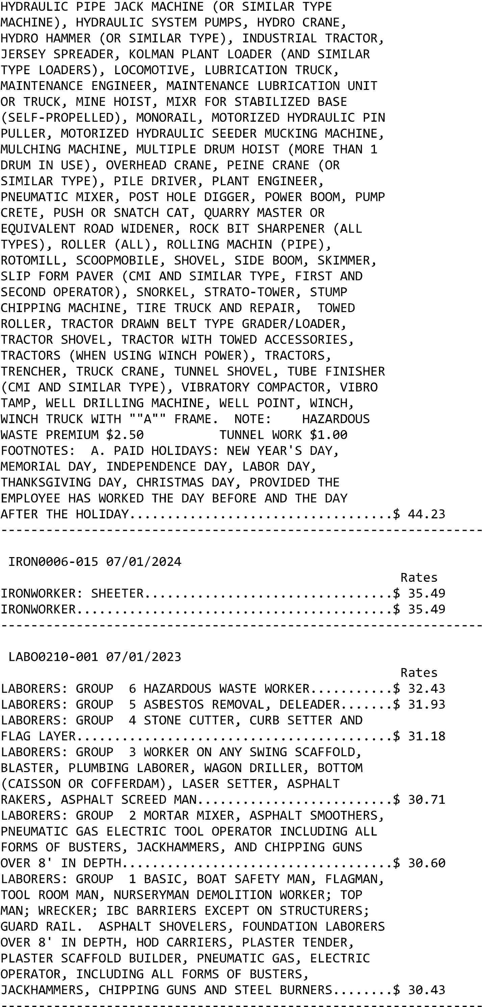
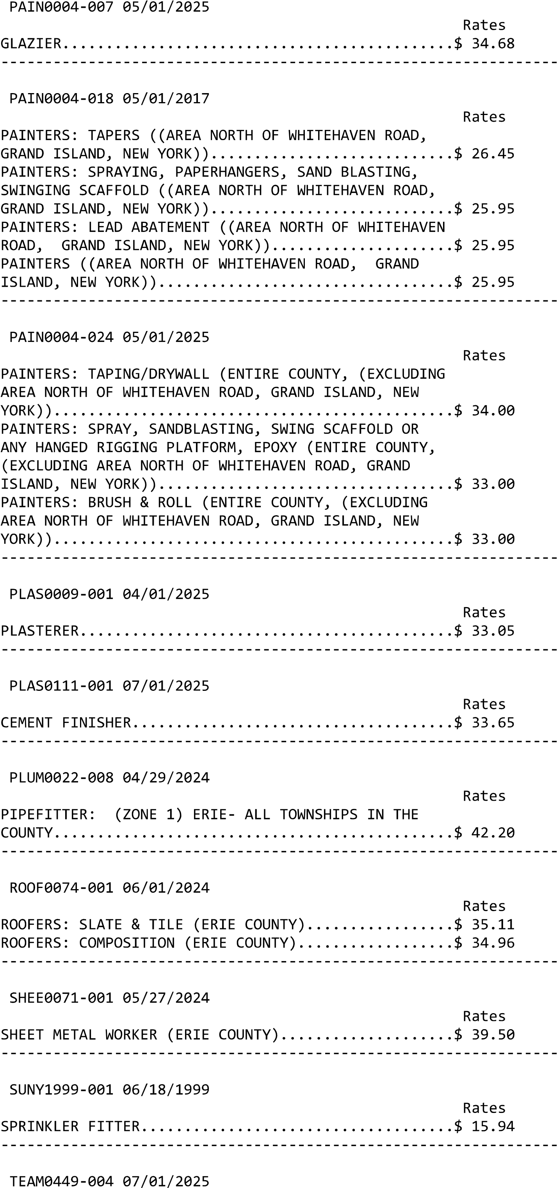
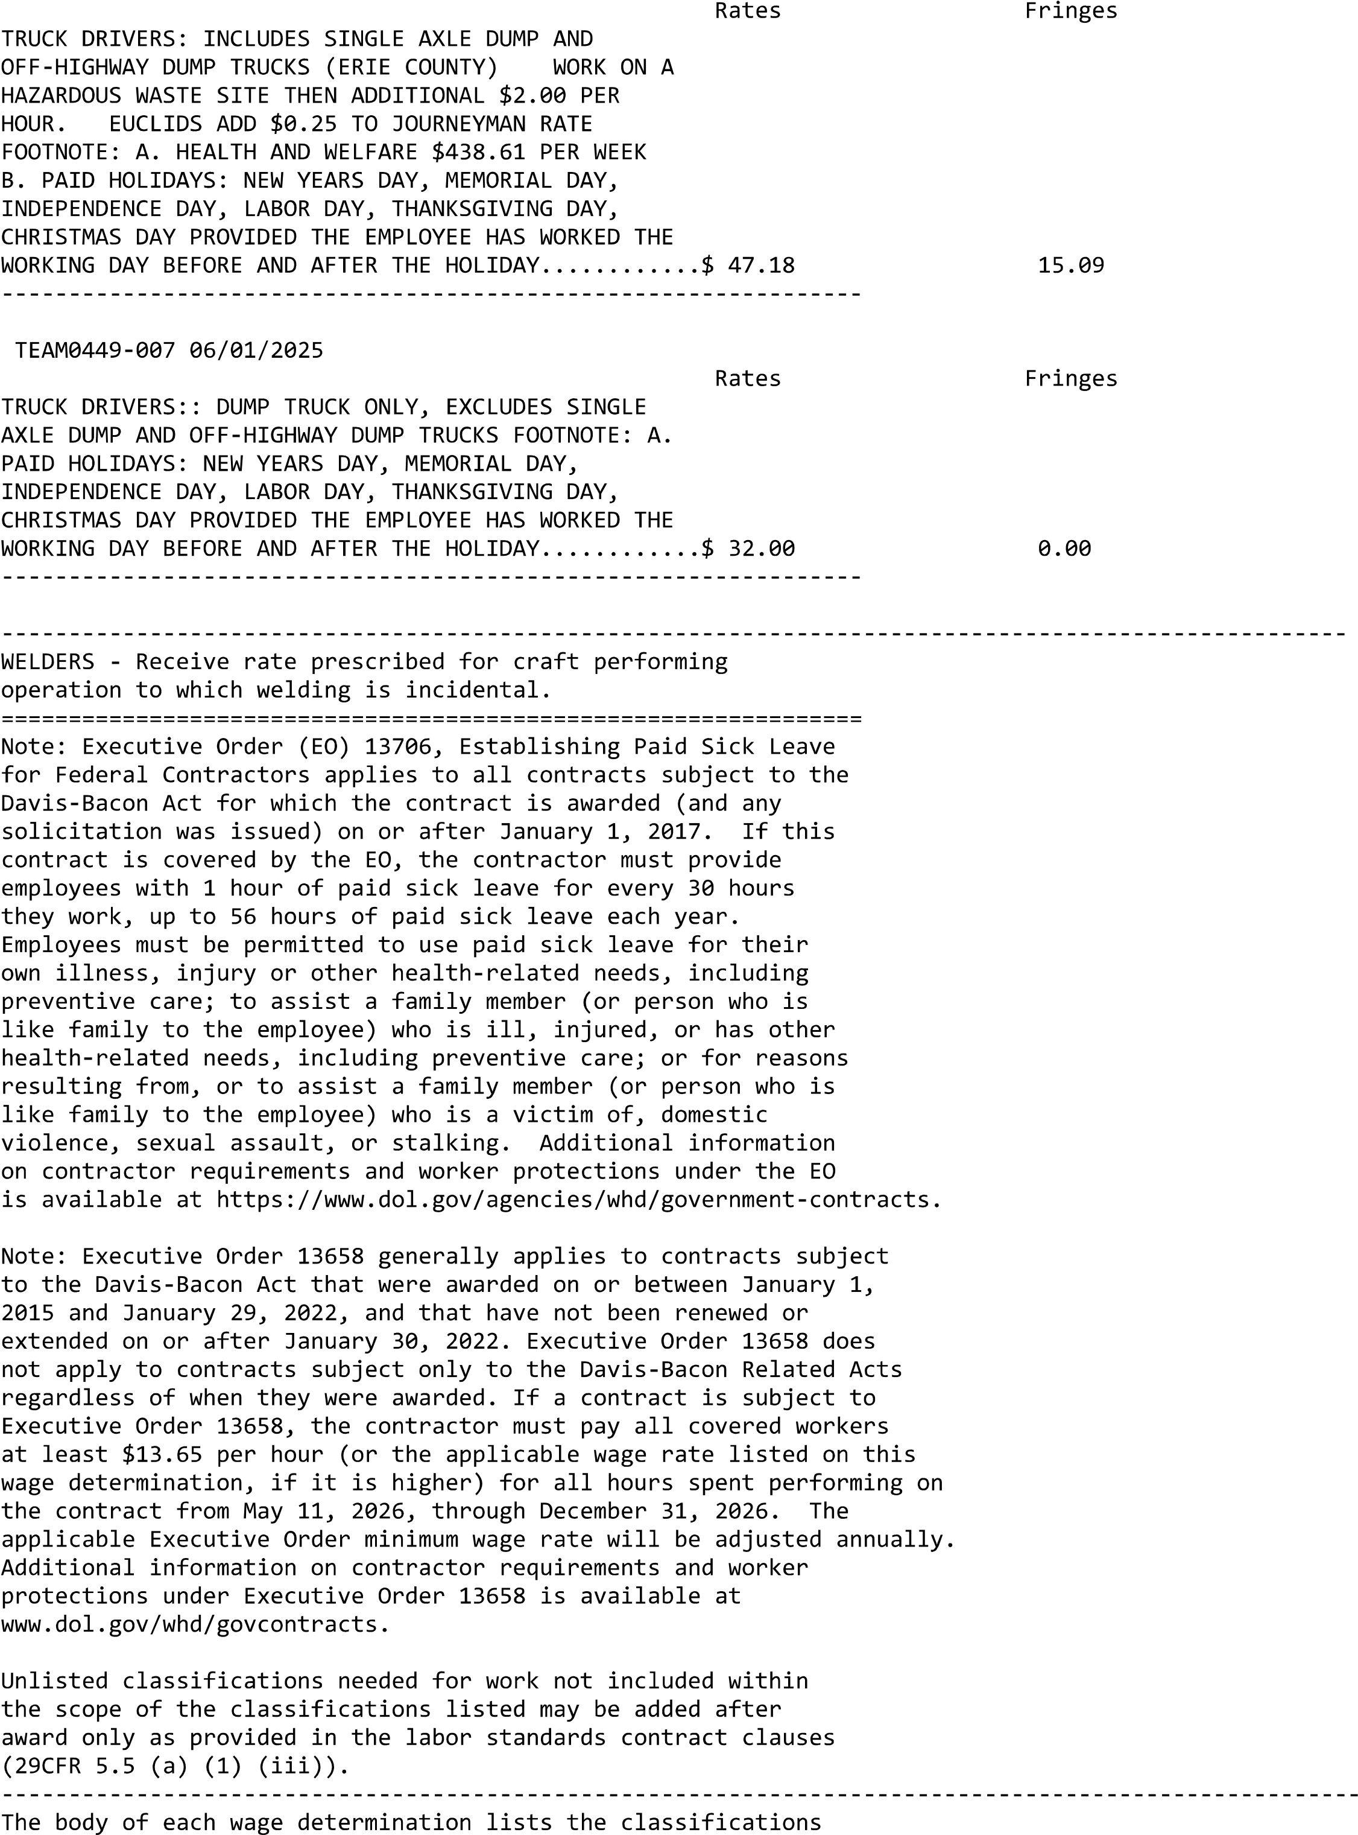
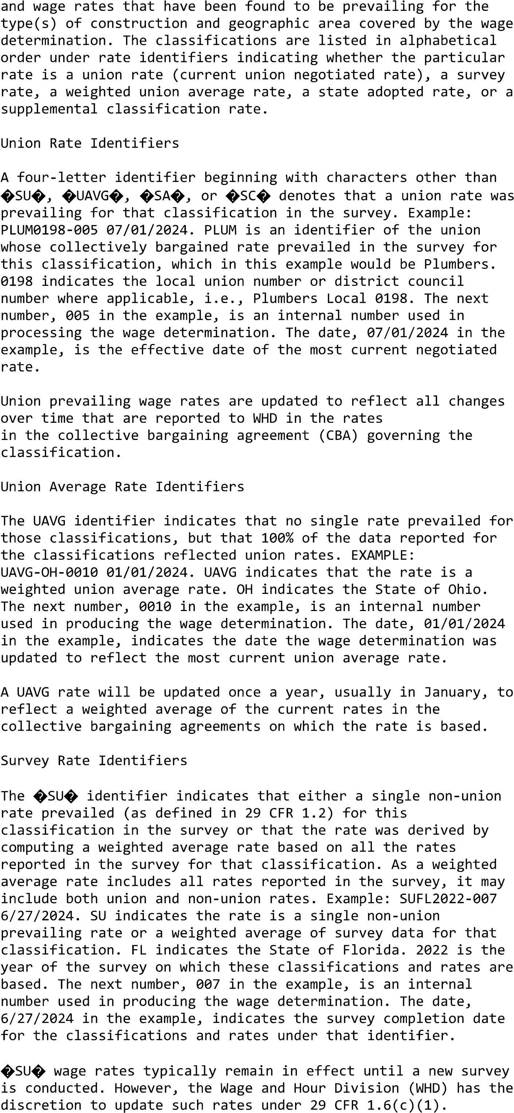
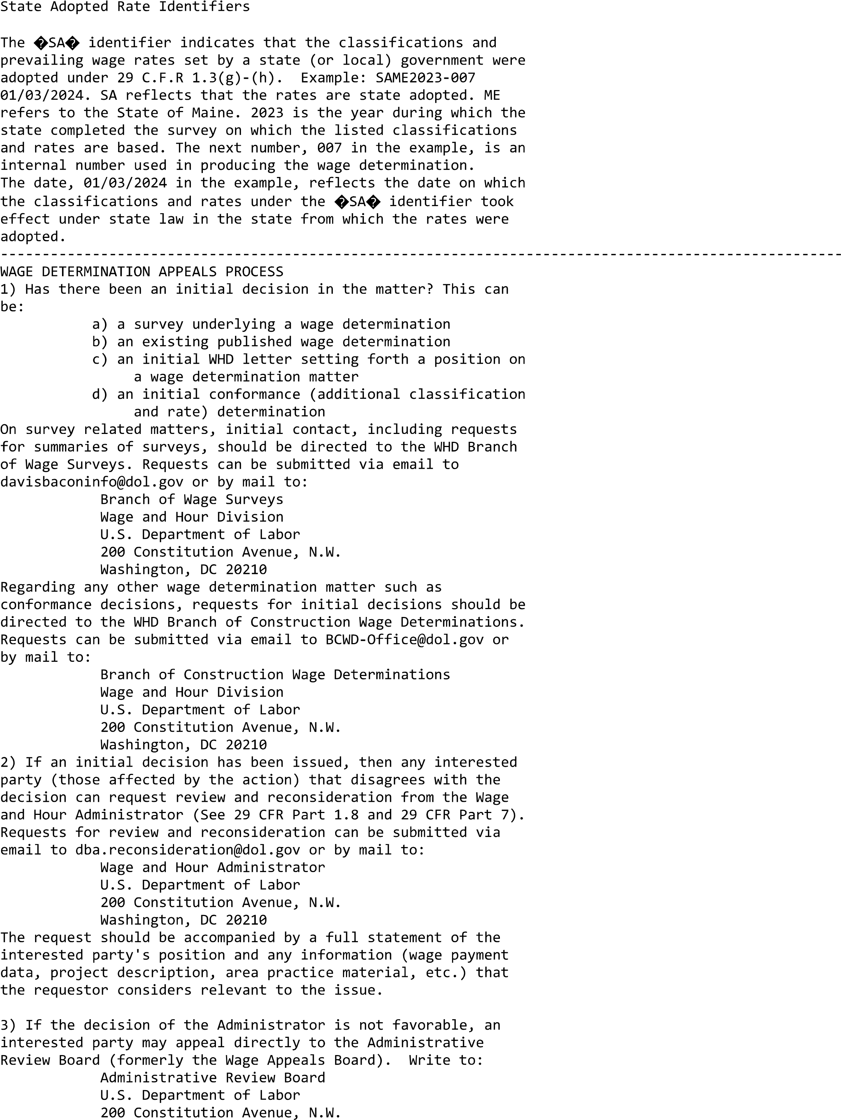
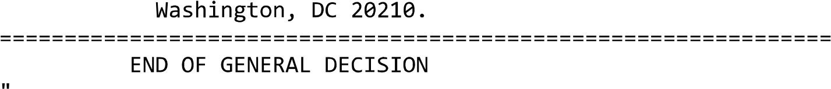

Construction Scope of Work
  - Urology Equipment Site Prep
Project 528-CSI-102

INFORMATION REGARDING BIDDING MATERIAL, BID GUARANTEE AND BONDS 6
INFORMATION REGARDING BIDDING MATERIAL, BID GUARANTEE AND BONDS 6
1.1 BID PRICING SHEET 7
INSTRUCTIONS, CONDITIONS AND OTHER STATEMENTS TO BIDDERS/OFFERORS 10
INSTRUCTIONS, CONDITIONS AND OTHER STATEMENTS TO BIDDERS/OFFERORS 10
2.1 BID OPENING INFORMATION 10
2.2 Special Notes regarding FAR 52.229-3: Federal, State and Local Taxes: 10
2.1 52.216-1 TYPE OF CONTRACT (NOV 2025) (DEVIATION) 11
2.2 52.222-5 CONSTRUCTION WAGE RATE REQUIREMENTS—SECONDARY SITE OF THE WORK (NOV 2025) (DEVIATION) 11
2.3 52.225-10 NOTICE OF BUY AMERICAN REQUIREMENT—CONSTRUCTION MATERIALS (MAY 2014) 11
2.4 52.228-1 BID GUARANTEE (SEP 1996) 12
2.5 52.228-17 INDIVIDUAL SURETY—PLEDGE OF ASSETS (BID GUARANTEE) (FEB 2021) 13
2.6 52.233-2 SERVICE OF PROTEST. (SEP 2006) (DEVIATION NOV 2025) 13
2.7 52.219-27 NOTICE OF SET-ASIDE FOR, OR SOLE-SOURCE AWARD TO, SERVICE-DISABLED VETERAN-OWNED SMALL BUSINESS (SDVOSB) CONCERNS ELIGIBLE UNDER THE SDVOSB PROGRAM (NOV 2025) (DEVIATION) 13
2.8 VAAR 852.204-72 PERSONNEL VETTING AND CREDENTIALING (DEVIATION) (MAR 2026) 15
2.9 VAAR 852.219-75 VA NOTICE OF LIMITATIONS ON SUBCONTRACTING—CERTIFICATE OF COMPLIANCE FOR SERVICES AND CONSTRUCTION (NOV 2022) 18
2.10 52.240-90 SECURITY PROHIBITIONS AND EXCLUSIONS REPRESENTATIONS AND CERTIFICATIONS (NOV 2025) (DEVIATION) 20
2.11 52.252-1 SOLICITATION PROVISIONS INCORPORATED BY REFERENCE (FEB 1998) 24
2.12 VAAR 852.233-71 ALTERNATE PROTEST PROCEDURE (OCT 2018) 24
REPRESENTATIONS AND CERTIFICATIONS 26
3.1 52.209-13 Violation of Arms Control Treaties or Agreements-Certification. (DEVIATION NOV 2025) 27
GENERAL CONDITIONS 30
4.1 52.219-28 POSTAWARD SMALL BUSINESS PROGRAM REREPRESENTATION (NOV 2025) (DEVIATION) 30
4.2 52.222-19 CHILD LABOR—COOPERATION WITH AUTHORITIES AND REMEDIES (MAR 2026) 32
4.3 52.222-15 CERTIFICATION OF ELIGIBILITY (MAY 2014) 33
4.4 52.222-40 NOTIFICATION OF EMPLOYEE RIGHTS UNDER THE NATIONAL LABOR RELATIONS ACT (NOV 2025) (DEVIATION) 33
4.5 52.222-90 ADDRESSING DEI DISCRIMINATION BY FEDERAL CONTRACTORS (DEVIATION APR 2026) 35
4.6 52.225-9 BUY AMERICAN—CONSTRUCTION MATERIALS (DEVIATION) (NOV 2025) 36
4.7 SUPPLEMENTAL INSURANCE REQUIREMENTS 40
4.8 52.240-91 SECURITY PROHIBITIONS AND EXCLUSIONS (NOV 2025) (DEVIATION) 41
4.9 52.252-2 CLAUSES INCORPORATED BY REFERENCE (FEB 1998) 50
4.10 52.248-3 VALUE ENGINEERING—CONSTRUCTION (OCT 2025) 53
4.11 VAAR 852.211-72 TECHNICAL INDUSTRY STANDARDS (NOV 2018) 56
4.12 VAAR 852.228-72 ASSISTING SERVICE-DISABLED VETERAN-OWNED AND VETERAN-OWNED SMALL BUSINESSES IN OBTAINING BONDS (DEC 2009) 57
4.13 VAAR 852.236-71 SPECIFICATIONS AND DRAWINGS FOR CONSTRUCTION (APR 2019) 57
4.14 VAAR 852.236-72 PERFORMANCE OF WORK BY THE CONTRACTOR (APR 2019) 58
4.15 VAAR 852.236-79 CONTRACTOR PRODUCTION REPORT (APR 2019) 59
4.16 VAAR 852.236-80 SUBCONTRACTS AND WORK COORDINATION (APR 2019) 59
4.17 VAAR 852.242-70 GOVERNMENT CONSTRUCTION CONTRACT ADMINISTRATION (OCT 2020) 59
4.18 VAAR 852.243-70 CONSTRUCTION CONTRACT CHANGES—SUPPLEMENT (SEP 2019) 61
4.19 MANDATORY WRITTEN DISCLOSURES 62
1 General Information 78
1.1 Location 78
1.2 Background 78
1.3 Purpose 78
1.4 Scope 78
1.5 Privacy 83
1.6 Records Management 83
1.7 Approach 84
1.8 Site Information 85
2 Applicable Documents 87
2.1 Government Documents 87
2.2 Veterans Health Administration Western New York Documents 87
2.3 Non-Government Publications 88
2.4 Order of Precedence 88
3 Requirements 89
3.1 General 89
3.2 Construction 92
4 Verification 95
5 Commissioning 96
6 Delivery 96
6.1 Technical POC 96
6.2 Schedule and Submittals 96
7 Government Furnished Information, Materials, & Equipment 97

General Information

Location
Services performed under this scope will be for and conducted in part at the VA Western New York Healthcare System (VAWNYHS) at the Buffalo VA Medical Center (VAMC) located at 3495 Bailey Avenue Buffalo, NY 14215 under VA Project Number 528-CSI-102.

Background
The Urology area is located on the 2nd floor of Building 1 in between C and D wings. It comprises a corridor, two Cystoscopy room, two procedure rooms, a check in area and office as well as a restroom and dressing area for patients.

Purpose
The purpose of this project is to renovate two Cystoscopy rooms (214 and 215), Procedure Room (212), Procedure Room (211), Check-In area, Office, Control, Vestibule, Dressing, Toilet and Corridor. The two Cystoscopy rooms (214 and 215) will also receive new medical equipment.
The Buffalo VAMC requires a Contractor to perform construction work necessary to accomplish this goal. The anticipated Construction Period of Performance is estimated to be 720 days.

Scope
This effort intends to perform site preparation renovations to support the installation of new medical equipment. The Contractor shall prepare rooms 214 and 215 to receive new equipment. A control room (215-1) is included and an electrical room (214-1) with new electrical panels and equipment is included in the design. In addition, Procedure Rooms 212 and 211, a stretch alcove, a check-in area, office, dressing area and restroom are included in this scope of work. The rooms included in the design are:
Room Number | Room Name
203-D | MECHANICAL ROOM
209 | PATIENT CHECK-IN
210 | PATIENT WAITING
210-1 | LOCKER ROOM
210-2 | DRESSING
210-3 | DRESSING
210-4 | TOILET
211 | SPECIAL PROCEDURE ROOM
211-1D | WORK ROOM CLEAN-UP CATHETERS
212 | SPECIAL EQUIPMENT ROOM
213 | CONSULTATION ROOM
214 | CYSTO ROOM
214-1 | CONTROL ROOM
214-3 | SCRUB-UP
214-4 | MECHANICAL ROOM
215 | CYSTO ROOM
215 | ELECT.
215-1 | EQUIPMENT STORAGE
215-3 | STORAGE
The existing air handling unit will be replaced. All systems (security, alarm, building management, nurse call, electrical, plumbing, mechanical, structural, architectural, fire protection, building envelope, IT infrastructure, etc.) related to these rooms and the neighboring spaces (same floor, spaces above and below) are within the scope of this effort and subject to renovation.
The scope of construction work is fully described in the construction documents (drawings and specifications). Additional administrative and management related requirements are described in this SOW in Section 3: Requirements. A brief overview of the construction work is included below:
HVAC:
- Remove and replace AHU-5, ductwork, and coils. This includes the current EF-14 and two pneumatic control panels contained in 207-1. The out of service Carbon dioxide manifold and associated components will also be removed from room 207-1.
- Install a new AHU, designed for 6600 CFM, to be located in existing mechanical room 203-D. The new unit will occupy the same footprint as the existing unit and will supply 100% outside air to a constant volume duct distribution network with steam reheats. Ensure supply is fitted with weatherproof screen that allows for access from approximately 5 feet from the ground.
- New constant volume air flow terminal units will be installed with hot water coils
- A custom hydronic system will be installed in the mechanical room 203-D which will supply hot water to for the reheat coils
- EF-14 will be replaced with an in-line centrifugal fan with VFD drive. The new EF-14 and VFD will be located in Mechanical room 202 and ductwork will extend into 204-D (storage room in PACU) and use the existing window opening (behind drywall). Ductwork will extend up the side of the building to the roof line.
- The contractor will be responsible for testing and balancing all affected rooms. Testing will be performed by a certified TAB testing company.
- A split system will be installed in the new electrical unit sized for 12,000 BTU
- Install room air pressure monitoring on rooms 211, 214 and 215.
Plumbing

- New systems in renovated areas include domestic cold water, domestic hot water, recirculated hot water, sanitary, vent, and medical gas.
- Scrub sinks with associated millwork will be provided adjacent to 215 and 214
- Procedure rooms 211 and 212 will have counter mounted stainless steel sinks
- Restroom 210-10 will be renovated and supplied with ADA components
- Medical gases in rooms 214 and 215 will have shall have two rows of outlets and inlets, ceiling mounted at the head and foot of the patient at the edge of the surgical sterile field
- Medical gases in procedure rooms 211 and 212 will have two rows of wall outlets on opposing sides of the room
- New medical gas zone valve boxes will be located in the corridor and a new area alarm will be located at the check in area.
- A procedure must be created to eliminate the growth of Legionella after the installation of any new water line that complies with the ICRA permit
Finishes
- Lead shielding will required for new cystoscopy equipment in 214 and 215. The lead existing ceiling will need to be verified and where new ceiling construction occurs, lead shielding shall be provided. Shielding will also need to be redone in the walls as a result of new wall construction.
- Where new doors are required, lead lining and stainless-steel frames shall be provided. All doors in the scope of the project shall be new except for the reuse of the doors in room 215. The doors of the corridor shall be fire-rated rated, lead-lined and shall have automatic operators to minimize the provider's need to touch the door since the scrub location has been relocated to the corridor.
- New epoxy flooring with an integral base will be provided throughout
- Existing hard ceilings will be removed and with steel-supported gypsum. The new hard ceiling and access panels shall be prepped and painted with epoxy ceiling white paint for cleanability.
- The control room shall have lead-lined windows with stainless steel lead-lined frame to give direct visibility into the Cystoscopy areas. In addition, there will be a chase constructed within the middle of this area to accommodate the existing med gas piping.
Electrical:
- New LED lighting fixtures and receptacles will be installed throughout
- New tele-communications VOIP (Voice and Phone) outlets are located throughout the space. Category 6a cabling shall be routed to each VOIP outlet, cabling shall be routed within the cable tray cable management system. The conduit system shall be 1 ¼-inch EMT (Electrical Metallic Tubing), the contractor shall include pull strings within the empty conduit system.
- WAP (Wireless Access Points) will be installed at locations shown in the drawings
- Card readers and Physical Access Control System Panel will be installed
- New fire alarm devices will be installed that are compatible with existing fire alarm systems. The fire alarm contractor shall be certified to work on fire alarm system and shall program new devices onto the existing fire alarm system.
- A new electrical room will be built off the corridor (214-1) to house control cabinets for the new equipment and multiple electrical panels and transformers. The equipment specific control cabinets will be installed by the manufacturer of the equipment, however the contractor will need to provide the necessary wall blocking and other installation requirements as prescribed by the manufacturer.
- The new electrical panels shall be connected to existing structural steel to ensure proper grounding system. The isolated transformers and panels within the surgical suites shall have isolated grounding system separate from the building steel grounding system. All branch circuits shall contain an equipment grounding system and shall bond to the grounding terminal within panel. The new cable tray cable management system shall bond to the building structural steel grounding system. Bonding jumpers shall also be utilized where the cable tray is physically separated, and grounding continuity needs to be maintained.
Structural:
- A custom base plate for the urology equipment packages in each suite will be installed on and anchored to the existing floor slab using post-installed expansion or epoxy anchors
Fire Protection:
- New piping and sprinkler heads will be installed to provide coverage for reconfigured space areas and use classifications.
Relocation of Clinical Operations:
- Perform renovations on 8A to support the temporary space for Urology. This work will at minimum consist of creating hallway access to an existing restroom.
- Perform renovations on 2E to support the temporary space for Podiatry. This work will at minimum include the relocation of mammography equipment from 209E to 228A and completing electrical hookups to existing disconnect.

Site Conditions, As-Built and Record Documents
Although the VA makes every effort to keep drawings current to existing conditions, changes and updates are sometimes not recorded. It is therefore the Contractor’s responsibility to perform field investigation and verify of the accuracy of the drawings with the actual conditions. The contractor should attend the site visit to check existing conditions at the project site prior to bidding.

Quality Assurance/Quality Control Plan
The Contractor is responsible for reviewing the work done by any subcontractors that the Contractor has hired to assist with the completion of this SOW. The Contractor must provide the Government with a Quality Assurance/Quality Control (QA/QC) Plan that documents the methods, processes, procedures that are going to be implemented by the Contractor to validate the work their subcontractors perform.

Hazardous Materials
Hazardous material testing has been conducted on accessible suspect materials and hazardous material removal is anticipated. Results have been documented in the construction drawings and demolition must coordinate with abatement of all identified materials.
If the contractor identifies additional suspect material during the demolition and/or construction process, notify the VA COR immediately.

Personal Protective Equipment (PPE)
The DB Team is responsible for obtaining/providing, inspecting, and maintaining any required Personal Protective Equipment (PPE) and access equipment (lifts, scaffolding, etc...) necessary to perform services identified in this SOW.

Privacy
1)Contractor shall treat all deliverables under the contract as the property of the U.S. Government for which the Government Agency shall have unlimited rights to use, dispose of, or disclose such data contained therein as it determines to be in the public interest.
2)Contractor shall not create or maintain any records that are not specifically tied to or authorized by the contract using Government IT equipment and/or Government records.
3) Contractor shall not retain, use, sell, or disseminate copies of any deliverable that contains information covered by the Privacy Act of 1974 or that which is generally protected by the Freedom of Information Act.
4) Contractor shall not create or maintain any records containing any Government Agency records that are not specifically tied to or authorized by the contract.
5) The Government Agency owns the rights to all data/records produced as part of this contract.
6) The Government Agency owns the rights to all electronic information (electronic data, electronic information systems, electronic databases, etc) and all supporting documentation created as part of this contract. Contractor must deliver sufficient technical documentation with all data deliverables to permit the agency to use the data.
7) Contractor agrees to comply with Federal and Agency records management policies, including those policies associated with the safeguarding of records covered by the Privacy Act of 1974. These policies include the preservation of all records created or received regardless of format (paper, electronic, etc.) or mode of transmission (email, fax, etc.) or state of completion (draft, final, etc.).
8) No disposition of documents will be allowed without the prior written consent of the Contracting Officer. The Agency and its contractors are responsible for preventing the alienation or unauthorized destruction of records, including all forms of mutilation. Willful and unlawful destruction, damage or alienation of Federal records is subject to the fines and penalties imposed by 18 U.S.C. 2701. Records may not be removed from the legal custody of the Agency or destroyed without regard to the provisions of the agency records schedules.
9) Contractor is required to obtain the Contracting Officer’s approval prior to engaging in any contractual relationship (sub-contractor) in support of this contract requiring the disclosure of information, documentary material and/or records generated under, or relating to, this contract. The Contractor (and any sub-contractor) is required to abide by Government and Agency guidance for protecting sensitive and proprietary information.

Records Management
1) Contractor shall treat all deliverables under the contract as the property of the U.S. Government for which the Government Agency shall have unlimited rights to use, dispose of, or disclose such data contained therein as it determines to be in the public interest.
2) Contractor shall not create or maintain any records that are not specifically tied to or authorized by the contract using Government IT equipment and/or Government records.
3) Contractor shall not retain, use, sell, or disseminate copies of any deliverable that contains information covered by the Privacy Act of 1974 or that which is generally protected by the Freedom of Information Act.
4) Contractor shall not create or maintain any records containing any Government Agency records that are not specifically tied to or authorized by the contract.
5) The Government Agency owns the rights to all data/records produced as part of this contract.
6) The Government Agency owns the rights to all electronic information (electronic data, electronic information systems, electronic databases, etc) and all supporting documentation created as part of this contract. Contractor must deliver sufficient technical documentation with all data deliverables to permit the agency to use the data.
7) Contractor agrees to comply with Federal and Agency records management policies, including those policies associated with the safeguarding of records covered by the Privacy Act of 1974. These policies include the preservation of all records created or received regardless of format (paper, electronic, etc.) or mode of transmission (email, fax, etc.) or state of completion (draft, final, etc.).
8) No disposition of documents will be allowed without the prior written consent of the Contracting Officer. The Agency and its contractors are responsible for preventing the alienation or unauthorized destruction of records, including all forms of mutilation. Willful and unlawful destruction, damage or alienation of Federal records is subject to the fines and penalties imposed by 18 U.S.C. 2701. Records may not be removed from the legal custody of the Agency or destroyed without regard to the provisions of the agency records schedules.
9) Contractor is required to obtain the Contracting Officer’s approval prior to engaging in any contractual relationship (sub-contractor) in support of this contract requiring the disclosure of information, documentary material and/or records generated under, or relating to, this contract. The Contractor (and any sub-contractor) is required to abide by Government and Agency guidance for protecting sensitive and proprietary information.

Approach
This Scope of Work has been broken down into general requirements that are applicable to the entire contract and the specific construction effort.
The bidding Contractor(s) shall conduct a brief pre award site survey of the campus. This will be arranged through the contracting officer and conducted as a group or individually as per the contracting officer.

Phasing
This is a phased project. Please refer to the construction drawings for phasing requirements.

Phasing and Hours of Work
The contractor will be required to submit a proposed work schedule that provides detailed project phasing and sequencing information to the VA for review and approval prior to the start of construction.
The medical campus will remain open to accommodate patients, visitors and employees during normal operating hours while this project is underway (7:00 am – 5:00 pm, Monday through Friday). Work that may create excessive noise, vibration or that may interrupt patients, visitors and employees will need to be closely coordinated with the VA and may be required to occur outside of normal operating hours. The contractor shall anticipate portions of work involved with this project occurring on evenings, nights, weekends and holidays.

Site Information

Safety
The Contractor shall pay special attention to Section 01 35 26 Safety Requirements of the Project Manual. Section 01 35 26 has been modified by the VAWNYHS to include site specific information for the Buffalo VAMC.
The Site Superintendent on this project can be designated as and perform the tasks of the Site Safety Officer (SSHO) (the Prime Contractor Competent Person (CP)). All competent persons must submit a 30 hour OSHA card that has been completed in the last 5 years. For more information on CP requirements please refer the Section 01 35 26 Safety Requirements. Please note that the contractor will be required to submit proof of specialized training for CPs in addition to the OSHA 30 card as required for specialized functions stated in Section 01 35 26 Safety Requirements.
Contractor personnel working onsite at the Medical Center will be required to attend a 1 hour Buffalo VAMC site specific safety training class. This class will be held on site and will be taught by a member of the Buffalo VAMC safety office. Attendance to this class and proof of the 10 hour OSHA requirement will allow Contractor personnel to obtain a photo ID badge from the Buffalo VAMC Police. All Contractor personnel shall wear this badge above the waist at all time while on the Buffalo VAMC campus. Participation in this class is mandatory and must be done prior to the commencement of work on-site. The training and the badge will be valid for 3 years from the date of issue.

Infection Control
An Infection Control permit will be issued for this project. At a minimum, the permit requires the contractor to construct barriers / fencing, contain and utilize proper dust control measures. An addendum will be required that pertains to water systems and will require additional activities to control the growth of Legionella. Additional infection control measures for this project may be required to maintain the safety of patients, visitors and employees.

Access
Although the VAWNYHS campuses are public facilities, access to facility maintenance areas, electrical areas, mechanical areas, roof access, and certain other portions of the medical facility are restricted from the general public. Accessing these areas may require advance notice, pre-approval, and scheduling to gain entry.
All visits and access requests to the VAWNYHS under this scope of work shall be coordinated through the COR.
Contractor personnel are expected to sign in and sign out each day that they work on-site as well as provide daily logs documenting efforts on this project, even when no work has been scheduled or completed.

Photography
It is VHA policy to respect the privacy of all persons (e.g., Veterans, patients, residents, members of the VHA workforce, and visitors) consistent with the needs of operating a national health care system. Privacy protections on VHA premises vary according to the needs and purposes of different types of areas, the persons included, and the purpose of the production and use of photographs, digital images, and video or audio recordings (excerpt from VHA Directive 1078).
Photography of as-built and site conditions are permissible actions under this SOW when photography activities are coordinated with the COR.
The Contractor shall ensure that any photographs taken do NOT include any VHA patients, members of the VHA workforce, or visitors to the VAMC facility.

Security
Contractor personnel must obtain a photo ID badge from the Buffalo VAMC Police. All Contractor personnel shall wear this badge above the waist at all times while on the Buffalo VAMC campus.
A listing of all personnel and their contact information working onsite shall be provided to the COR and VA Police.
The construction site shall always be secured. If locks are used they must be VA approved. Four keys to the lock will be held, one-each by the following individuals: 1) contractor’s site supervisor, 2) the VA COR, 3) VA Police Force, and 4) VA Key Control Supervisor. No individual will be provided access to the construction site without approval from the VA. Subcontractors will be provided access by the contractor’s site supervisor, who will remain onsite for the entirety of the subcontractor’s work, and following the work will secure the site, after a complete site inspection.

Applicable Documents
The following documents are applicable to this Scope of Work (SOW) to the extent specified herein. While every effort has been made to ensure the completeness of this list, document users are cautioned that they must meet all specified requirements of documents cited in section 3 of this SOW, whether or not they are listed here.

Government Documents
The following directives, guides, handbooks, and drawings form a part of this document to the extent specified herein. Unless otherwise specified, the latest revisions available shall be used.
Copies of construction related Department of Veterans Affairs directives, guides, and handbooks are available from the Office of Construction and Facilities Management website:
http://www.cfm.va.gov/til/index.asp

DEPARTMENT OF VETERANS AFFAIRS DIRECTIVES
1078 PRIVACY OF PERSONS REGARDING PHOTOGRAPHS, DIGITAL IMAGES,
AND VIDEO OR AUDIO RECORDINGS

Veterans Health Administration Western New York Documents
The following documents of the exact revision listed below form a part of this document to the extent specified herein.
Documents identified as “AS MODIFIED BY VHA WNY” are base VA documents that have been tailored to the needs of the Veterans Health Administration Western New York (VHA WNY) or this specific effort. While the base VA documents are available on the Office of Construction and Facilities Management website listed above, the Contractor shall use the modified version listed below, NOT the base document. Copies of these documents are available from the KO, COR, or Technical POC.
Please note that 528-CSI-102 was previously identified as project number 528-19-102 as may also be identified under this number.

VA WESTERN NEW YORK HEALTHCARE SYSTEM, BUFFALO VA MEDICAL CENTER
DRAWINGS:
PG-18-1: MASTER CONSTRUCTION SPECIFICATIONS, SECTION 00 01 15 LIST OF DRAWING SHEETS (AS MODIFIED FOR VA PROJECT 528-CSI-102) lists all drawings for this construction effort.
SPECIFICATIONS (AS MODIFIED FOR VA PROJECT 528-CSI-102):
PG-18-1: MASTER CONSTRUCTION SPECIFICATIONS, SECTION (TOC) TABLE OF CONTENTS (AS MODIFIED FOR VA PROJECT 528-CSI-102) lists all relevant and modified construction specifications for this construction effort.
ADDITIONAL DOCUMENTS: APPROVED FACILITY FINISHES AND DEVICES

Non-Government Publications
All work shall be accomplished in strict accordance with the latest codes and standards. The DB Team shall follow any/all applicable standards and codes, including, but not limited to applicable NFPA standards, NEC, JCAHO, OSHA, ANSI, ASHRAE, and any other codes.

Order of Precedence
In the event of a conflict between the text of this document and the references cited herein, the text of this document takes precedence. Nothing in this document, however, supersedes applicable laws and regulations unless a specific exemption has been obtained.

Requirements
The DB Team shall provide personnel, material, services, and facilities to perform, accomplish, and deliver the required services detailed in this scope of work.

General
This section contains general information that is applicable for the duration of the contract (i.e. applies to all Parts of this effort).

Construction Management Software
The Contractor will be required to use Autodesk Build as the Construction Management Platform for this project. The requirements are the following:
- Construction contractors and A/E design firms, selected by award to perform work at VISN 2 VA facilities, are required to utilize VISN 2 Autodesk Build Construction management platform, also called Autodesk Construction Cloud (ACC). Access to the platform and training portal will be provided by VISN 2 through project Contracting Officer Representative (COR) at no cost for the duration of the project. Autodesk Build is the management and collaborative environment that VISN 2 uses for all its Non-Recurring Maintenance (NRM), Minor Program projects, Feasibility Studies, Commissioning and Retro-Commissioning contracts. There is no user, license, or subscription fee to the contractor for using this cloud-based platform.
- Contractor shall accomplish and complete the following tasks upon award of contract:
- Request access to ACC platform and ProductivityNOW eLearning Site to project VA COR NLT 14 days from contract award.
- Only staff that shall utilize the platform to be granted access. Examples: Project manager, sub-contractors POC, Site Superintendent, Site Safety and Health Officer, etc.
- The access request shall be in writing and include a list of staff. The list shall include the following information:
  - Full Name
  - Company Name
  - Email Address
  - Role/Position on the project (i.e., Project manager, Site Superintendent)
- Upon granting access, staff shall complete required ACC training through ProductivityNOW platform within 12 Calendar days.
- Upon successful completion of training, contractor shall submit certificates of completion to COR NLT 2 business days.
- Access to ProductivityNOW eLearning will expire after 12 Calendar days after online access is granted. Contractor shall complete ACC training within that period.
- Additional Staff and Subcontractors can be added at any time with a request submission to the project COR as described above.
- The contractor shall only use the ACC platform for contract required submissions, official project correspondence to be acknowledged, reviewed, and actioned by the responsible party. No additional time shall be added to the contract, nor an increase in contract amount be provided for the contractor’s failure to utilize the ACC platform as the project’s official communication and collaboration system. Any correspondence out of platform shall not be the governing authority contradicting direction and will be at the contractor’s expense. Official project correspondence and collaboration includes but not limited to: RFIs, submittals, schedules, shutdown requests, actionable tasks, reports, testing, safety inspections, photos, and site surveys.
- Contractor must inform the COR of any staff changes NLT 2 business days from the change. Staff changes pertains to staff who was granted access to the ACC platform. Contractor shall request termination of access, replacement of personnel and/or any other action that might impact the contractor ability to maintain required utilization of the platform.
- Contractor submission requirements cannot be accepted for work to begin without meeting all ACC Platform requirements outlined herein, including completing required ACC platform training.

Status Reports
The Contractor shall provide monthly status reports throughout the duration of the contract, or more frequently as directed by the COR or CO. The reports should include at a minimum the bulleted items below. The status report will be supplied as a digital product to the Government in a Microsoft Word compatible format (*.DOC) or Portable Document Format (*.PDF) that can be emailed to COR, however, note that the VA email cannot accept file sizes larger than 5mb. Files over that size may be provided through an internet-based file sharing software such as sharepoint. The reporting period will begin at Notice to Proceed.
- Photographs of work taken during the reporting period, specifically the following iterations:
  - As built (pre-demo) images of any exposed building structural element, electric, plumbing or other utility system
  - Completed demolition, showing base condition
  - Progress photos
  - Photos of any area of concern
  - Photos of items subsequently hidden or covered as construction progresses
- Progress Report Update
  - Itemized list of progress completed during the reporting period
  - Itemized list of tasks behind schedule
  - Updated project schedule
  - Any Requests for future work, i.e. access, Shutdowns, Utility coordination, VA Engineering team assistance, etc.
- Project and safety issues, or other concerns
- Certified Payroll

An updated project schedule and project progress status report shall be supplied with each invoice. Invoices will not be processed without this information.

Meetings
Meetings will be held, at a minimum once each month, or more or less frequently as directed by the COR or CO. Meetings will start after the initial kickoff meeting. Meeting location and exact schedule will be arranged as agreed upon between the VA and Contractor. The intent of the meetings is to discuss the project schedule, status of submittals and RFIs, construction progress, cause of delays, issues / concerns and safety, and review the status report.
The Contractor shall provide meeting minutes to document discussions had during the meeting. The contents of meeting minutes shall include but is not limited to the following information/topics:
        - Meeting attendees
        - Narrative to describe contents of meeting (will likely mirror the meeting agenda)
        - List of action items (for both the Government and the Contractor)
Meeting minutes may be organized in Contractor specified format. Meeting minutes will be supplied as a digital product to the Government in a Microsoft Word compatible format (*.DOC) or Portable Document Format (*.PDF).
The Contractor shall provide draft meeting minutes within 5 business days of the meeting. The Government will review and provide comments back to the Contractor within 3 business days of receipt of the draft meeting minutes. The Contractor shall finalize the meeting minutes and submit the final meeting minutes to the Government within 3 business days of receipt of Government comments.

Meeting Agenda
The Contractor shall provide a meeting agenda 5 business days prior to the scheduled date of the meeting.
Meeting agendas may be organized in Contractor specified format. Meeting agendas will be supplied as a digital product to the Government in a Microsoft Word compatible format (*.DOC, *.DOCX) or Portable Document Format (*.PDF). Meeting agendas shall be submitted via email to the COR.

Meeting Presentation Materials
Any required presentation materials (e.g. handouts, slide presentation, design information, drawings, schedules, cut sheets, etc…) shall be provided to the Government at the same time as the meeting agenda.
Meeting presentation materials may be organized in Contractor specified format. Meeting presentation materials will be supplied as a digital product to the Government in a Microsoft Office compatible format (*.DOC, *.DOCX, *.PPT, *.PPTX), Portable Document Format (*.PDF), or AutoCAD (*.DWG, *.DXF) as applicable to the specific document and meeting.
While email is acceptable method to receive this information, note that the VA has a size restriction for attachments on email. No email can be sent or received by the VA that is larger than 5MB. If meeting presentation materials are larger than this size, the Contractor must determine an alternate method to submit the required materials by the due date (e.g. FTP website, optical digital media, etc…).

Meeting Minutes
The Contractor shall provide meeting minutes to document the discussion had during the meeting. The contents of meeting minutes shall include but is not limited to the following information/topics:
- Meeting attendees
- Narrative to describe contents of meeting (will likely mirror the meeting agenda)
- List of action items (for both the Government and the Contractor)
- Presentation materials used during the meeting should be included as enclosures
Meeting minutes may be organized in Contractor specified format. Meeting minutes will be supplied as a digital product to the Government in a Microsoft Word compatible format (*.DOC, *.DOCX) or Portable Document Format (*.PDF).
The Contractor shall provide draft meeting minutes within 5 business days of the meeting. The Government will review and provide comments back to the Contractor within 3 business days of receipt of the draft meeting minutes. The Contractor shall finalize the meeting minutes and submit the final meeting minutes to the Government within 3 business days of receipt of Government comments.

Construction
The Contractors scope of work for Construction shall include, but is not limited to the following:

Kick-off Meeting and Site Survey
The Contractor shall participate in a kick-off meeting at the VAMC. During the kick-off meeting the Government shall review applicable rules/regulations/procedures related to contract administration and contract execution expectations.
As part of the kick-off meeting, a survey of the site will be conducted (see PG-18-1: MASTER CONSTRUCTION SPECIFICATIONS, Section 01 00 00 (General Requirements - 528-CSI-102), Article 1.7 (Alterations)).

Submittals
In accordance with the terms of PG-18-1 MASTER CONSTRUCTION SPECIFICATIONS; SECTION 01 33 23 SHOP DRAWINGS, PRODUCT DATA, AND SAMPLES (528-CSI-102), the contractor shall provide submittals and shop drawings for review prior to starting work. The exact number and type of submittals required to start physical construction will ultimately be determined by the CO or COR, and is dependent on the contractors proposed / VA approved project schedule and sequencing. Submittals must be approved prior to starting any work associated with the submittal. A base submittal log is included in section 01 33 23 of the project specifications.
Provide a transmittal with each submittal containing project title, location, project number, date, subcontractor name if applicable, associated section of the specifications, product identification, and revision number if submittal is not initially approved.
The VA review period for submittals is 21 calendar days or less. The VA will return submittals to the contractor notated as “Approved”, “Approved as Noted”, “Revise and Resubmit” or “Not Reviewed”.
The contractor is advised to carefully review project documents to develop an understanding of the number and type of submittals required. The contractor shall assume that any products, materials or equipment that is part of parking ramp expansion construction will require a submittal and approval prior to use / integration. In addition to products, materials and equipment; the contractor will be required to submit work plans, phasing plans, accident prevention plan, activity hazard analysis, fire safety plan and lift plans.
*All submittals must be submitted in advance of work / as early as possible as to not cause scheduling delays. It is recommended that the contractor submit a minimum of 30 days in advance of any work that depends on approval of a submittal.

Preconstruction Conference
Once the submittals have been approved, the Contractor shall attend a Preconstruction Conference. This meeting will be a follow-up to the Kick-off Meeting and Site Survey. In preparation for this meeting the Contractor shall submit:
- An updated work plan that adds any additional details required to describe the intended work based upon approved submittal information.
- Revised or new Activity Hazard Analysis (AHA) based on approved submittals
- Any additional clarifying details about the work to be performed that have been updated based upon the approved submittals.
Any action items resulting from this meeting shall be addressed prior to ordering any materials or beginning the actual construction work.
This meeting shall comply with the terms of this SOW and the terms of PG-18-1 MASTER CONSTRUCTION SPECIFICATIONS; SECTION 01 35 26 SAFETY REQUIREMENTS (528-CSI-102).

General Construction
The Contractors scope of work for General Construction shall include, but is not limited to, the procedures outlined in PG-18-1: MASTER CONSTRUCTION SPECIFICATIONS (528-CSI-102).
Work includes, but not limited to, all labor, material, equipment and supervision to perform the required demolition, modification, construction, and/or installation of switchgear and associated systems as described in the drawings, specifications, and this SOW.

Construction Inspections
Periodic formal and informal construction site visits and inspections will be performed by VA staff and the A/E Consultant throughout the construction process to assess the quality and compliance of the build in comparison to the Contract Documents. Typical inspection examples include structural, framing, electrical rough in, plumbing rough in, mechanical rough in, post insulation installation.
Timing of critical inspection points shall be discussed with the VA COR during the development of project construction schedule submittal.
Any findings identified during an inspection will be photographed, documented in writing, and delivered to the contractor.
The Contractor shall respond in writing and provide evidential proof of compliance/rectification/resolution to each finding identified.
Some findings may require resolution prior to moving to the next construction process.

Verification
Pre drywall inspections and above ceiling inspections will be performed by VA Engineering. No work to conceal utilities can be done until this inspection is completed and the work is satisfactory to the VA.
Final inspection of the renovated space shall be conducted jointly before final acceptance of the constructed product. The groups that will participate in the verification process include:
- Prime Contractor
- Subcontractor (as applicable)
- AE firm
- VA Engineering
These inspections will be based upon manufacturers data and will be checked against VA regulatory requirements as applicable.
Any work that does not pass inspection, the Contractor shall troubleshoot the issue and determine if the root cause of the problem.
If the root cause is the result of the construction work, the Contractor shall repair and/or replace the faulty construction work and any subsequently damaged equipment at no additional cost to the Government.
If the root cause is the result of faulty equipment (manufacturer defect), the Contractor shall coordinate with the fabricator to repair and/or replace the faulty equipment and any subsequently damaged equipment at no additional cost to the Government.

Commissioning
The contractor shall be responsible for providing a third party to perform commissioning procedures for the following systems:
- HVAC system (including the air handling unit, hydronic system, ventilation/exhaust, direct digital control system) as required by MASTER CONSTRUCTION SPECIFICATIONS; SECTION 01 91 00 General Commissioning Requirements and Section 23.08.00 Commissioning of HVAC Systems
- Plumbing (Medical Gas System) as required by MASTER CONSTRUCTION SPECIFICATIONS; SECTION 01 91 00 General Commissioning Requirements and Section 22.08.00 Commissioning of Plumbing Systems
- Fire Suppression System as required by MASTER CONSTRUCTION SPECIFICATIONS; SECTION 01 91 00 General Commissioning Requirements and Section 21.08.00 Commissioning of Fire Suppression Systems
The contractor will be responsible for naming a commissioning agent to manage commissioning activities. The commissioning agent shall be responsible for carrying out all required activities per by MASTER CONSTRUCTION SPECIFICATIONS; SECTION 01 91 00 General Commissioning Requirements and the commissioning specification for the disciplines as contained above. All startup, functional testing, and training information will be documented and provided to VA upon completion of work as part of the Final Commissioning Report.

Delivery

Technical POC
The Contractor shall coordinate all visits and meetings with and provide the required quantity of submittals to:
Angela Muir
VA Western New York Healthcare System
Buffalo VA Medical Center
3495 Bailey Avenue
Buffalo, NY 14215
Phone: | (716) 862-3138
Cell: | (716) 352-7977
Email: | angela.muir@va.gov

Schedule and Submittals
The Period of Performance for the total effort will not exceed 720 days. The period of performance starts at Notice to Proceed and ends after final acceptance of completed works, including commissioning, turning over all project documentation, manuals, forms, warranties, etc, and project closeout has occurred.
The Contractor is responsible for submitting a detailed schedule that includes all initial submittals, preparations and administrative work; and must also show associated predecessor and successor logic associated with all tasks to be performed under this contract. It must also show necessary shutdowns as well as verification tasks described in Section 4.0 and Commissioning tasks as described in Section 5.0.

Government Furnished Information, Materials, & Equipment
The government shall supply the following information:
- All Buffalo VAMC drawings and modified program guides and specifications from section 2.2.
Government Furnished Materials (GFM) and Government Furnished Equipment (GFE) will not be provided.

See attached document: UPDATED- Final Construction Drawings-2_01.
See attached document: Facility Approved Finishes and Devices.
See attached document: UPDATED-528-19-102-BuffaloUrology Combined Specifications 05-18-2026.
See attached document: FAR 52.225-2 Buy American Certification.

