IFB # 9136
Technical Specifications
Supply of Optical Ground Wire (OPGW) Transmission Conductor and Accessories

A. PURPOSE
The City of Denton is providing information that will allow prospective suppliers to prepare submissions to supply OPGW Conductor and Accessories. The products will be received and distributed through a centralized warehouse located at 901B Texas Street, Denton, TX 76209. Orders will be placed as needed over the contract term.
This specification provides the information necessary to allow prospective suppliers to prepare proposals for supplying and delivering 72 and 144 fiber optical ground wire (OPGW) and associated hardware to be used as the static conductor on the transmission lines. DME has selected the AFL OPGW conductor described in AFL DNO-8168 and DNO-10583 as its standard for this purpose. Designs have been developed using the mechanical properties of this OPGW. The AFL DNO-8168 and DNO-10583 information is included as the final pages of this specification. Only AFL OPGW and accessories are acceptable.
The City of Denton is seeking an annually renewable unit price agreement for furnishing the OPGW. It is intended that the agreement includes a fair and equitable price adjustment mechanism for changes in material and delivery costs over time. OPGW will be ordered to accommodate project construction schedules.

B. REEL AND REEL LENGTHS
It is expected that the majority of the orders for OPGW will be requested to be placed on standard wood reels. Cut to order lengths will be necessary for most projects. To the extent feasible, shorter lengths needed will be combined to make reasonable reel lengths. The standard wood reels shown on the DNO-8168 and DNO-10583 specification will be used.

C. SUBMISSIONS
Submissions shall follow the instructions listed in the solicitation with supporting documentation as required. Additional information clarifying the supplier’s product may be attached to their submission. Pricing shall include all costs to deliver goods as specified in this specification. Any special fees or commissions, and all freight for delivery to the City of Denton Warehouse and unloading costs must be included in the quoted price. Item pricing shall be mutually exclusive; thus the City of Denton reserves the right to choose the best valued item from different vendors.

D. QUALITY CONTROL
The manufacturer shall be responsible for the quality control of the manufacturing processes to ensure that all requirements of these specifications are met. However, the City reserves the right to observe, to inspect and to require additional quality control investigations, either by its personnel or an independently employed quality control investigator, at any or all stages of fabrication at the manufacturer’s facilities. Failure to adequately maintain fabrication and quality of fabrication until completion shall be grounds for cancellation of the order or any part thereof.
Field failure or field repairs required due to quality control failures or manufacturing procedures shall be the responsibility of the manufacturer.

E. WRITTEN WARRANTY and GUARANTEES
Written guarantees shall include any limitations as to the nature of failure or time limitations. The guarantee shall begin upon receipt of the accepted units, not on the date of manufacture. Guarantees shall indicate whether or not it is made on a full replacement basis or a prorated basis and if prorated then what are the terms. Manufacturer/supplier guarantees that the goods furnished under this specification are of high quality and agrees to replace any goods found to be defective during inspection, installation, or service for a minimum period of 12 months after unit is delivered to Denton. All replacements by the manufacturer/supplier shall be free of charge F.O.B. at the same delivery point called for in the original order. Replacements must be handled in a professional and timely manner and in no case shall a replacement unit take longer than 60 days to arrive in Denton after first being submitted for replacement.
Respondent guarantees that all products quoted and furnished under this agreement will be accepted at any normally used United States approved repair and warranty shop should one be available for the manufacturer’s product quoted. The City of Denton will not accept a manufacturer’s product that was rejected or substandard and then sold to a broker for either resale or scrap that would not be fully warranted by the original manufacturer.
The respondent must be an approved distributor by the manufacturer of these products and is authorized to sell the products to the City of Denton. The respondent also guarantees that the City will be represented by the Manufacturer, should an issue arise, and that all manufacturer’s warranties will be in effect for the life of the contract.

F. SPECIAL DELIVERY REQUIREMENTS
Deliveries shall be made between 8:00 AM -3:00 PM Monday through Friday, excluding holidays to City of Denton Warehouse, 901B Texas Street, Denton, TX 76209. This location does have a forklift and dock available for offloading.

G. ACCEPTABLE MANUFACTURERS
DME will only accept submissions from specific manufacturers listed in the approved manufacturers list below.

AFL ONLY

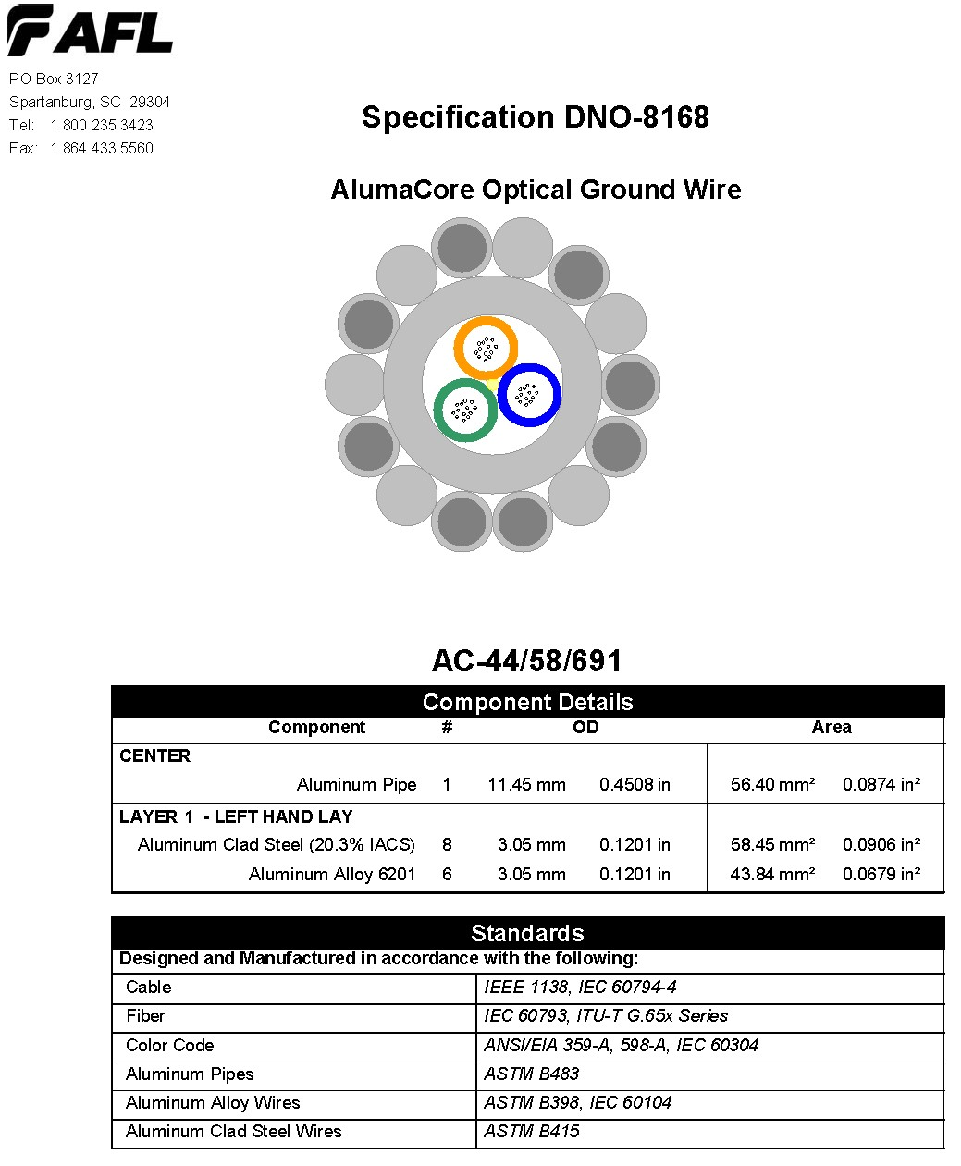
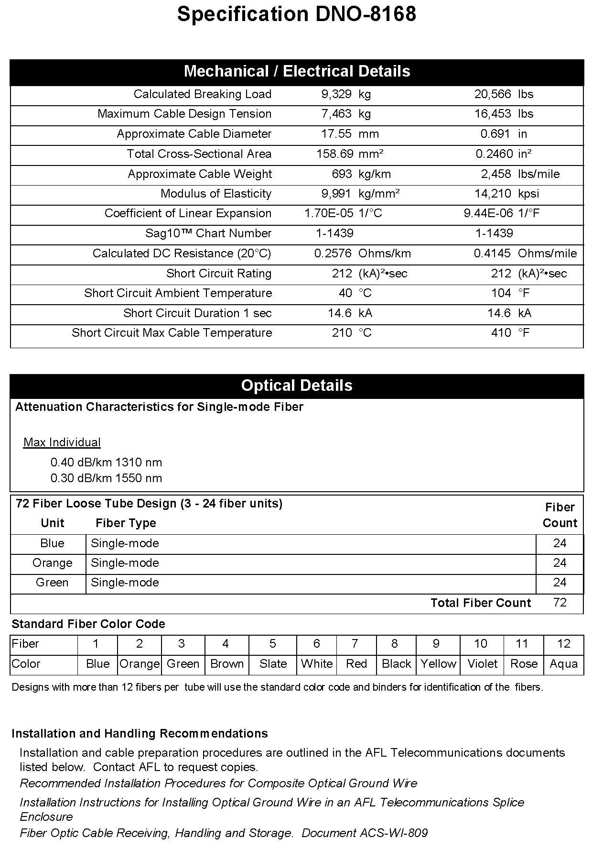
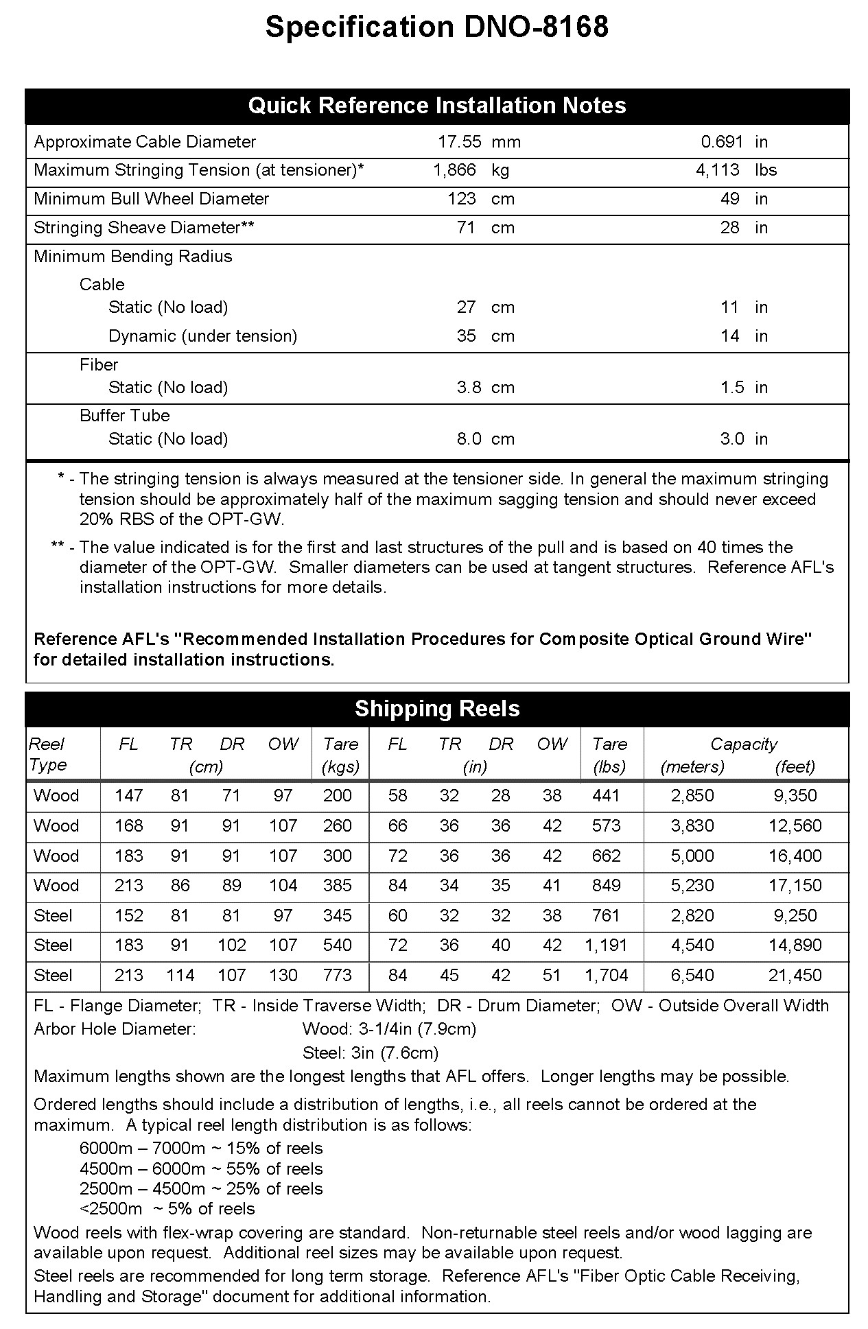
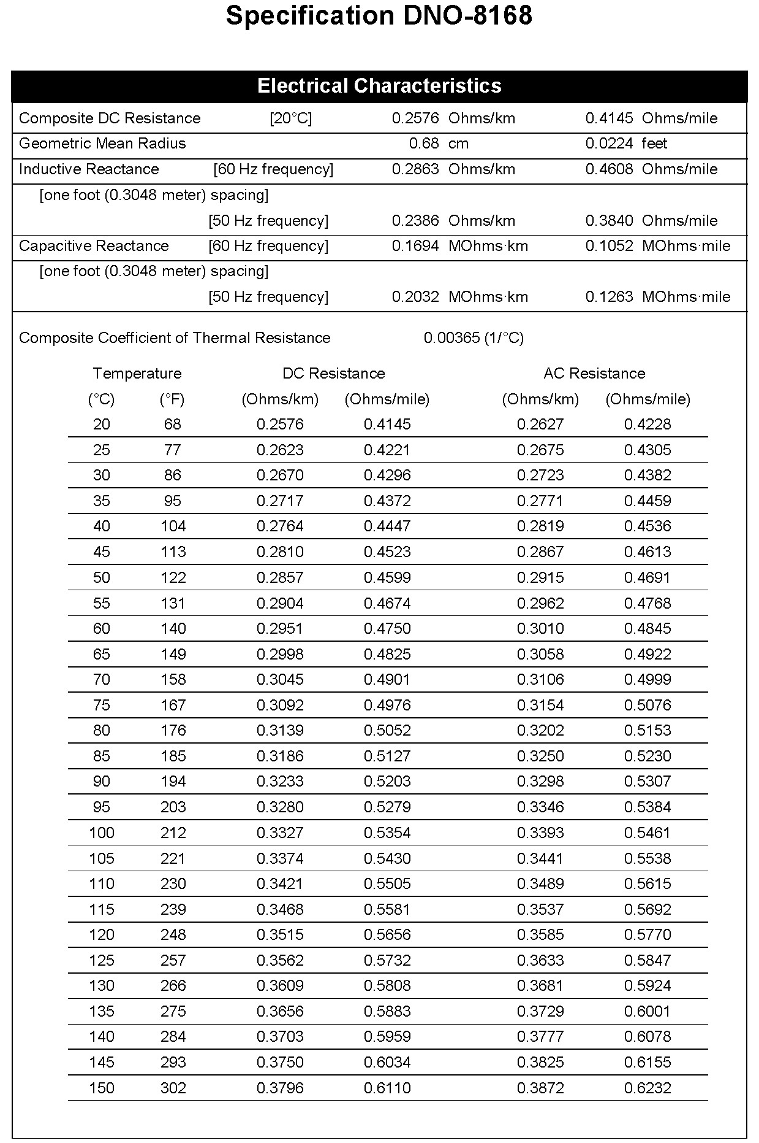
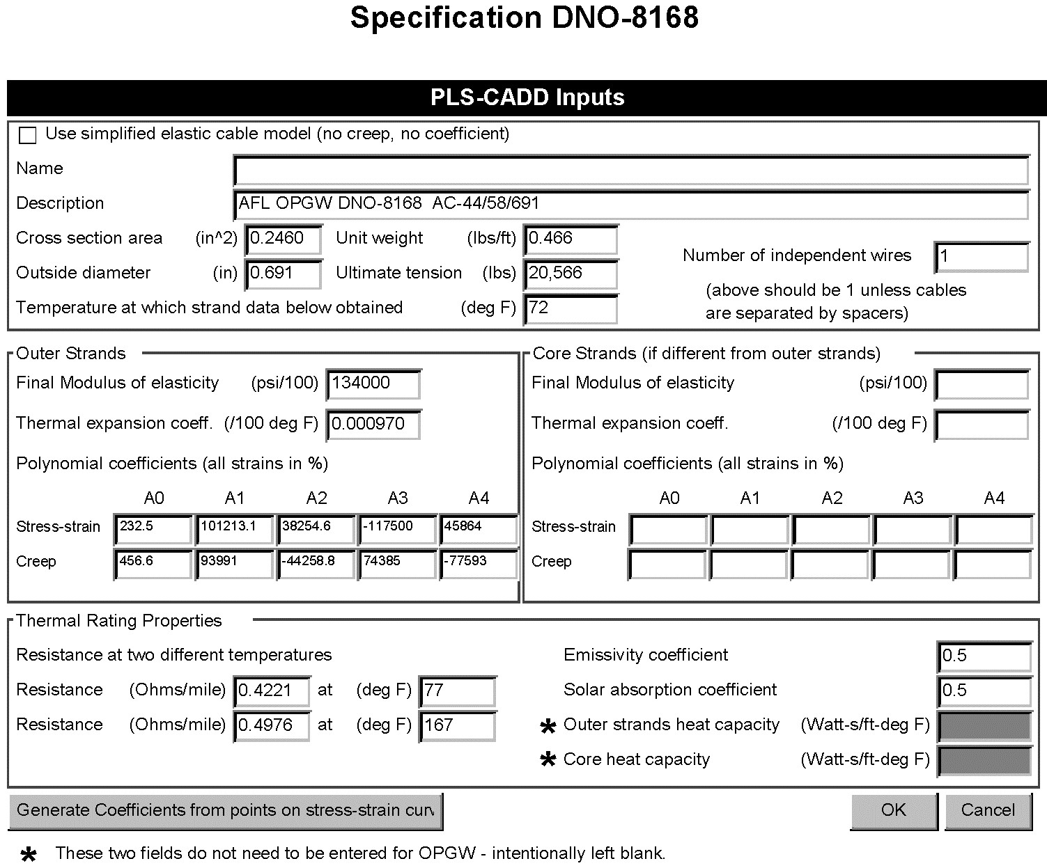
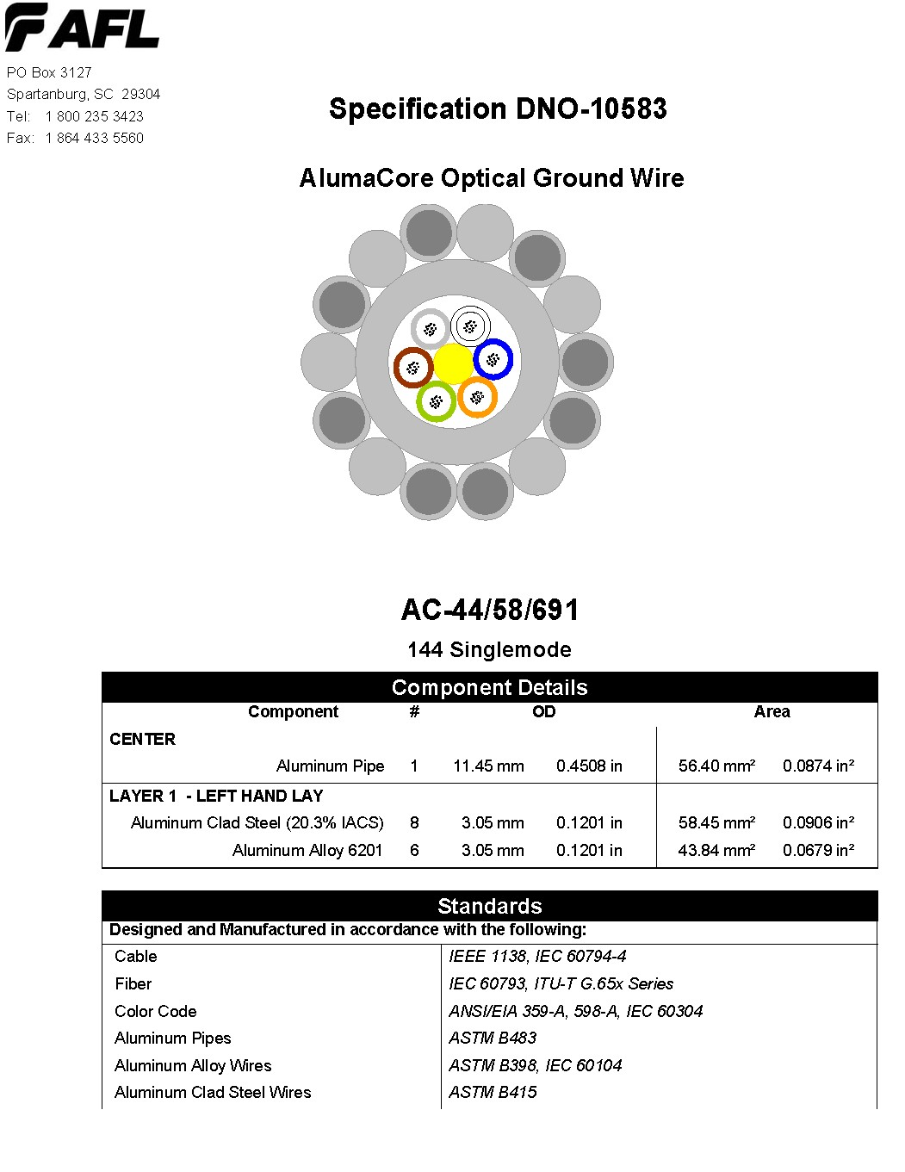

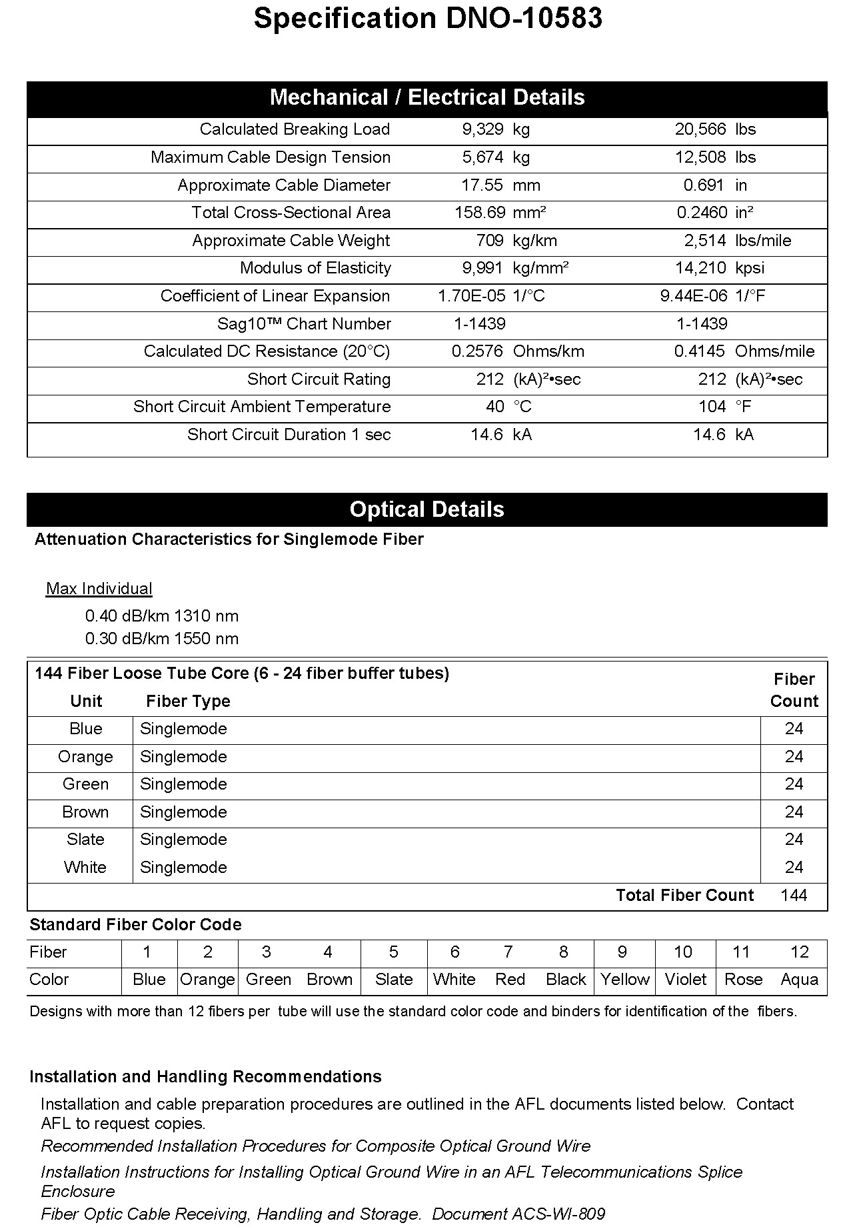
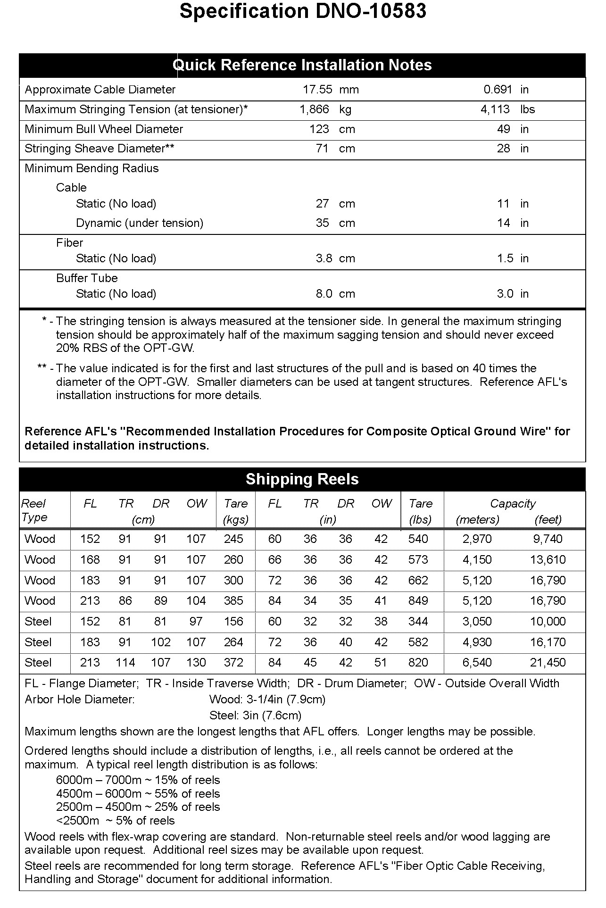
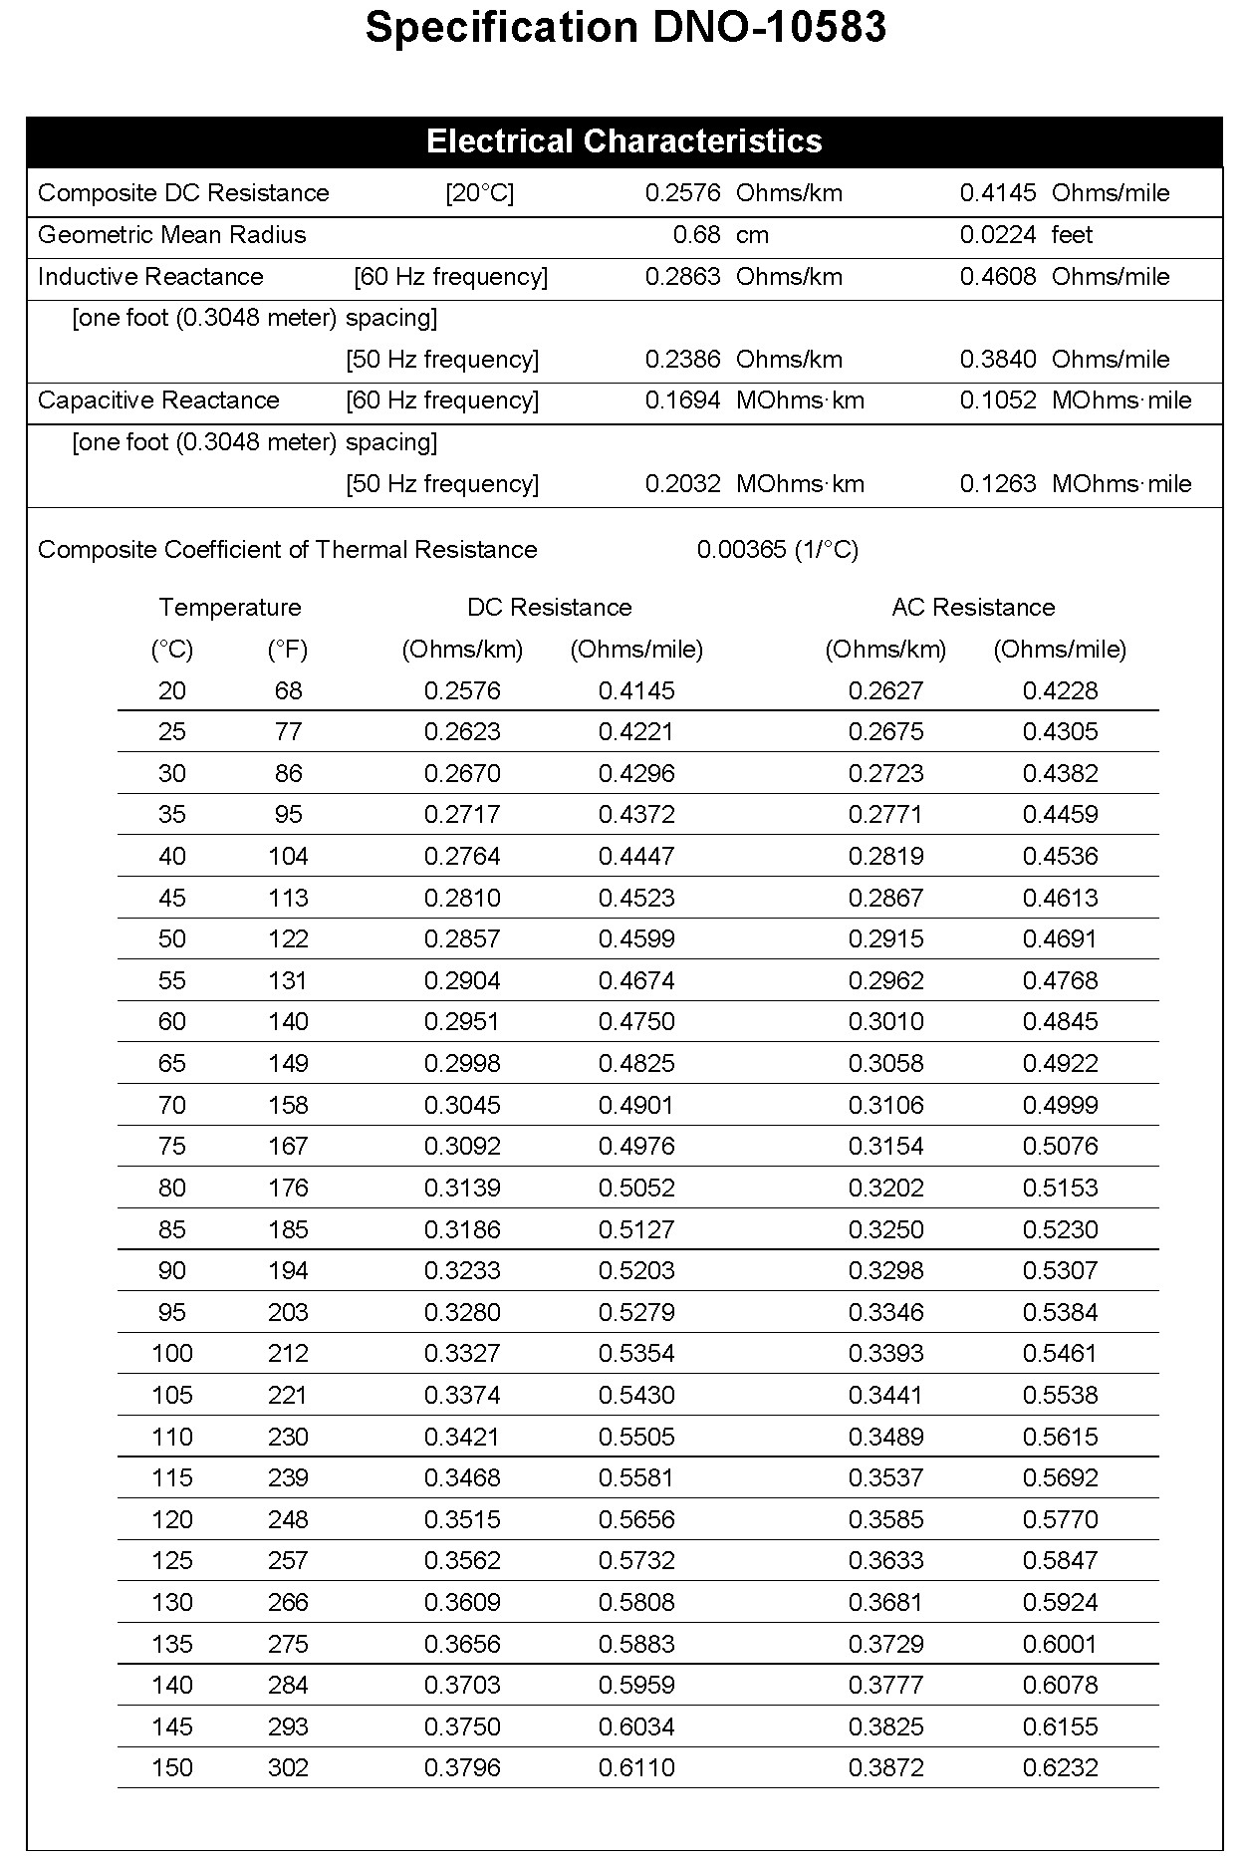
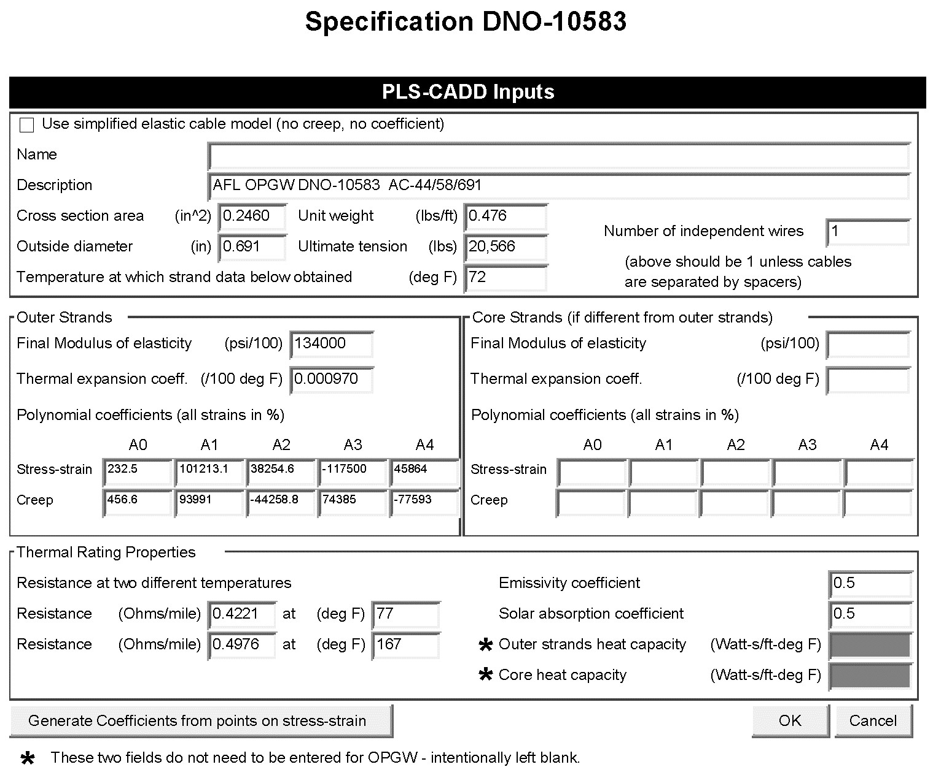

AFL OCA690699
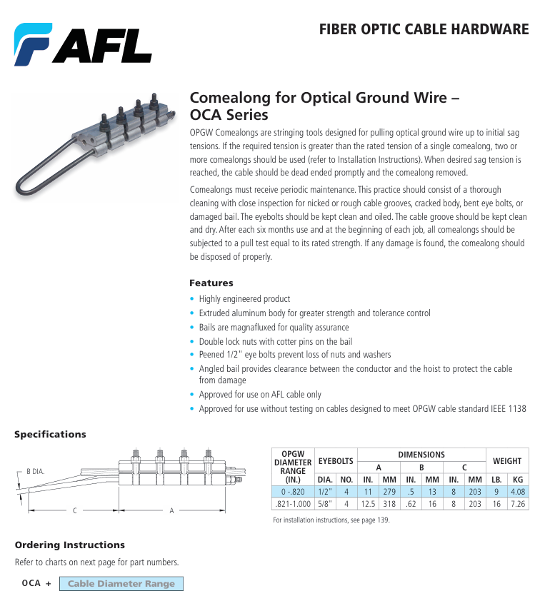

AFL SUME680/714BNC

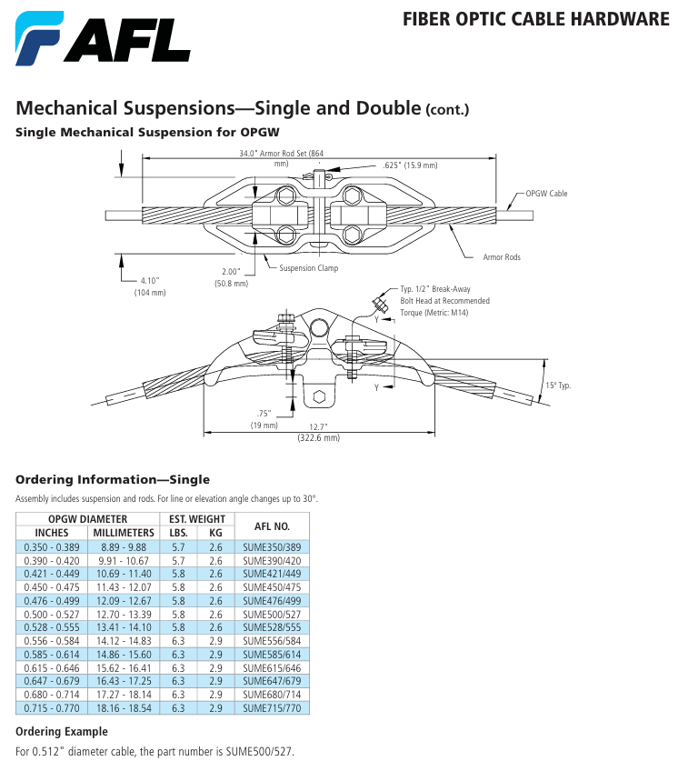

AFL ODSME680/714BNC

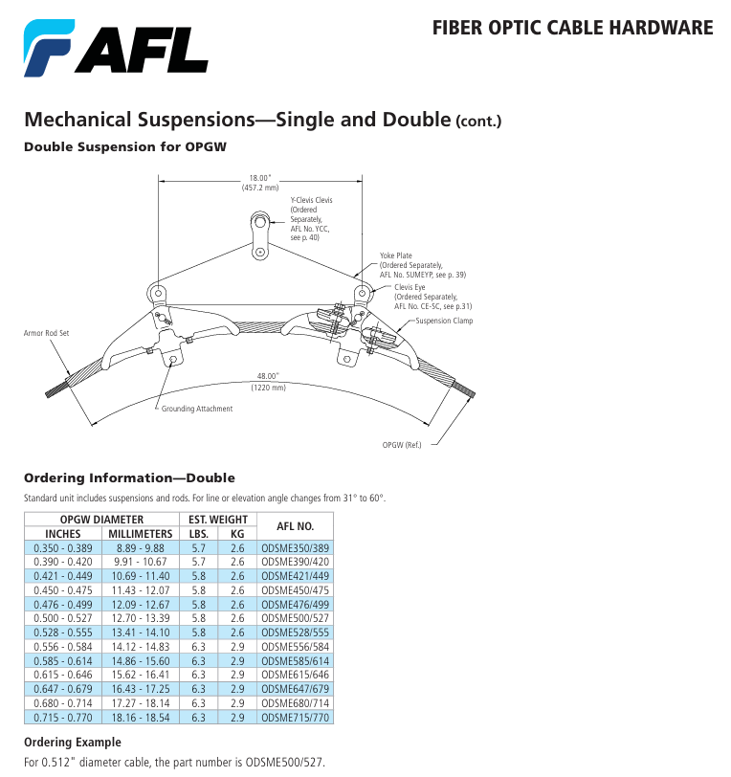

AFL ODEC690/699G09BNC

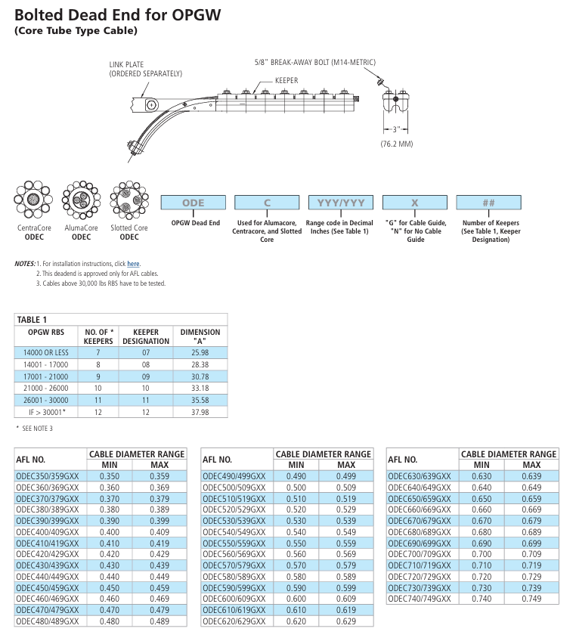

AFL FDOA-B6B6

AFL FDOA-B6B6A

AFL FDOA-B6B6B

AFL FDOA-B6B6C
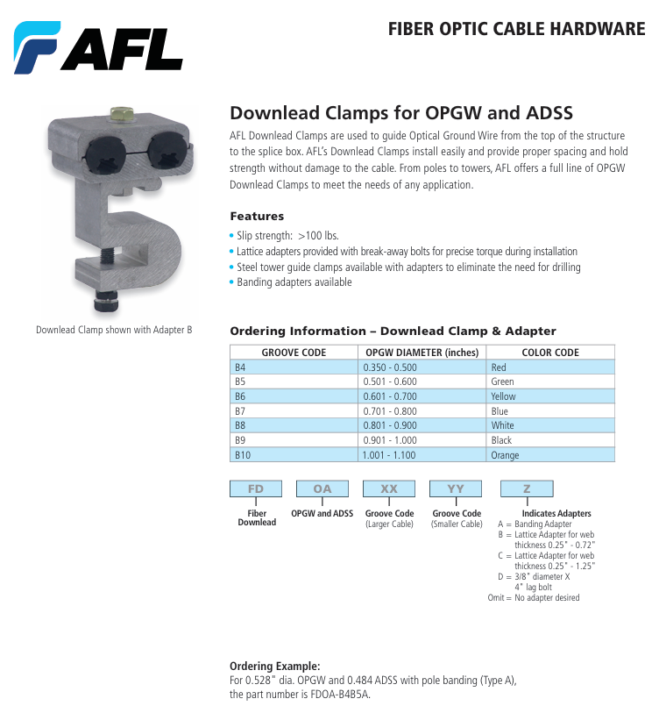

AFL APCKE678/693

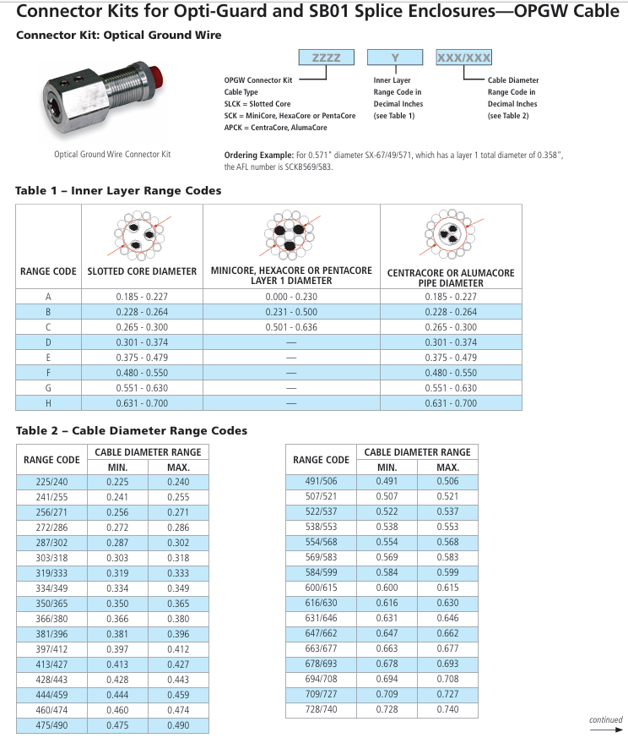

AFL BCK647/662

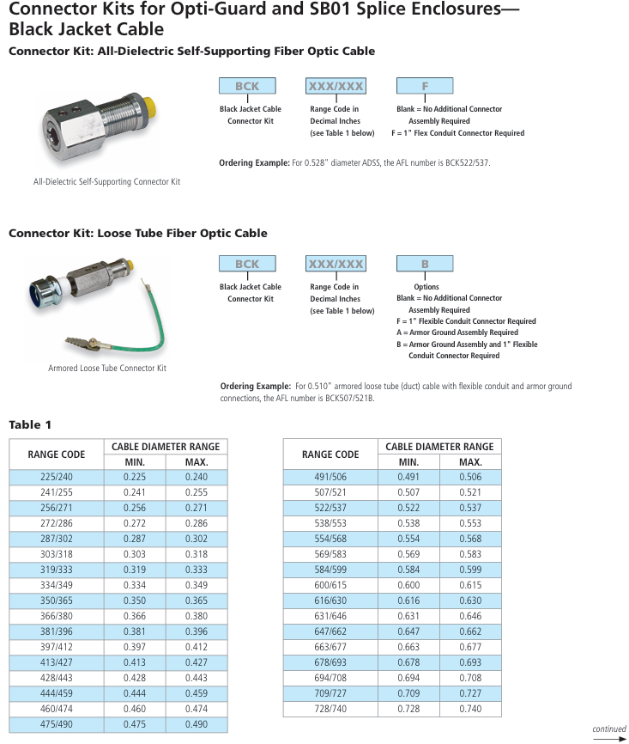

AFL OGST0172

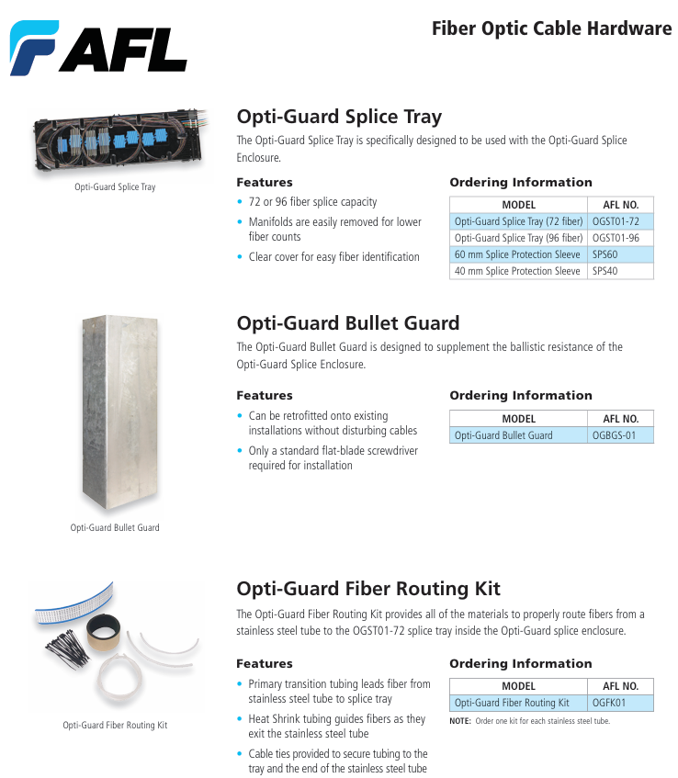

AFL OG03

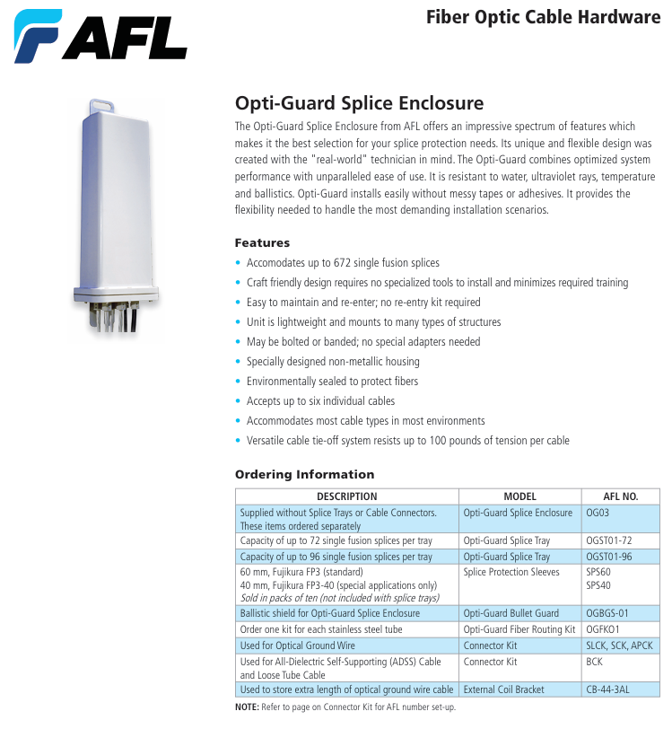

AFL OGBG01

AFL CB-44-3AL

