Solicitation FA465427R0001 Questions and Answers – Building 450 Fire Suppression System Installation

1. Requesting plan - schematics for the worksite area involved with this project
Answer: Tap from POL yard approx. 250 feet.
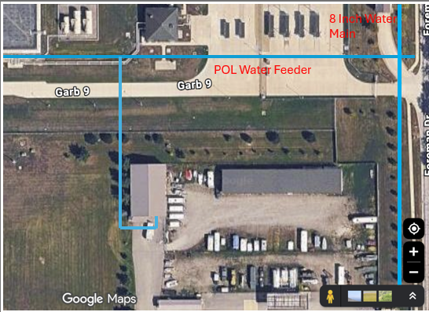
2. What Size and Material is the main water line we are tapping into?
Answer: Water Main is 6”. Ductal Iron.
3. What Size and Material is to be used from the tap to the fire hydrant?
Answer: For outside use, use ductile iron (DI) piping. For piping 2-inches and smaller, Schedule 40 is the minimum, and for pipes larger than 2-inches, Schedule 10 is the minimum. Acceptable materials include black steel pipe, and galvanized pipe is only permitted for specific applications like deluge systems and exterior drain piping. CPVC is permitted for residential occupancies, and the Air Force allows other listed plastic sprinkler pipes in any occupancy for which a listing exists but thin-walled PVC is not permitted for main pressurized fire lines inside or outside of the building. The Grissom Base Standards also mentions ductile iron pipe as a suitable replacement for cast iron pipe. Jamie Lay will need to provide his expertise on the piping inside the facility. Please consult a FP engineer.
4. Is a post Indicator Valve needed? If so, where is it to be placed?
Answer: Yes. Southwest corner of building 450, or where the FP engineer recommends.
5. Where is the fire hydrant being placed?
Answer: Yes. Southwest corner of building 450, or where the FP engineer recommends.
6. Where is the fire department connection needing to be placed on the building?
Answer: Yes. On the building where the water enters the building, or where the FP engineer recommends.
7. Is a water meter required? If so, where is it to be placed?
Answer: Yes. In the mechanical room.
8. Is the current mechanical room sufficient to add onto with it being constructed of wood studs, not metal?
Answer: Regardless of material the room needs to be fire rated per the NFPA . Please consult a FP engineer.
9. Is there a dump site on base?
Answer: No dump station.
10. Can the Riser / Mechanical room be constructed on the West of the new “Office space,” or does it have to remain on the East (current wood frame structure)?
Answer: This is unlikely. UFC 3-600-01 specifies that elevator machine rooms must have the same fire-resistance rating as the elevator shaft they serve. While this applies to elevators, it indicates a general principle of fire-rated enclosures for critical equipment rooms. The Grissom Base Standards do not explicitly prohibit wood studs, but they do refer to following UFC and other codes. Given that the riser room contains critical fire protection equipment, it would likely need to be constructed with fire-rated materials, not standard wood studs, to ensure the integrity of the fire suppression system. Fire Retardant Treated (FRT) wood might be an option in some cases, but its use is restricted. This should be reviewed and approved by the fire protection engineer.
  - Consult the SOW.

11. Will a fire vault be required for the backflow preventor or will it be allowed to be put in the riser room.
Answer: A separate fire vault will likely not be required. The backflow preventer can be located in the riser room, provided certain conditions are met. UFC 3-600-01 states that for locations subject to freezing, backflow preventers must be located in the facility, or within a heated enclosure. The riser room, being part of the constructed heated facility of this contract, would satisfy this requirement. UFC 3-600-01 also specifies clearance requirements around the equipment (3 feet in front, 6 inches behind) for access.

12. Will a water meter be required?
Answer: A water meter is not explicitly required for this fire suppression system. However, if a meter is installed, it must be a type listed by a Nationally Recognized Testing Laboratory (NRTL) as a fire service meter and must be approved by Fire Protection and Engineering. Additionally, if a flow meter is used as part of a fire pump test header, it has specific installation requirements.

13. Can you provide a drawing for where the fire protection line goes?
Answer: I cannot currently execute AUTOCAD. However, the "Grissom Air Reserve Base, Base Standards (2020)" document emphasizes that site utilities are to be underground. The exact routing of the fire protection line would be determined during site visit and the design phase of the project and would be shown on the project-specific drawings.
All fire protection design must be designed and stamped by the contractors certified, licensed, fire protection engineer.
Attached is an edited photo of the existing 8” main and the POL water line.

14. What is the fire line material and size? (C-900, DI, PVC)
Answer: For outside use, use ductile iron (DI) piping. For piping 2-inches and smaller, Schedule 40 is the minimum, and for pipes larger than 2-inches, Schedule 10 is the minimum. Acceptable materials include black steel pipe, and galvanized pipe is only permitted for specific applications like deluge systems and exterior drain piping. CPVC is permitted for residential occupancies, and the Air Force allows other listed plastic sprinkler pipe in any occupancy for which a listing exists but thin walled PVC is not permitted for main pressurized fire lines inside or outside of the building. The Grissom Base Standards also mentions ductile iron pipe as a suitable replacement for cast iron pipe. Jamie Lay will need to provide his expertise on the piping inside the facility.

15. Can the mechanical room – Riser closet stay framed as is out of wood studs?
Answer: This is unlikely. UFC 3-600-01 specifies that elevator machine rooms must have the same fire-resistance rating as the elevator shaft they serve. While this applies to elevators, it indicates a general principle of fire-rated enclosures for critical equipment rooms. The Grissom Base Standards do not explicitly prohibit wood studs, but they do refer to following UFC and other codes. Given that the riser room contains critical fire protection equipment, it would likely need to be constructed with fire-rated materials, not standard wood studs, to ensure the integrity of the fire suppression system. Fire Retardant Treated (FRT) wood might be an option in some cases, but its use is restricted. This should be reviewed by the fire protection engineer.

16. Can the spoils from the installing the fire line stay on post?
Answer: Yes, but with coordination. The "Grissom Air Reserve Base, Base Standards (2020)" document states that the contractor is responsible for proper disposal of waste and must coordinate with the base recycling department. Any spoils (dirt, stones etc.) from the POL area must be reused in the same trench created for the fire line. While Grissom ARB may be able to recycle selected items, the contractor retains ownership of the waste and is responsible for its proper disposal, which includes providing weight tickets in the O&M manual.

